**Tugas10**

**(Latihan Soal Tugas)**



**Disusun Oleh :**

Arief Nauvan Ramadha

Junior Web Developer A

**PELATIHAN VSGA**

**JUNIOR WEB DEVELOPER**

**DIGITAL TALENT SCHOLARSHIP**

**2021**

* **Script php:**

1. **Koneksi.php**

Script untuk konek ke database

<?php

$server = "localhost";

$user = "root";

$password = "";

$nama_database = "dbrs";

$db = mysqli_connect($server, $user, $password, $nama_database);

if( !$db ){

    die("Gagal terhubung dengan database: " . mysqli_connect_error());

}

//EOF

1. **Login.php**

<!DOCTYPE HTML>

<html>

    <head>

        <title>Login</title>

        <link rel="stylesheet" type="text/css" href="css/bootstrap.css">

        <link rel="stylesheet" href="style/style_login.css">

    </head>

    <body>

        <!-- Navbar -->

        <nav class="navbar navbar-light fixed-top">

            <div class="container-fluid">

                <span class="navbar-brand mb-0 h1" style="font-weight: bold; color: white">RS HUSADA MANDIRI</span>

            </div>

        </nav>

        <!-- Akhir Navbar -->

        <!-- Form Login -->

        <div class="container col-sm-5 " style="margin-left: 18rem">

            <form method="post" action="cek_login.php">

                <div class="row">

                    <div class="col">

                        <h1 class="header text-center">Login</h1>

                    </div>

                </div>

                <div class="form-group mt-3">

                    <label>Username:</label>

                    <input class="form-control"  type="text" name="user" placeholder="masukkan username">

                </div>

                <div class="form-group">

                    <label>Password:</label>

                    <input class="form-control" type="password" name="pass" placeholder="masukkan password">

                </div>

                <button type="submit" name="submit" class="btn btn-primary">Login</button>

            </form>

        </div>

        <!-- Akhir Form Login -->

        <!-- Footer -->

        <footer class="bg-primary text-white text-center pb-2 fixed-bottom">

            <p>Copyright Admin Information 2021</p>

        </footer>

        <!-- Akhir Footer -->

    </body>

</html>

1. **cek_login.php**

<?php

    session_start();

    $_SESSION['sesi'] = NULL;

    include "koneksi.php";

        if( isset($_POST['submit']))

        {

                $user   = isset($_POST['user']) ? $_POST['user'] : "";

                $pass   = isset($_POST['pass']) ? $_POST['pass'] : "";

                $qry    = mysqli_query($db,"SELECT * FROM admin WHERE username = '$user' AND password = '$pass'");

                $sesi   = mysqli_num_rows($qry);

                if ($sesi == 1)

                {

                    $data_admin = mysqli_fetch_array($qry);

                    $_SESSION['id_admin'] = $data_admin['id_admin'];

                    $_SESSION['sesi'] = $data_admin['nm_admin'];

                    echo "<script>alert('Anda berhasil Log In');</script>";

                    echo "<meta http-equiv='refresh' content='0; url=index.php?user=$sesi'>";

                }

                else

                {

                    echo "<meta http-equiv='refresh' content='0; url=login.php'>";

                    echo "<script>alert('Anda Gagal Log In');</script>";

                }

        }

        else

        {

            include "login.php";

        }

    //EOF

Halaman utama login

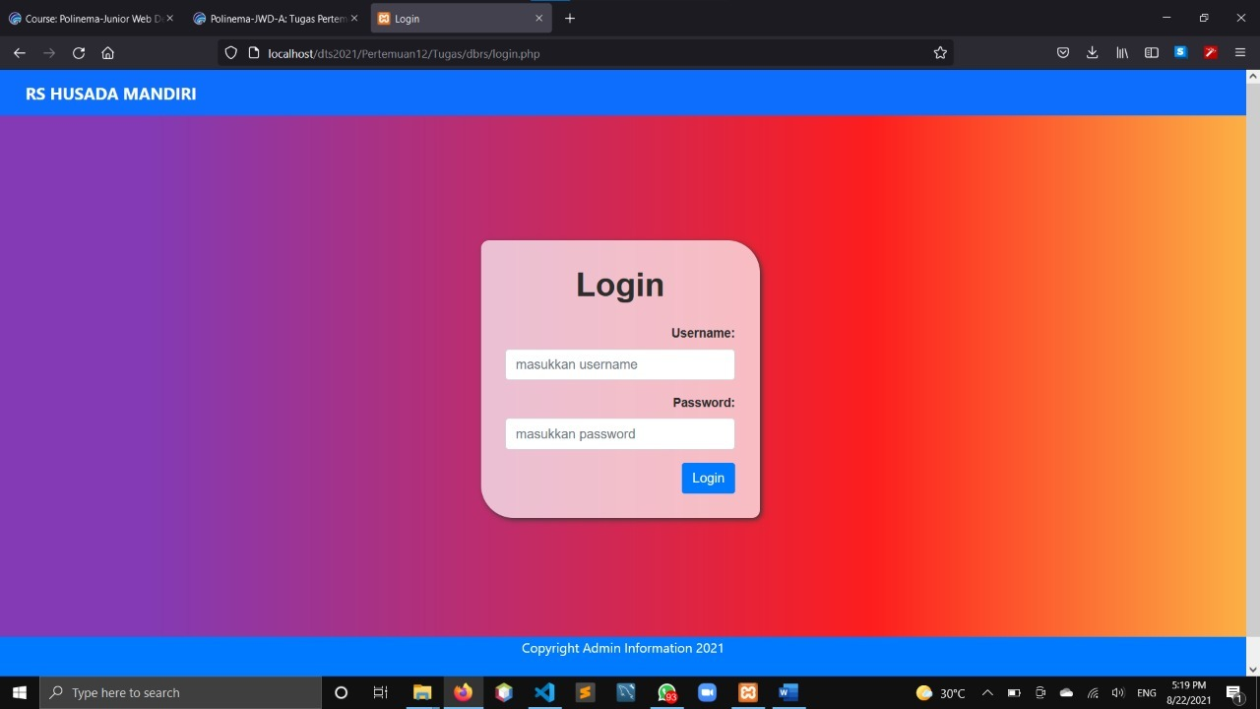

Melakukan cek login pada file cek_login.php. dan ketika username atau password ada yang salah atau tidak ada dalam database, maka akan muncul alert seperti gambar dibawah.

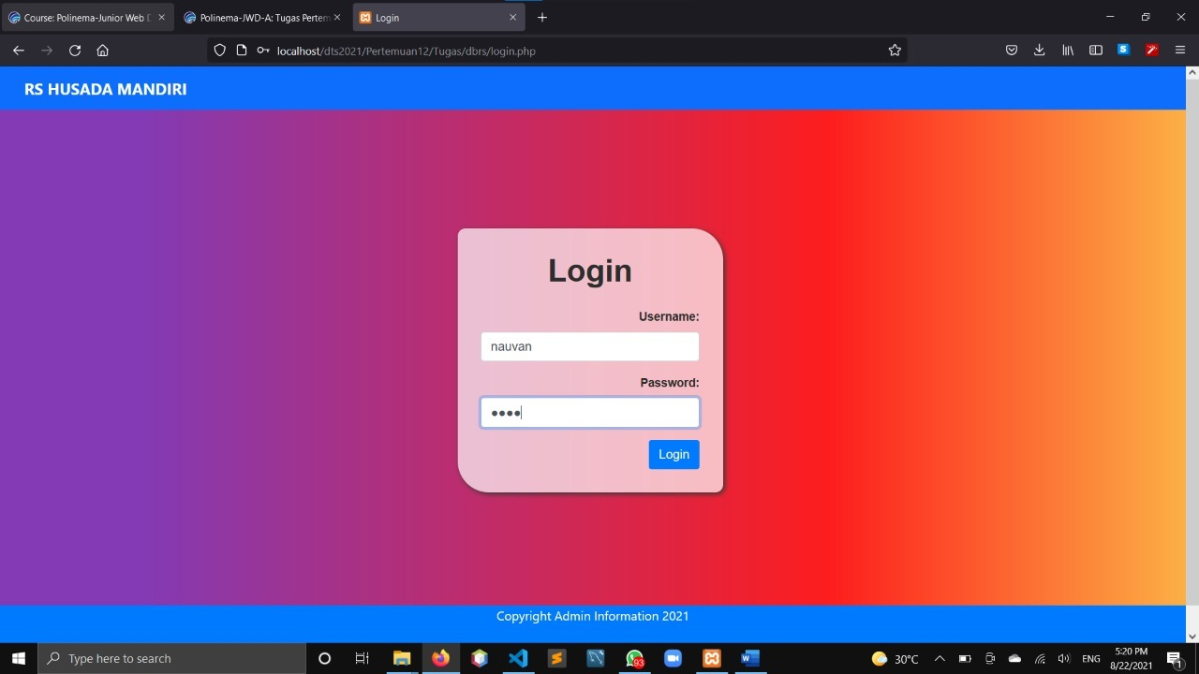

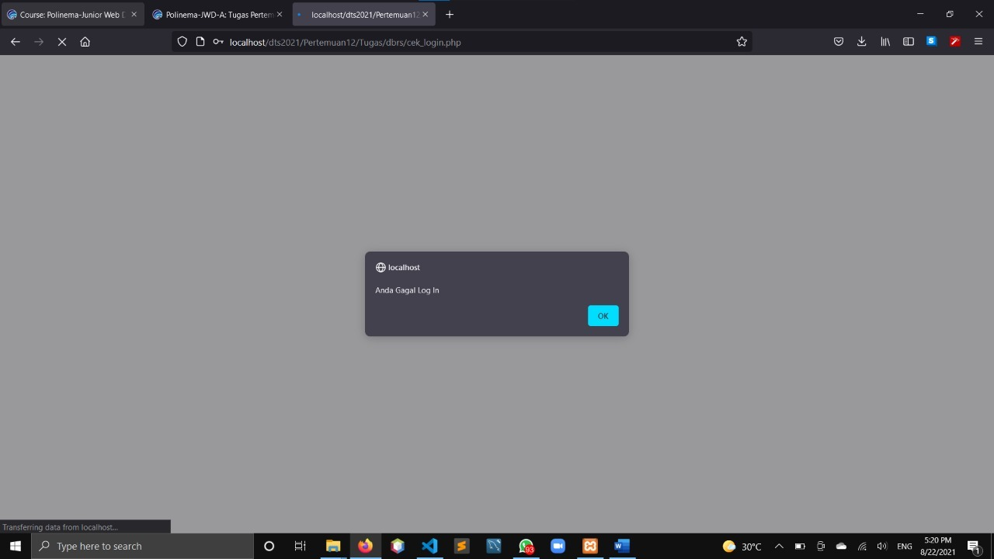

ketika username atau password ada yang benar atau ada dalam database, maka akan muncul alert seperti gambar dibawah.

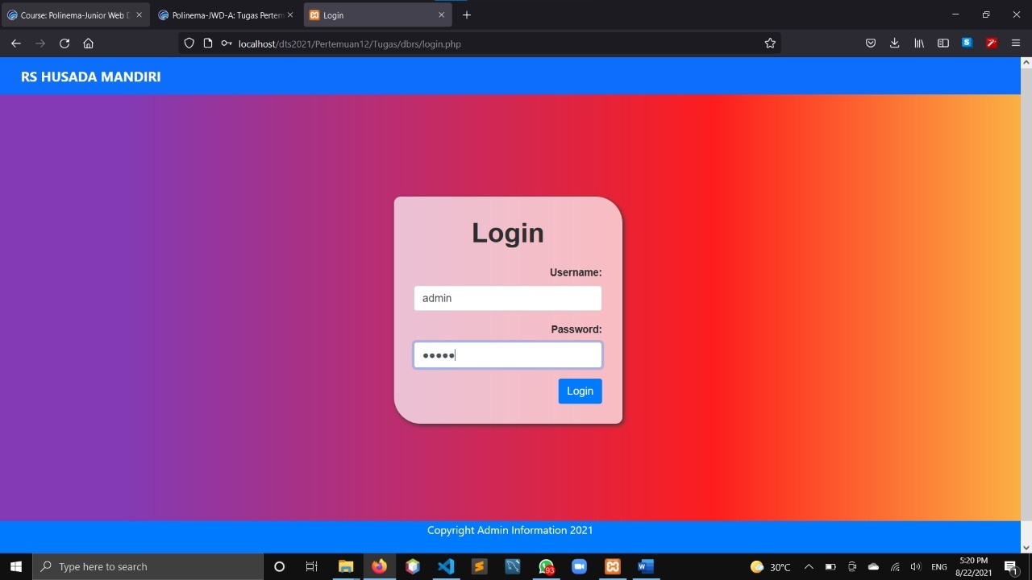

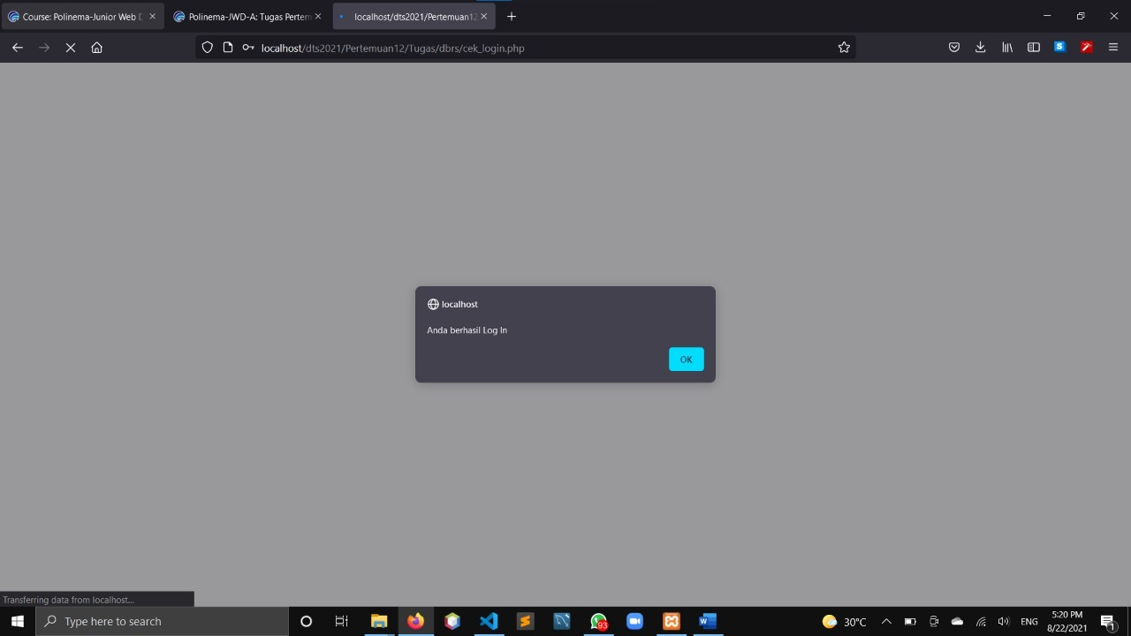

1. **Index.php**

Script saat masuk index.php atau halaman home

<?php

    include'koneksi.php';

    $tgl=date('Y-m-d');

    session_start();

    if(isset($_SESSION['sesi'])){

?>

<!DOCTYPE html>

 <html>

 <head>

    <meta charset="utf-8">

    <title>Home</title>

     <!-- style tanpa bootstrap -->

     <link rel="stylesheet" href="style/style_index.css">

     <!-- Style dengan bootstrap -->

     <link rel="stylesheet" href="css/bootstrap.css">

 </head>

 <body>

    <div id="container">

        <div id="header">

            <!-- Navbar -->

            <nav class="navbar navbar-expand-xl navbar-dark bg-primary shadow fixed-top">

                <div class="container">

                    <a class="navbar-brand" style="font-weight: bold" href="index.php">RS HUSADA MANDIRI</a>

                    <div class="collapse navbar-collapse justify-content-end" id="navbarNav">

                    <ul class="navbar-nav ms-auto">

                        <li class="nav-item">

                        <a class="nav-link active" aria-current="page" href="index.php">Home</a>

                        </li>

                        <li class="nav-item">

                            <a class="nav-link" href="pencarian.php">Pencarian</a>

                        </li>

                        <li class="nav-item">

                            <a class="nav-link" href="logout.php">Logout</a>

                        </li>

                    </ul>

                    </div>

                </div>

            </nav>

            <!-- Akhir Navbar -->

            <!-- Header Grid -->

            <div id="container-grid" class="text-center" style="background-color: grey">

                <div class="row">

                    <div class="col">

                        <h2 style="margin-top: 3rem">Pencarian Informasi Data Dokter</h2>

                    </div>

                </div>

            </div>

            <!-- Akhir Header Grid -->

            <!-- Salam Pengguna -->

            <div class="ml-2" id="header2">

                <div id="nama-user">Hai <?php echo$_SESSION['sesi']; ?>!</div>

            </div>

            <!-- Akhir Salam Pengguna -->

            <!-- Selamat Datang -->

            <div class="text-center">

                <p style="font-size: 500%; margin-top:9rem">SELAMAT DATANG!</p>

            </div>

            <!-- Akhir Selamat Datang -->

            <!-- Footer -->

            <footer class="bg-primary text-white text-center pb-2 fixed-bottom">

                <p>©Copyright Information 2021</p>

                <p>

                </p>

            </footer>

            <!-- Akhir Footer -->

        </div>

    </div>

 </body>

 </html>

 <?php

}

else {

    echo "<script>

        alert('Anda Harus Login Dahulu!');

    </script>";

    header('location:login.php');

}

?>

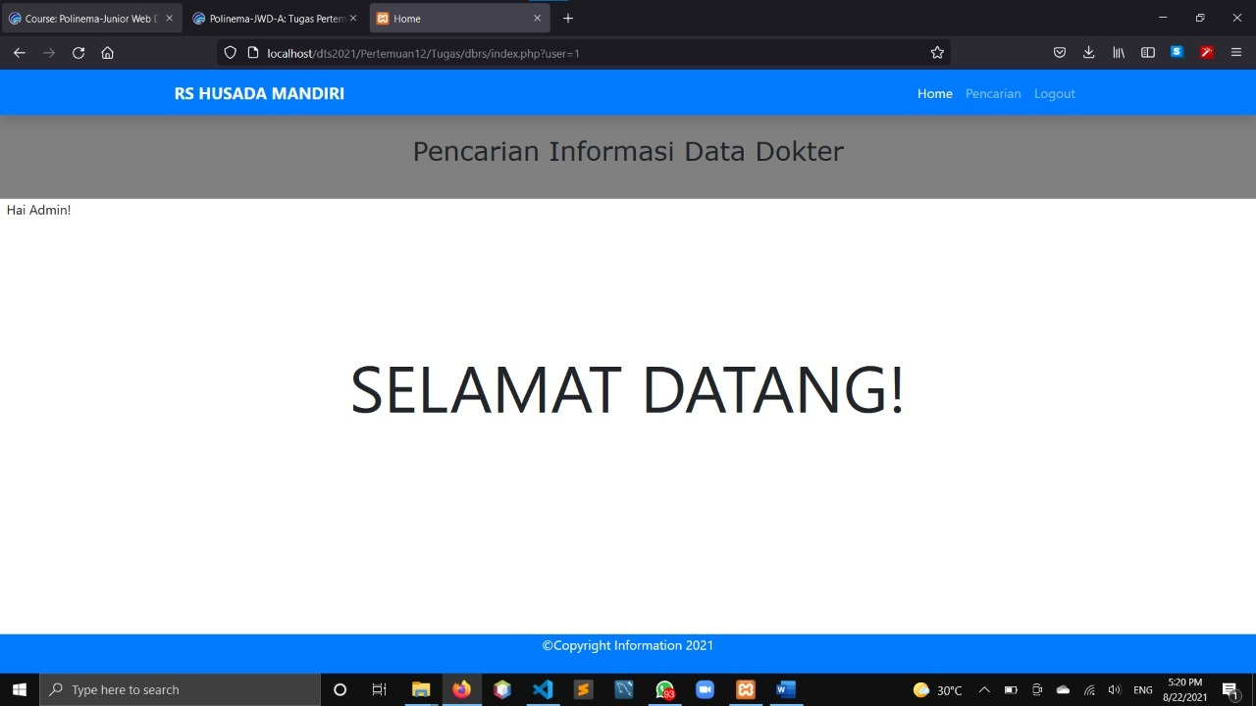

1. **Pencarian.php**

Script untuk masuk dalam halaman pencarian atau kedalam file pencarian.php

<?php

    include'koneksi.php';

    $tgl=date('Y-m-d');

    session_start();

    if(isset($_SESSION['sesi'])){

?>

<!DOCTYPE html>

<html lang="en">

<head>

    <meta charset="UTF-8">

    <meta http-equiv="X-UA-Compatible" content="IE=edge">

    <meta name="viewport" content="width=device-width, initial-scale=1.0">

    <title>Pencarian</title>

    <link rel="stylesheet" href="css/bootstrap.css">

    <link rel="stylesheet" href="style/pencarian.css">

</head>

<body>

    <div id="container">

        <div id="header">

            <!-- Navbar -->

            <nav class="navbar navbar-expand-xl navbar-dark bg-primary shadow fixed-top">

                <div class="container">

                    <a class="navbar-brand" style="font-weight: bold" href="index.php">RS HUSADA MANDIRI</a>

                    <div class="collapse navbar-collapse justify-content-end" id="navbarNav">

                    <ul class="navbar-nav ms-auto">

                        <li class="nav-item">

                        <a class="nav-link" aria-current="page" href="index.php">Home</a>

                        </li>

                        <li class="nav-item">

                            <a class="nav-link active" href="pencarian.php">Pencarian</a>

                        </li>

                        <li class="nav-item">

                            <a class="nav-link" href="logout.php">Logout</a>

                        </li>

                    </ul>

                    </div>

                </div>

            </nav>

            <!-- Akhir Navbar -->

            <!-- Header Grid -->

            <div id="container-grid" class="text-center" style="background-color: grey">

                <div class="row">

                    <div class="col">

                        <h2 style="margin-top: 3rem">Pencarian Informasi Data Dokter</h2>

                    </div>

                </div>

            </div>

            <!-- Akhir Header Grid -->

            <!-- Isi -->

            <div class="text-center mt-3 mb-5" style="font-family: Segoe UI;" id="label-page">

                <h3>Tampil Data Anggota</h3>

            </div>

            <div id="content">

                <div class="row">

                    <div class="col">

                        <div style="margin-left: 18rem; margin-top: -1.34rem;;">

                            <p id="tombol-tambah-container">

                                <a href="pages/anggota-input.php" class="tombol">Tambah Anggota</a>  |

                                <a target="_blank" href="pages/cetak.php">

                                    cetak

                                </a>

                            </p>

                        </div>

                        <FORM CLASS="form-inline" METHOD="POST">

                            <div align="right">

                                <form method=post>

                                    <input type="text" name="pencarian" placeholder="cari....">

                                    <input style="color:white" class="bg-primary" type="submit" name="search" value="search" class="tombol">

                                </form>

                        </FORM>

                        <table style="margin-left: 17rem; margin-bottom: 0rem" id="tabel-tampil" border="5" cellspacing="0" cellpadding="15" class="text-center mt-4">

                            <tr>

                                <th id="label-tampil-no">No</td>

                                <th>ID Anggota</th>

                                <th>Nama</th>

                                <th>Foto</th>

                                <th>Jenis Kelamin</th>

                                <th>Alamat</th>

                                <th>Spesialis</th>

                                <th id="label-opsi">Opsi</th>

                            </tr>

                            <?php

                        $batas = 5;

                        extract($_GET);

                        if(empty($hal)){

                            $posisi = 0;

                            $hal = 1;

                            $nomor = 1;

                        }

                        else {

                            $posisi = ($hal - 1) * $batas;

                            $nomor = $posisi+1;

                        }

                        if($_SERVER['REQUEST_METHOD'] == "POST"){

                            $pencarian = trim(mysqli_real_escape_string($db, $_POST['pencarian']));

                            if($pencarian != ""){

                                $sql = "SELECT * FROM tbanggota WHERE nama LIKE '%$pencarian%'

                                        OR idanggota LIKE '%$pencarian%'

                                        OR jeniskelamin LIKE '%$pencarian%'

                                        OR alamat LIKE '%$pencarian%'

                                        OR spesialis LIKE '%$pencarian%'";

                                $query = $sql;

                                $queryJml = $sql;

                            }

                            else {

                                $query = "SELECT * FROM tbanggota LIMIT $posisi, $batas";

                                $queryJml = "SELECT * FROM tbanggota";

                                $no = $posisi * 1;

                            }

                        }

                        else {

                            $query = "SELECT * FROM tbanggota LIMIT $posisi, $batas";

                            $queryJml = "SELECT * FROM tbanggota";

                            $no = $posisi * 1;

                        }

                        //$sql="SELECT * FROM tbanggota ORDER BY idanggota DESC";

                        $q_tampil_anggota = mysqli_query($db, $query);

                        if(mysqli_num_rows($q_tampil_anggota)>0)

                        {

                        while($r_tampil_anggota=mysqli_fetch_array($q_tampil_anggota)){

                            if(empty($r_tampil_anggota['foto'])or($r_tampil_anggota['foto']=='-'))

                                $foto = "admin-no-photo.jpg";

                            else

                                $foto = $r_tampil_anggota['foto'];

                        ?>

                        <tr>

                            <td><?php echo $nomor; ?></td>

                            <td><?php echo $r_tampil_anggota['idanggota']; ?></td>

                            <td><?php echo $r_tampil_anggota['nama']; ?></td>

                            <td><img src="images/<?php echo $foto; ?>" width=70px height=70px></td>

                            <td><?php echo $r_tampil_anggota['jeniskelamin']; ?></td>

                            <td><?php echo $r_tampil_anggota['alamat']; ?></td>

                            <td><?php echo $r_tampil_anggota['spesialis']; ?></td>

                            <td>

                                <div class="tombol-opsi-container">

                                    <button type="button" class="bg-primary">

                                        <a style="color: white; text-decoration: none" target="_blank" href="pages/cetak_kartu.php?id=<?php echo $r_tampil_anggota['idanggota'];?>" class="tombol">Cetak Kartu</a>

                                    </button>

                                </div>

                                <div class="tombol-opsi-container">

                                    <button type="button" class="bg-warning">

                                        <a style="color: white; text-decoration: none" href="pages/anggota-edit.php?id=<?php echo $r_tampil_anggota['idanggota'];?>" class="tombol">Edit</a>

                                    </button>

                                </div>

                                <div class="tombol-opsi-container">

                                    <button type="button" class="bg-danger">

                                        <a style="color: white; text-decoration: none" href="proses/anggota-hapus.php?id=<?php echo $r_tampil_anggota['idanggota']; ?>" onclick = "return confirm ('Apakah Anda Yakin Akan Menghapus Data Ini?')" class="tombol">Hapus</a>

                                    </button>

                                </div>

                            </td>

                        </tr>

                        <?php $nomor++; }

                        }

                        else {

                            echo "<tr><td colspan=6>Data Tidak Ditemukan</td></tr>";

                        }?>

                        </table>

                    </div>

                </div>

            </div>

            <!-- Akhir Isi -->

            <!-- Banyak Data -->

            <?php

                if(isset($_POST['pencarian'])){

                if($_POST['pencarian']!=''){

                    echo "<div style=\"float:left;\">";

                    $jml = mysqli_num_rows(mysqli_query($db, $queryJml));

                    echo "Data Hasil Pencarian: <b>$jml</b>";

                    echo "</div>";

                }

                }

                else{

            ?>

            <div id="banyak-data" style="float: left; margin-left: 18rem;">

                <?php

                    $jml = mysqli_num_rows(mysqli_query($db, $queryJml));

                    echo "Jumlah Data : <b>$jml</b>";

                ?>

                </div>

                <div id="halaman-data" class="pagination mb-5 mb-5" style="margin-left: 73rem; margin-botton: 15rem">

                        <?php

                        $jml_hal = ceil($jml/$batas);

                        for($i=1; $i<=$jml_hal; $i++){

                            if($i != $hal){

                                echo "<a href=\"?p=anggota&hal=$i\">$i</a>";

                            }

                            else {

                                echo "<a class=\"active\">$i</a>";

                            }

                        }

                        ?>

                </div>

            <?php

            }

            ?>

            <!-- Akhir Banyak Data -->

            <!-- Header Grid Bawah -->

            <div id="container-grid" class="text-center" style="background-color: white">

            </div>

            <!-- Akhir Header Grid Bawah -->

            <!-- Footer -->

            <footer class="bg-primary text-white text-center mt-5 pb-5 fixed-bottom">

                <p>©Copyright Information 2021</p>

            </footer>

            <!-- Akhir Footer -->

        </div>

    </div>

</body>

</html>

<?php

}

else {

    echo "<script>

        alert('Anda Harus Login Dahulu!');

    </script>";

    header('location:login.php');

}

?>

1. **Pages/anggota.php**

mencari data dengan menggunakan search didalam file pencarian.php... pencarian bisa menggunakan idanggota atau nama anggota, atau jenis kelamin, atau alamat, atau bisa menggunakan spesialis dokter.

<div id="label-page"><h3>Tampil Data Anggota</h3></div>

<div id="content">

    <p id="tombol-tambah-container"><a href="index.php?p=anggota-input" class="tombol">Tambah Anggota</a>

    <a target="_blank" href="pages/cetak.php"><img src="print.png" height="50px" height="50px"></a>

    <FORM CLASS="form-inline" METHOD="POST">

    <div align="right"><form method=post><input type="text" name="pencarian"><input type="submit" name="search" value="search" class="tombol"></form>

    </FORM>

    </p>

    <table id="tabel-tampil">

        <tr>

            <th id="label-tampil-no">No</td>

            <th>ID Anggota</th>

            <th>Nama</th>

            <th>Foto</th>

            <th>Jenis Kelamin</th>

            <th>Alamat</th>

            <th id="label-opsi">Opsi</th>

        </tr>

        <?php

        $batas = 5;

        extract($_GET);

        if(empty($hal)){

            $posisi = 0;

            $hal = 1;

            $nomor = 1;

        }

        else {

            $posisi = ($hal - 1) * $batas;

            $nomor = $posisi+1;

        }

        if($_SERVER['REQUEST_METHOD'] == "POST"){

            $pencarian = trim(mysqli_real_escape_string($db, $_POST['pencarian']));

            if($pencarian != ""){

                $sql = "SELECT * FROM tbanggota WHERE nama LIKE '%$pencarian%'

                        OR idanggota LIKE '%$pencarian%'

                        OR jeniskelamin LIKE '%$pencarian%'

                        OR alamat LIKE '%$pencarian%'";

                $query = $sql;

                $queryJml = $sql;

            }

            else {

                $query = "SELECT * FROM tbanggota LIMIT $posisi, $batas";

                $queryJml = "SELECT * FROM tbanggota";

                $no = $posisi * 1;

            }

        }

        else {

            $query = "SELECT * FROM tbanggota LIMIT $posisi, $batas";

            $queryJml = "SELECT * FROM tbanggota";

            $no = $posisi * 1;

        }

        //$sql="SELECT * FROM tbanggota ORDER BY idanggota DESC";

        $q_tampil_anggota = mysqli_query($db, $query);

        if(mysqli_num_rows($q_tampil_anggota)>0)

        {

        while($r_tampil_anggota=mysqli_fetch_array($q_tampil_anggota)){

            if(empty($r_tampil_anggota['foto'])or($r_tampil_anggota['foto']=='-'))

                $foto = "admin-no-photo.jpg";

            else

                $foto = $r_tampil_anggota['foto'];

        ?>

        <tr>

            <td><?php echo $nomor; ?></td>

            <td><?php echo $r_tampil_anggota['idanggota']; ?></td>

            <td><?php echo $r_tampil_anggota['nama']; ?></td>

            <td><img src="images/<?php echo $foto; ?>" width=70px height=70px></td>

            <td><?php echo $r_tampil_anggota['jeniskelamin']; ?></td>

            <td><?php echo $r_tampil_anggota['alamat']; ?></td>

            <td>

                <div class="tombol-opsi-container"><a target="_blank" href="pages/cetak_kartu.php?id=<?php echo $r_tampil_anggota['idanggota'];?>" class="tombol">Cetak Kartu</a></div>

                <div class="tombol-opsi-container"><a href="index.php?p=anggota-edit&id=<?php echo $r_tampil_anggota['idanggota'];?>" class="tombol">Edit</a></div>

                <div class="tombol-opsi-container"><a href="proses/anggota-hapus.php?id=<?php echo $r_tampil_anggota['idanggota']; ?>" onclick = "return confirm ('Apakah Anda Yakin Akan Menghapus Data Ini?')" class="tombol">Hapus</a></div>

            </td>

        </tr>

        <?php $nomor++; }

        }

        else {

            echo "<tr><td colspan=6>Data Tidak Ditemukan</td></tr>";

        }?>

    </table>

    <?php

    if(isset($_POST['pencarian'])){

    if($_POST['pencarian']!=''){

        echo "<div style=\"float:left;\">";

        $jml = mysqli_num_rows(mysqli_query($db, $queryJml));

        echo "Data Hasil Pencarian: <b>$jml</b>";

        echo "</div>";

    }

    }

    else{ ?>

        <div style="float: left;">

        <?php

            $jml = mysqli_num_rows(mysqli_query($db, $queryJml));

            echo "Jumlah Data : <b>$jml</b>";

        ?>

        </div>

        <div class="pagination">

                <?php

                $jml_hal = ceil($jml/$batas);

                for($i=1; $i<=$jml_hal; $i++){

                    if($i != $hal){

                        echo "<a href=\"?p=anggota&hal=$i\">$i</a>";

                    }

                    else {

                        echo "<a class=\"active\">$i</a>";

                    }

                }

                ?>

        </div>

    <?php

    }

    ?>

</div>

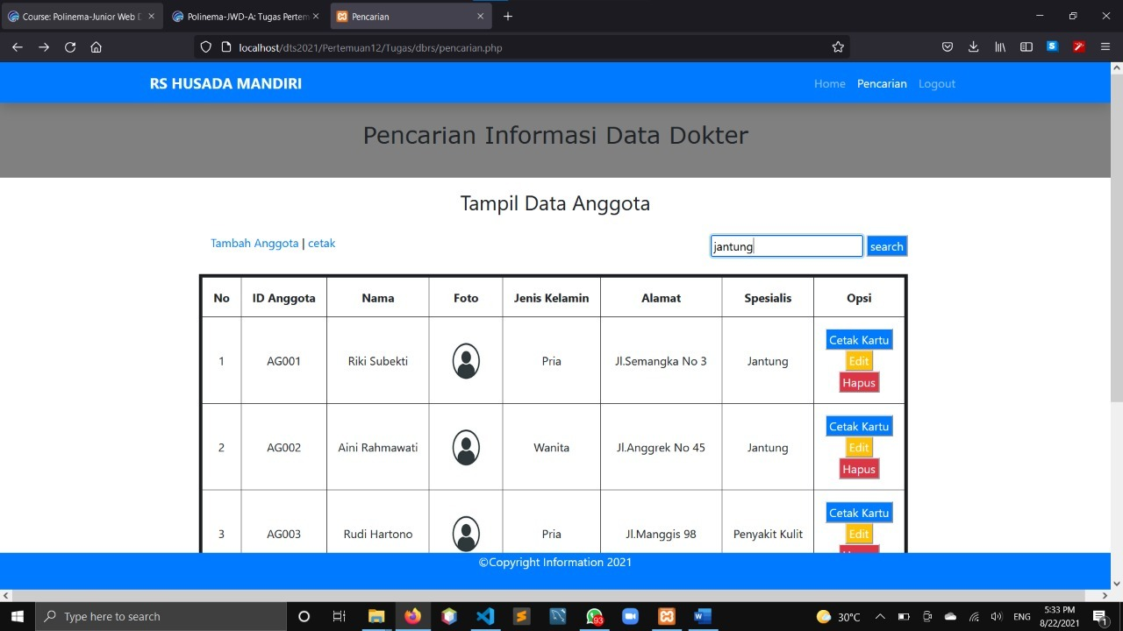

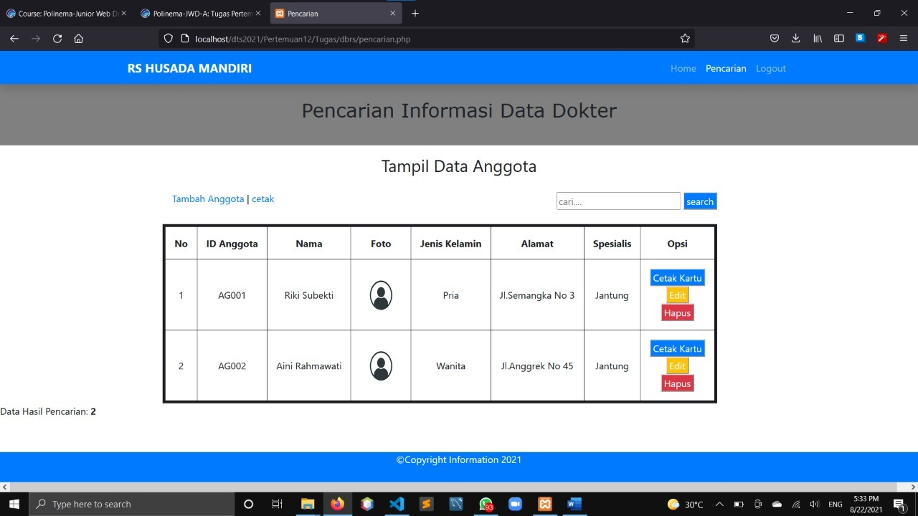

1. **Pages/anggota-input.php**

Melakukan input data anggota

<div id="label-page"><h3>Input Data Anggota</h3></div>

<div id="content">

    <form action="../proses/anggota-input-proses.php" method="post" enctype="multipart/form-data">

    <table id="tabel-input">

        <tr>

            <td class="label-formulir">FOTO</td>

            <td class="isian-formulir"><input type="file" name="foto" class="isian-formulir isian-formulir-border"></td>

        </tr>

        <tr>

            <td class="label-formulir">ID Anggota</td>

            <td class="isian-formulir"><input type="text" name="id_anggota" class="isian-formulir isian-formulir-border"></td>

        </tr>

        <tr>

            <td class="label-formulir">Nama</td>

            <td class="isian-formulir"><input type="text" name="nama" class="isian-formulir isian-formulir-border"></td>

        </tr>

        <tr>

            <td class="label-formulir">Jenis Kelamin</td>

            <td class="isian-formulir"><input type="radio" name="jenis_kelamin" value="Pria">Pria</label></td>

        </tr>

        <tr>

            <td class="label-formulir"></td>

            <td class="isian-formulir"><input type="radio" name="jenis_kelamin" value="Wanita">Wanita</td>

        </tr>

        <tr>

            <td class="label-formulir">Alamat</td>

            <td class="isian-formulir"><textarea rows="2" cols="40" name="alamat" class="isian-formulir isian-formulir-border"></textarea></td>

        </tr>

        <tr>

            <td class="label-formulir">Spesialis</td>

            <td class="isian-formulir"><textarea rows="2" cols="40" name="spesialis" class="isian-formulir isian-formulir-border"></textarea></td>

        </tr>

        <tr>

            <td class="label-formulir"></td>

            <td class="isian-formulir"><input type="submit" name="simpan" value="Simpan" class="tombol"></td>

        </tr>

    </table>

    </form>

</div>

1. **Proses/anggota-input-proses.php**

<?php

include'../koneksi.php';

$id_anggota=$_POST['id_anggota'];

$nama=$_POST['nama'];

$jenis_kelamin=$_POST['jenis_kelamin'];

$alamat=$_POST['alamat'];

$spesialis=$_POST['spesialis'];

$status="Tidak Meminjam";

if(isset($_POST['simpan'])){

        extract($_POST);

        $nama_file   = $_FILES['foto']['name'];

        if(!empty($nama_file)){

        // Baca lokasi file sementar dan nama file dari form (fupload)

        $lokasi_file = $_FILES['foto']['tmp_name'];

        $tipe_file = pathinfo($nama_file, PATHINFO_EXTENSION);

        $file_foto = $id_anggota.".".$tipe_file;

        // Tentukan folder untuk menyimpan file

        $folder = "../images/$file_foto";

        // Apabila file berhasil di upload

        move_uploaded_file($lokasi_file,"$folder");

        }

        else

            $file_foto="-";

    $sql =

    "INSERT INTO tbanggota

        VALUES('$id_anggota','$nama','$jenis_kelamin','$alamat','$spesialis,'$status','$file_foto')";

    $query = mysqli_query($db, $sql);

    header("location:../pencarian.php?p=anggota");

}

?>

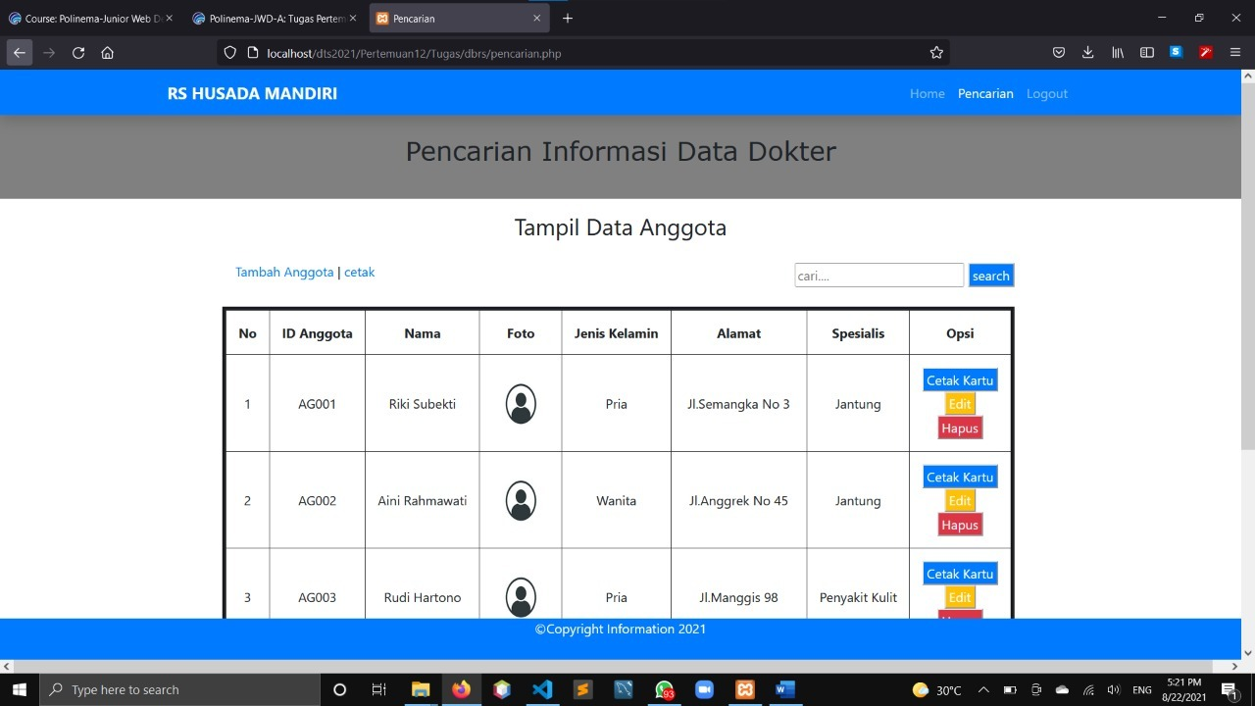

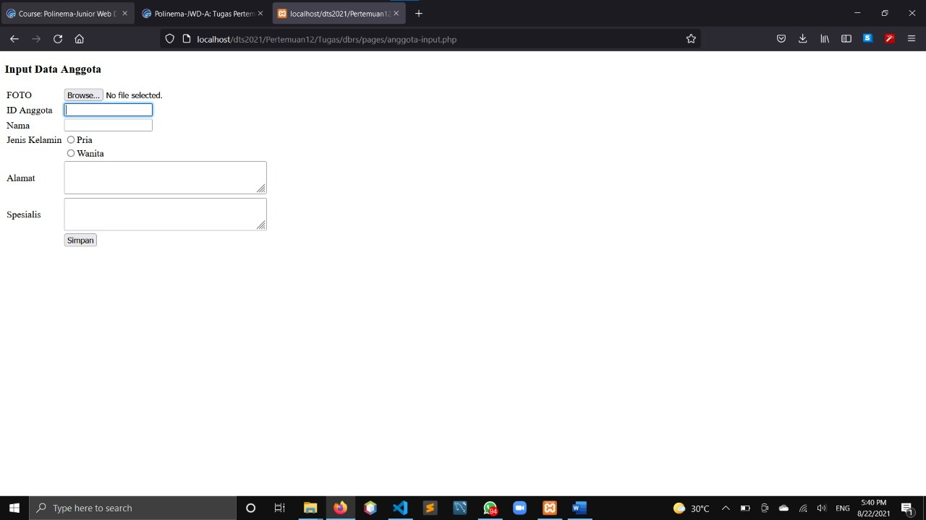

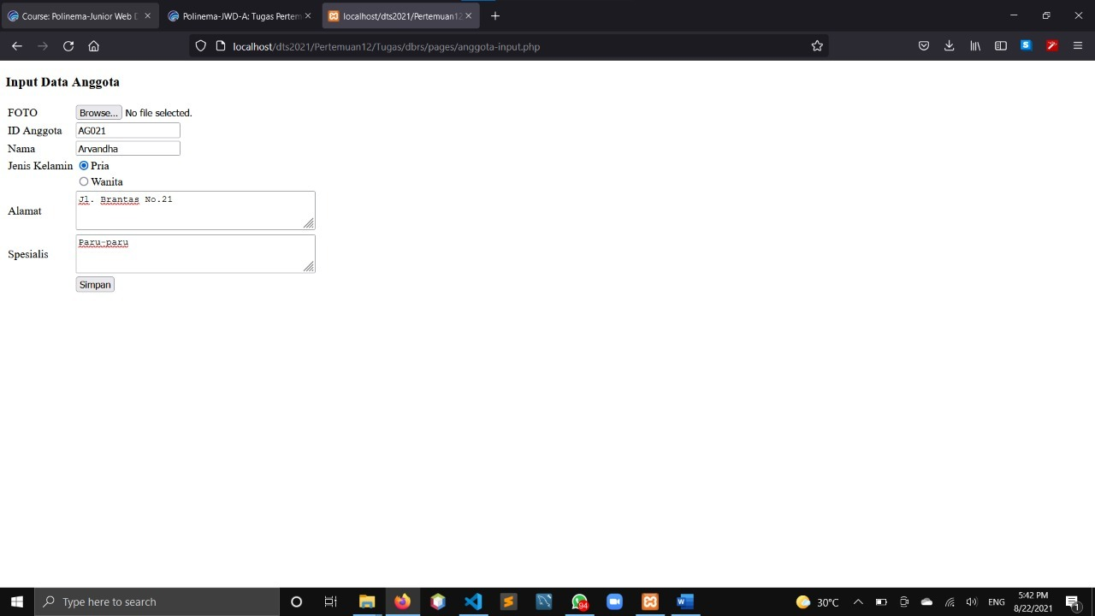

Hasil setelah diinput dan di search nama anggota "arvandha" akan muncul

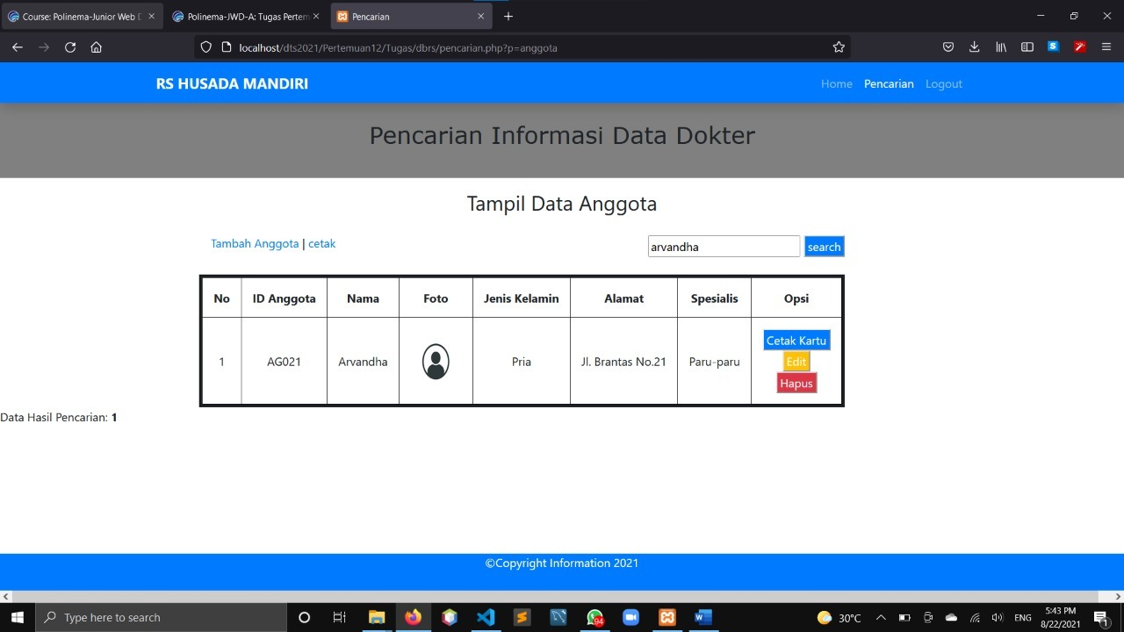

1. **Pages/cetak.php**

Melakukan cetak seluruh anggota dokter yang terletak disamping tombol “tambah anggota”

<?php

include "../koneksi.php";

?>

<link rel="stylesheet" type="text/css" href="../style.css">

<h3>Data Anggota</h3></div>

<div id="content">

<table border="1" id="tabel-tampil">

        <tr>

            <th id="label-tampil-no">No</th>

            <th>ID Anggota</th>

            <th>Nama</th>

            <th>Foto</th>

            <th>Jenis Kelamin</th>

            <th>Alamat</th>

        </tr>

        <?php

        $nomor=1;

        $query="SELECT * FROM tbanggota ORDER BY idanggota DESC";

        $q_tampil_anggota = mysqli_query($db, $query);

        if(mysqli_num_rows($q_tampil_anggota)>0)

        {

        while($r_tampil_anggota=mysqli_fetch_array($q_tampil_anggota)){

            if(empty($r_tampil_anggota['foto'])or($r_tampil_anggota['foto']=='-'))

                $foto = "admin-no-photo.jpg";

            else

                $foto = $r_tampil_anggota['foto'];

        ?>

        <tr>

            <td><?php echo $nomor; ?></td>

            <td><?php echo $r_tampil_anggota['idanggota']; ?></td>

            <td><?php echo $r_tampil_anggota['nama']; ?></td>

            <td><img src="../images/<?php echo $foto; ?>" width=70px height=70px></td>

            <td><?php echo $r_tampil_anggota['jeniskelamin']; ?></td>

            <td><?php echo $r_tampil_anggota['alamat']; ?></td>

        </tr>

        <?php $nomor++; }

        }?>

    </table>

    <script>

        window.print();

    </script>

</div>

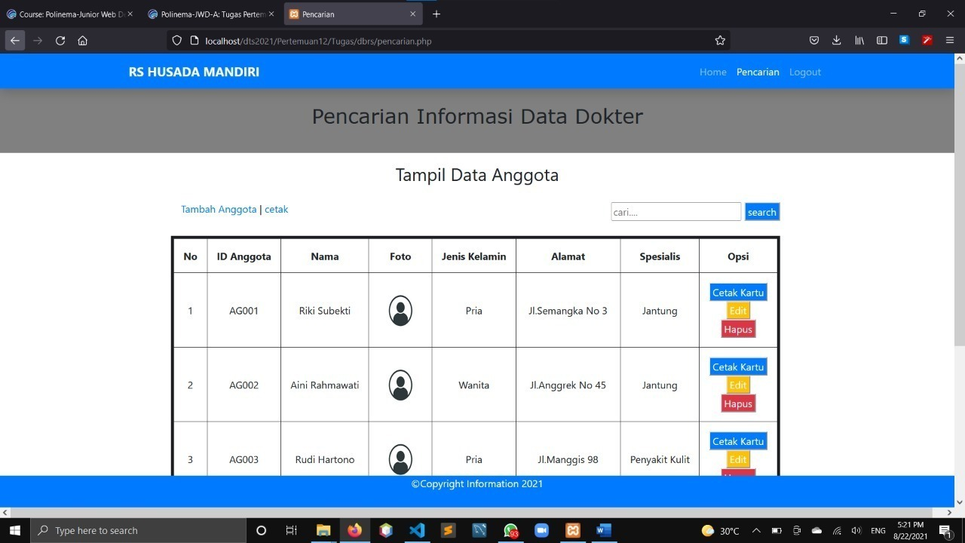

akan masuk kedalam file pages/cetak.php dan muncul pop up memilih jenis printer yang akan digunakan. jika tidak punya, bisa menyimpan atau print dengan format pdf.

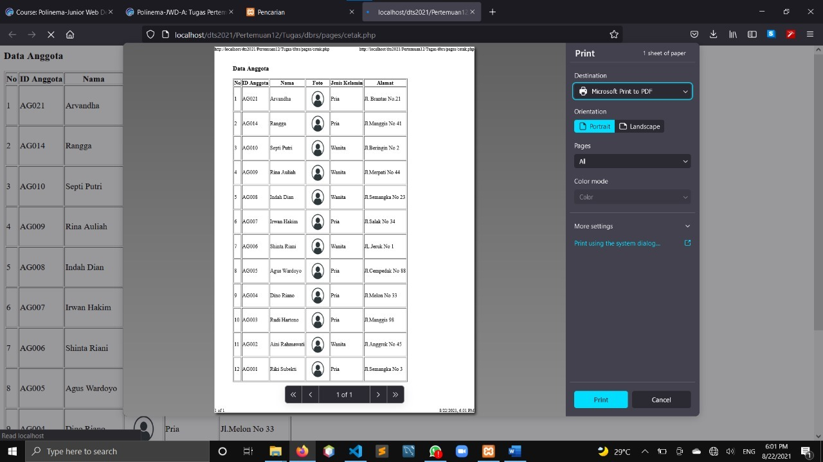

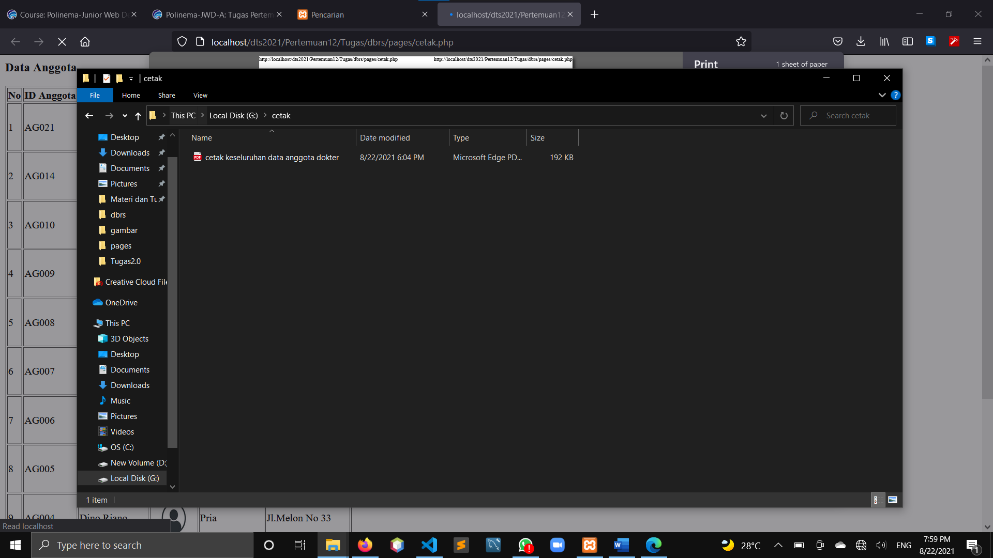

1. **pages/cetak_kartu.php**

Jika tekan tombol cetak kartu, maka akan mencetak data anggota personal atau perseorangan.

<?php

    include "../koneksi.php";

    $id_anggota=$_GET['id'];

    $q_tampil_anggota=mysqli_query($db,"SELECT * FROM tbanggota WHERE idanggota='$id_anggota'");

    $r_tampil_anggota=mysqli_fetch_array($q_tampil_anggota);

    if(empty($r_tampil_anggota['foto'])or($r_tampil_anggota['foto']=='-'))

        $foto = "admin-no-photo.jpg";

    else

        $foto = $r_tampil_anggota['foto'];

?>

<div id="label-page"><h3>Kartu Anggota</h3></div>

<div id="content">

    <table id="tabel-input">

        <tr>

            <td class="label-formulir">FOTO</td>

            <td class="isian-formulir">

            <img src="../images/<?php echo $foto; ?>" width=70px height=75px>

            </td>

        </tr>

        <tr>

            <td class="label-formulir">ID Anggota</td>

            <td class="isian-formulir"><?php echo $r_tampil_anggota['idanggota']; ?></td>

        </tr>

        <tr>

            <td class="label-formulir">Nama</td>

            <td class="isian-formulir"><?php echo $r_tampil_anggota['nama']; ?></td>

        </tr>

        <tr>

            <td class="label-formulir">Jenis Kelamin</td>

            <td class="isian-formulir"><?php echo $r_tampil_anggota['jeniskelamin']; ?></td>

        </tr>

        <tr>

            <td class="label-formulir">Alamat</td>

            <td class="isian-formulir"><?php echo $r_tampil_anggota['alamat']; ?></td>

        </tr>

    </table>

</div>

<script>

        window.print();

    </script>

?>

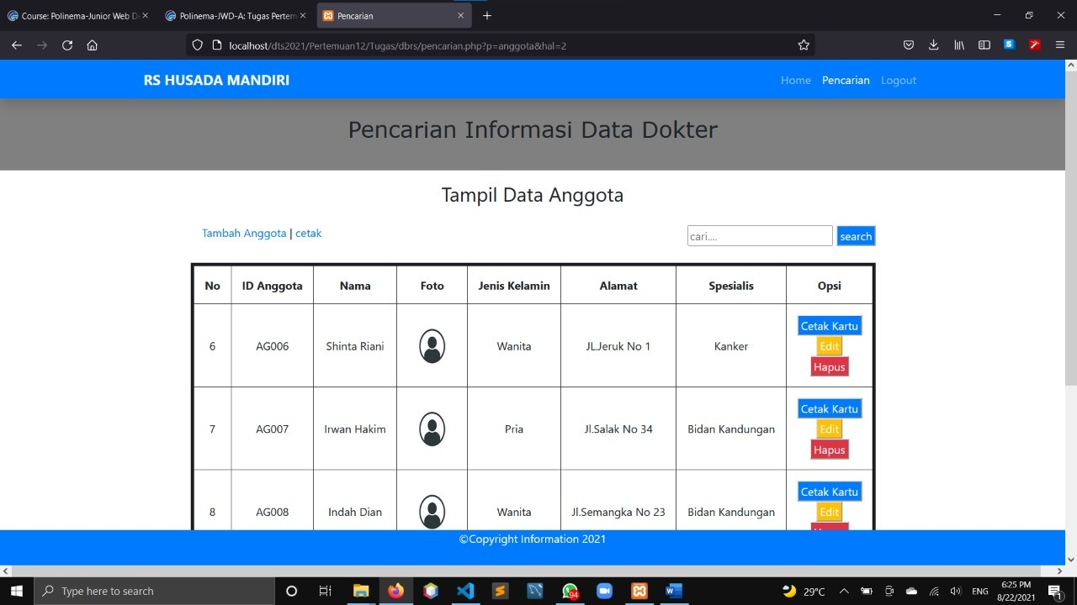

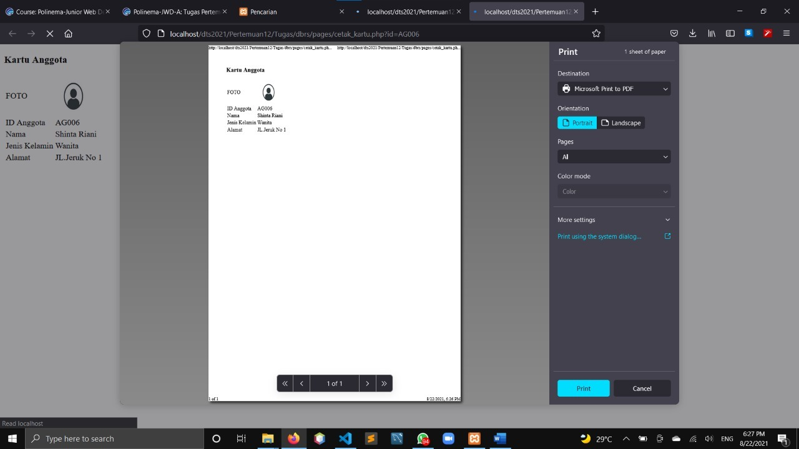

1. **progress/anggota-hapus.php**

menghapus data anggota

<?php

include'../koneksi.php';

$id_anggota=$_GET['id'];

mysqli_query($db,

    "DELETE FROM tbanggota WHERE idanggota='$id_anggota'"

);

header("location:../index.php?p=anggota");

?>

jika menekan tombol hapus, maka akan mucul notifikasi alert "ingin menghapus data ini?". jika klik ok maka data akan terhapus, dan jika klik cancel maka data tidak jadi terhapus.



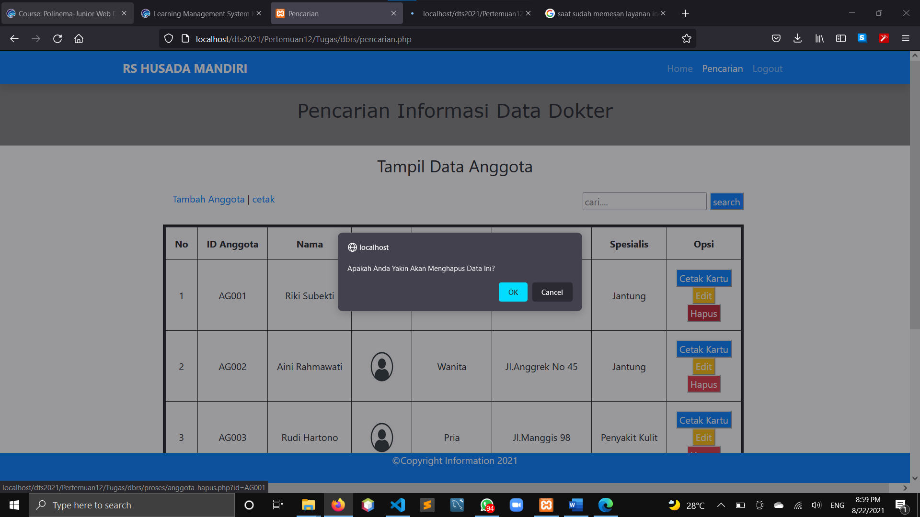

1. **logout.php**

jika menekan tombol logout, maka akan kembali ke halaman login di file login.php

<?php

session_start();

unset($_SESSION['sesi']);

unset($_SESSION['id_admin']);

session_destroy();

header("Location:index.php");

?>



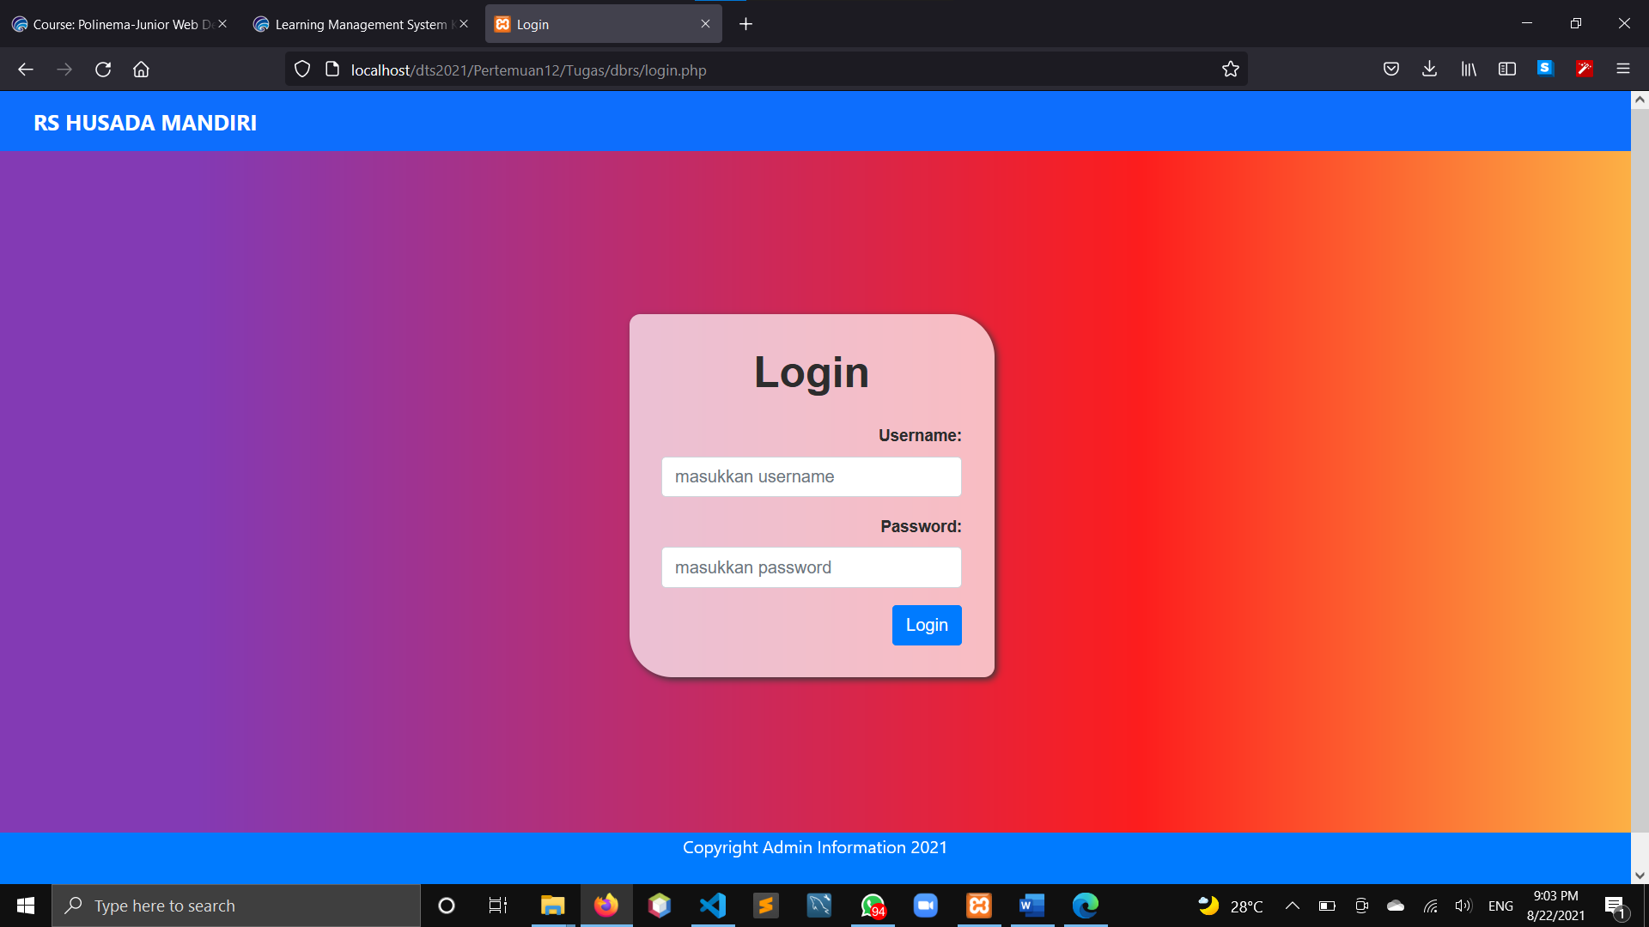

* **Script CSS:**

1. File Style/style_login.css

.container {

  width: calc(100% - 20px);

  padding: 8px 10px;

  margin-bottom: 15px;

  border: none;

  background-color: transparent;

  border-bottom: 2px solid white;

  color: #00000;

  font-size: 15px;

}

form {

  font-family: arial;

  background-color: rgb(255, 255, 255, 0.7);

  width: 340px;

  margin: 200px auto;

  margin-left: 18rem;

  padding: 30px;

  text-align: right;

  color: #2d2d2d;

  border-radius: 10px 40px;

  box-shadow: 2px 2px 7px #393939;

  font-weight: bold;

}

h1 {

  font-weight: normal;

  text-align: center;

  font-weight: bold;

}

body {

  background: rgb(231, 77, 144);

  background: linear-gradient(90deg, rgba(131, 58, 180, 1) 12%, rgba(253, 29, 29, 1) 70%, rgba(252, 176, 69, 1) 100%);

}

.navbar {

  background: #0d6efd;

}

1. File Style/style_index.css

#container-grid{

    padding: 2rem 1rem;

}

h2{

    font-family:Verdana, Geneva, Tahoma, sans-serif;

    font-weight: normal;

}

1. File Style/pencarian.css

#container-grid{

    padding: 2rem 1rem;

}

h2{

    font-family:Verdana, Geneva, Tahoma, sans-serif;

    font-weight: normal;

}

#tabel-tampil{

    margin-left: auto;

    margin-right: auto;

}

p{

    margin-bottom: -1.34rem;

}

1. File css/bootstrap.css

/*!

* Bootstrap v4.3.1 (https://getbootstrap.com/)

* Copyright 2011-2019 The Bootstrap Authors

* Copyright 2011-2019 Twitter, Inc.

* Licensed under MIT (https://github.com/twbs/bootstrap/blob/master/LICENSE)

*/

:root {

--blue: #007bff;

--indigo: #6610f2;

--purple: #6f42c1;

--pink: #e83e8c;

--red: #dc3545;

--orange: #fd7e14;

--yellow: #ffc107;

--green: #28a745;

--teal: #20c997;

--cyan: #17a2b8;

--white: #fff;

--gray: #6c757d;

--gray-dark: #343a40;

--primary: #007bff;

--secondary: #6c757d;

--success: #28a745;

--info: #17a2b8;

--warning: #ffc107;

--danger: #dc3545;

--light: #f8f9fa;

--dark: #343a40;

--breakpoint-xs: 0;

--breakpoint-sm: 576px;

--breakpoint-md: 768px;

--breakpoint-lg: 992px;

--breakpoint-xl: 1200px;

--font-family-sans-serif: -apple-system, BlinkMacSystemFont, "Segoe UI", Roboto, "Helvetica Neue", Arial, "Noto Sans", sans-serif, "Apple Color Emoji", "Segoe UI Emoji", "Segoe UI Symbol", "Noto Color Emoji";

--font-family-monospace: SFMono-Regular, Menlo, Monaco, Consolas, "Liberation Mono", "Courier New", monospace;

}

*,

*::before,

*::after {

box-sizing: border-box;

}

html {

font-family: sans-serif;

line-height: 1.15;

-webkit-text-size-adjust: 100%;

-webkit-tap-highlight-color: rgba(0, 0, 0, 0);

}

article, aside, figcaption, figure, footer, header, hgroup, main, nav, section {

display: block;

}

body {

margin: 0;

font-family: -apple-system, BlinkMacSystemFont, "Segoe UI", Roboto, "Helvetica Neue", Arial, "Noto Sans", sans-serif, "Apple Color Emoji", "Segoe UI Emoji", "Segoe UI Symbol", "Noto Color Emoji";

font-size: 1rem;

font-weight: 400;

line-height: 1.5;

color: #212529;

text-align: left;

background-color: #fff;

}

[tabindex="-1"]:focus {

outline: 0 !important;

}

hr {

box-sizing: content-box;

height: 0;

overflow: visible;

}

h1, h2, h3, h4, h5, h6 {

margin-top: 0;

margin-bottom: 0.5rem;

}

p {

margin-top: 0;

margin-bottom: 1rem;

}

abbr[title],

abbr[data-original-title] {

text-decoration: underline;

-webkit-text-decoration: underline dotted;

text-decoration: underline dotted;

cursor: help;

border-bottom: 0;

-webkit-text-decoration-skip-ink: none;

text-decoration-skip-ink: none;

}

address {

margin-bottom: 1rem;

font-style: normal;

line-height: inherit;

}

ol,

ul,

dl {

margin-top: 0;

margin-bottom: 1rem;

}

ol ol,

ul ul,

ol ul,

ul ol {

margin-bottom: 0;

}

dt {

font-weight: 700;

}

dd {

margin-bottom: .5rem;

margin-left: 0;

}

blockquote {

margin: 0 0 1rem;

}

b,

strong {

font-weight: bolder;

}

small {

font-size: 80%;

}

sub,

sup {

position: relative;

font-size: 75%;

line-height: 0;

vertical-align: baseline;

}

sub {

bottom: -.25em;

}

sup {

top: -.5em;

}

a {

color: #007bff;

text-decoration: none;

background-color: transparent;

}

a:hover {

color: #0056b3;

text-decoration: underline;

}

a:not([href]):not([tabindex]) {

color: inherit;

text-decoration: none;

}

a:not([href]):not([tabindex]):hover, a:not([href]):not([tabindex]):focus {

color: inherit;

text-decoration: none;

}

a:not([href]):not([tabindex]):focus {

outline: 0;

}

pre,

code,

kbd,

samp {

font-family: SFMono-Regular, Menlo, Monaco, Consolas, "Liberation Mono", "Courier New", monospace;

font-size: 1em;

}

pre {

margin-top: 0;

margin-bottom: 1rem;

overflow: auto;

}

figure {

margin: 0 0 1rem;

}

img {

vertical-align: middle;

border-style: none;

}

svg {

overflow: hidden;

vertical-align: middle;

}

table {

border-collapse: collapse;

}

caption {

padding-top: 0.75rem;

padding-bottom: 0.75rem;

color: #6c757d;

text-align: left;

caption-side: bottom;

}

th {

text-align: inherit;

}

label {

display: inline-block;

margin-bottom: 0.5rem;

}

button {

border-radius: 0;

}

button:focus {

outline: 1px dotted;

outline: 5px auto -webkit-focus-ring-color;

}

input,

button,

select,

optgroup,

textarea {

margin: 0;

font-family: inherit;

font-size: inherit;

line-height: inherit;

}

button,

input {

overflow: visible;

}

button,

select {

text-transform: none;

}

select {

word-wrap: normal;

}

button,

[type="button"],

[type="reset"],

[type="submit"] {

-webkit-appearance: button;

}

button:not(:disabled),

[type="button"]:not(:disabled),

[type="reset"]:not(:disabled),

[type="submit"]:not(:disabled) {

cursor: pointer;

}

button::-moz-focus-inner,

[type="button"]::-moz-focus-inner,

[type="reset"]::-moz-focus-inner,

[type="submit"]::-moz-focus-inner {

padding: 0;

border-style: none;

}

input[type="radio"],

input[type="checkbox"] {

box-sizing: border-box;

padding: 0;

}

input[type="date"],

input[type="time"],

input[type="datetime-local"],

input[type="month"] {

-webkit-appearance: listbox;

}

textarea {

overflow: auto;

resize: vertical;

}

fieldset {

min-width: 0;

padding: 0;

margin: 0;

border: 0;

}

legend {

display: block;

width: 100%;

max-width: 100%;

padding: 0;

margin-bottom: .5rem;

font-size: 1.5rem;

line-height: inherit;

color: inherit;

white-space: normal;

}

progress {

vertical-align: baseline;

}

[type="number"]::-webkit-inner-spin-button,

[type="number"]::-webkit-outer-spin-button {

height: auto;

}

[type="search"] {

outline-offset: -2px;

-webkit-appearance: none;

}

[type="search"]::-webkit-search-decoration {

-webkit-appearance: none;

}

::-webkit-file-upload-button {

font: inherit;

-webkit-appearance: button;

}

output {

display: inline-block;

}

summary {

display: list-item;

cursor: pointer;

}

template {

display: none;

}

[hidden] {

display: none !important;

}

h1, h2, h3, h4, h5, h6,

.h1, .h2, .h3, .h4, .h5, .h6 {

margin-bottom: 0.5rem;

font-weight: 500;

line-height: 1.2;

}

h1, .h1 {

font-size: 2.5rem;

}

h2, .h2 {

font-size: 2rem;

}

h3, .h3 {

font-size: 1.75rem;

}

h4, .h4 {

font-size: 1.5rem;

}

h5, .h5 {

font-size: 1.25rem;

}

h6, .h6 {

font-size: 1rem;

}

.lead {

font-size: 1.25rem;

font-weight: 300;

}

.display-1 {

font-size: 6rem;

font-weight: 300;

line-height: 1.2;

}

.display-2 {

font-size: 5.5rem;

font-weight: 300;

line-height: 1.2;

}

.display-3 {

font-size: 4.5rem;

font-weight: 300;

line-height: 1.2;

}

.display-4 {

font-size: 3.5rem;

font-weight: 300;

line-height: 1.2;

}

hr {

margin-top: 1rem;

margin-bottom: 1rem;

border: 0;

border-top: 1px solid rgba(0, 0, 0, 0.1);

}

small,

.small {

font-size: 80%;

font-weight: 400;

}

mark,

.mark {

padding: 0.2em;

background-color: #fcf8e3;

}

.list-unstyled {

padding-left: 0;

list-style: none;

}

.list-inline {

padding-left: 0;

list-style: none;

}

.list-inline-item {

display: inline-block;

}

.list-inline-item:not(:last-child) {

margin-right: 0.5rem;

}

.initialism {

font-size: 90%;

text-transform: uppercase;

}

.blockquote {

margin-bottom: 1rem;

font-size: 1.25rem;

}

.blockquote-footer {

display: block;

font-size: 80%;

color: #6c757d;

}

.blockquote-footer::before {

content: "\2014\00A0";

}

.img-fluid {

max-width: 100%;

height: auto;

}

.img-thumbnail {

padding: 0.25rem;

background-color: #fff;

border: 1px solid #dee2e6;

border-radius: 0.25rem;

max-width: 100%;

height: auto;

}

.figure {

display: inline-block;

}

.figure-img {

margin-bottom: 0.5rem;

line-height: 1;

}

.figure-caption {

font-size: 90%;

color: #6c757d;

}

code {

font-size: 87.5%;

color: #e83e8c;

word-break: break-word;

}

a > code {

color: inherit;

}

kbd {

padding: 0.2rem 0.4rem;

font-size: 87.5%;

color: #fff;

background-color: #212529;

border-radius: 0.2rem;

}

kbd kbd {

padding: 0;

font-size: 100%;

font-weight: 700;

}

pre {

display: block;

font-size: 87.5%;

color: #212529;

}

pre code {

font-size: inherit;

color: inherit;

word-break: normal;

}

.pre-scrollable {

max-height: 340px;

overflow-y: scroll;

}

.container {

width: 100%;

padding-right: 15px;

padding-left: 15px;

margin-right: auto;

margin-left: auto;

}

@media (min-width: 576px) {

.container {

max-width: 540px;

}

}

@media (min-width: 768px) {

.container {

max-width: 720px;

}

}

@media (min-width: 992px) {

.container {

max-width: 960px;

}

}

@media (min-width: 1200px) {

.container {

max-width: 1140px;

}

}

.container-fluid {

width: 100%;

padding-right: 15px;

padding-left: 15px;

margin-right: auto;

margin-left: auto;

}

.row {

display: -ms-flexbox;

display: flex;

-ms-flex-wrap: wrap;

flex-wrap: wrap;

margin-right: -15px;

margin-left: -15px;

}

.no-gutters {

margin-right: 0;

margin-left: 0;

}

.no-gutters > .col,

.no-gutters > [class*="col-"] {

padding-right: 0;

padding-left: 0;

}

.col-1, .col-2, .col-3, .col-4, .col-5, .col-6, .col-7, .col-8, .col-9, .col-10, .col-11, .col-12, .col,

.col-auto, .col-sm-1, .col-sm-2, .col-sm-3, .col-sm-4, .col-sm-5, .col-sm-6, .col-sm-7, .col-sm-8, .col-sm-9, .col-sm-10, .col-sm-11, .col-sm-12, .col-sm,

.col-sm-auto, .col-md-1, .col-md-2, .col-md-3, .col-md-4, .col-md-5, .col-md-6, .col-md-7, .col-md-8, .col-md-9, .col-md-10, .col-md-11, .col-md-12, .col-md,

.col-md-auto, .col-lg-1, .col-lg-2, .col-lg-3, .col-lg-4, .col-lg-5, .col-lg-6, .col-lg-7, .col-lg-8, .col-lg-9, .col-lg-10, .col-lg-11, .col-lg-12, .col-lg,

.col-lg-auto, .col-xl-1, .col-xl-2, .col-xl-3, .col-xl-4, .col-xl-5, .col-xl-6, .col-xl-7, .col-xl-8, .col-xl-9, .col-xl-10, .col-xl-11, .col-xl-12, .col-xl,

.col-xl-auto {

position: relative;

width: 100%;

padding-right: 15px;

padding-left: 15px;

}

.col {

-ms-flex-preferred-size: 0;

flex-basis: 0;

-ms-flex-positive: 1;

flex-grow: 1;

max-width: 100%;

}

.col-auto {

-ms-flex: 0 0 auto;

flex: 0 0 auto;

width: auto;

max-width: 100%;

}

.col-1 {

-ms-flex: 0 0 8.333333%;

flex: 0 0 8.333333%;

max-width: 8.333333%;

}

.col-2 {

-ms-flex: 0 0 16.666667%;

flex: 0 0 16.666667%;

max-width: 16.666667%;

}

.col-3 {

-ms-flex: 0 0 25%;

flex: 0 0 25%;

max-width: 25%;

}

.col-4 {

-ms-flex: 0 0 33.333333%;

flex: 0 0 33.333333%;

max-width: 33.333333%;

}

.col-5 {

-ms-flex: 0 0 41.666667%;

flex: 0 0 41.666667%;

max-width: 41.666667%;

}

.col-6 {

-ms-flex: 0 0 50%;

flex: 0 0 50%;

max-width: 50%;

}

.col-7 {

-ms-flex: 0 0 58.333333%;

flex: 0 0 58.333333%;

max-width: 58.333333%;

}

.col-8 {

-ms-flex: 0 0 66.666667%;

flex: 0 0 66.666667%;

max-width: 66.666667%;

}

.col-9 {

-ms-flex: 0 0 75%;

flex: 0 0 75%;

max-width: 75%;

}

.col-10 {

-ms-flex: 0 0 83.333333%;

flex: 0 0 83.333333%;

max-width: 83.333333%;

}

.col-11 {

-ms-flex: 0 0 91.666667%;

flex: 0 0 91.666667%;

max-width: 91.666667%;

}

.col-12 {

-ms-flex: 0 0 100%;

flex: 0 0 100%;

max-width: 100%;

}

.order-first {

-ms-flex-order: -1;

order: -1;

}

.order-last {

-ms-flex-order: 13;

order: 13;

}

.order-0 {

-ms-flex-order: 0;

order: 0;

}

.order-1 {

-ms-flex-order: 1;

order: 1;

}

.order-2 {

-ms-flex-order: 2;

order: 2;

}

.order-3 {

-ms-flex-order: 3;

order: 3;

}

.order-4 {

-ms-flex-order: 4;

order: 4;

}

.order-5 {

-ms-flex-order: 5;

order: 5;

}

.order-6 {

-ms-flex-order: 6;

order: 6;

}

.order-7 {

-ms-flex-order: 7;

order: 7;

}

.order-8 {

-ms-flex-order: 8;

order: 8;

}

.order-9 {

-ms-flex-order: 9;

order: 9;

}

.order-10 {

-ms-flex-order: 10;

order: 10;

}

.order-11 {

-ms-flex-order: 11;

order: 11;

}

.order-12 {

-ms-flex-order: 12;

order: 12;

}

.offset-1 {

margin-left: 8.333333%;

}

.offset-2 {

margin-left: 16.666667%;

}

.offset-3 {

margin-left: 25%;

}

.offset-4 {

margin-left: 33.333333%;

}

.offset-5 {

margin-left: 41.666667%;

}

.offset-6 {

margin-left: 50%;

}

.offset-7 {

margin-left: 58.333333%;

}

.offset-8 {

margin-left: 66.666667%;

}

.offset-9 {

margin-left: 75%;

}

.offset-10 {

margin-left: 83.333333%;

}

.offset-11 {

margin-left: 91.666667%;

}

@media (min-width: 576px) {

.col-sm {

-ms-flex-preferred-size: 0;

flex-basis: 0;

-ms-flex-positive: 1;

flex-grow: 1;

max-width: 100%;

}

.col-sm-auto {

-ms-flex: 0 0 auto;

flex: 0 0 auto;

width: auto;

max-width: 100%;

}

.col-sm-1 {

-ms-flex: 0 0 8.333333%;

flex: 0 0 8.333333%;

max-width: 8.333333%;

}

.col-sm-2 {

-ms-flex: 0 0 16.666667%;

flex: 0 0 16.666667%;

max-width: 16.666667%;

}

.col-sm-3 {

-ms-flex: 0 0 25%;

flex: 0 0 25%;

max-width: 25%;

}

.col-sm-4 {

-ms-flex: 0 0 33.333333%;

flex: 0 0 33.333333%;

max-width: 33.333333%;

}

.col-sm-5 {

-ms-flex: 0 0 41.666667%;

flex: 0 0 41.666667%;

max-width: 41.666667%;

}

.col-sm-6 {

-ms-flex: 0 0 50%;

flex: 0 0 50%;

max-width: 50%;

}

.col-sm-7 {

-ms-flex: 0 0 58.333333%;

flex: 0 0 58.333333%;

max-width: 58.333333%;

}

.col-sm-8 {

-ms-flex: 0 0 66.666667%;

flex: 0 0 66.666667%;

max-width: 66.666667%;

}

.col-sm-9 {

-ms-flex: 0 0 75%;

flex: 0 0 75%;

max-width: 75%;

}

.col-sm-10 {

-ms-flex: 0 0 83.333333%;

flex: 0 0 83.333333%;

max-width: 83.333333%;

}

.col-sm-11 {

-ms-flex: 0 0 91.666667%;

flex: 0 0 91.666667%;

max-width: 91.666667%;

}

.col-sm-12 {

-ms-flex: 0 0 100%;

flex: 0 0 100%;

max-width: 100%;

}

.order-sm-first {

-ms-flex-order: -1;

order: -1;

}

.order-sm-last {

-ms-flex-order: 13;

order: 13;

}

.order-sm-0 {

-ms-flex-order: 0;

order: 0;

}

.order-sm-1 {

-ms-flex-order: 1;

order: 1;

}

.order-sm-2 {

-ms-flex-order: 2;

order: 2;

}

.order-sm-3 {

-ms-flex-order: 3;

order: 3;

}

.order-sm-4 {

-ms-flex-order: 4;

order: 4;

}

.order-sm-5 {

-ms-flex-order: 5;

order: 5;

}

.order-sm-6 {

-ms-flex-order: 6;

order: 6;

}

.order-sm-7 {

-ms-flex-order: 7;

order: 7;

}

.order-sm-8 {

-ms-flex-order: 8;

order: 8;

}

.order-sm-9 {

-ms-flex-order: 9;

order: 9;

}

.order-sm-10 {

-ms-flex-order: 10;

order: 10;

}

.order-sm-11 {

-ms-flex-order: 11;

order: 11;

}

.order-sm-12 {

-ms-flex-order: 12;

order: 12;

}

.offset-sm-0 {

margin-left: 0;

}

.offset-sm-1 {

margin-left: 8.333333%;

}

.offset-sm-2 {

margin-left: 16.666667%;

}

.offset-sm-3 {

margin-left: 25%;

}

.offset-sm-4 {

margin-left: 33.333333%;

}

.offset-sm-5 {

margin-left: 41.666667%;

}

.offset-sm-6 {

margin-left: 50%;

}

.offset-sm-7 {

margin-left: 58.333333%;

}

.offset-sm-8 {

margin-left: 66.666667%;

}

.offset-sm-9 {

margin-left: 75%;

}

.offset-sm-10 {

margin-left: 83.333333%;

}

.offset-sm-11 {

margin-left: 91.666667%;

}

}

@media (min-width: 768px) {

.col-md {

-ms-flex-preferred-size: 0;

flex-basis: 0;

-ms-flex-positive: 1;

flex-grow: 1;

max-width: 100%;

}

.col-md-auto {

-ms-flex: 0 0 auto;

flex: 0 0 auto;

width: auto;

max-width: 100%;

}

.col-md-1 {

-ms-flex: 0 0 8.333333%;

flex: 0 0 8.333333%;

max-width: 8.333333%;

}

.col-md-2 {

-ms-flex: 0 0 16.666667%;

flex: 0 0 16.666667%;

max-width: 16.666667%;

}

.col-md-3 {

-ms-flex: 0 0 25%;

flex: 0 0 25%;

max-width: 25%;

}

.col-md-4 {

-ms-flex: 0 0 33.333333%;

flex: 0 0 33.333333%;

max-width: 33.333333%;

}

.col-md-5 {

-ms-flex: 0 0 41.666667%;

flex: 0 0 41.666667%;

max-width: 41.666667%;

}

.col-md-6 {

-ms-flex: 0 0 50%;

flex: 0 0 50%;

max-width: 50%;

}

.col-md-7 {

-ms-flex: 0 0 58.333333%;

flex: 0 0 58.333333%;

max-width: 58.333333%;

}

.col-md-8 {

-ms-flex: 0 0 66.666667%;

flex: 0 0 66.666667%;

max-width: 66.666667%;

}

.col-md-9 {

-ms-flex: 0 0 75%;

flex: 0 0 75%;

max-width: 75%;

}

.col-md-10 {

-ms-flex: 0 0 83.333333%;

flex: 0 0 83.333333%;

max-width: 83.333333%;

}

.col-md-11 {

-ms-flex: 0 0 91.666667%;

flex: 0 0 91.666667%;

max-width: 91.666667%;

}

.col-md-12 {

-ms-flex: 0 0 100%;

flex: 0 0 100%;

max-width: 100%;

}

.order-md-first {

-ms-flex-order: -1;

order: -1;

}

.order-md-last {

-ms-flex-order: 13;

order: 13;

}

.order-md-0 {

-ms-flex-order: 0;

order: 0;

}

.order-md-1 {

-ms-flex-order: 1;

order: 1;

}

.order-md-2 {

-ms-flex-order: 2;

order: 2;

}

.order-md-3 {

-ms-flex-order: 3;

order: 3;

}

.order-md-4 {

-ms-flex-order: 4;

order: 4;

}

.order-md-5 {

-ms-flex-order: 5;

order: 5;

}

.order-md-6 {

-ms-flex-order: 6;

order: 6;

}

.order-md-7 {

-ms-flex-order: 7;

order: 7;

}

.order-md-8 {

-ms-flex-order: 8;

order: 8;

}

.order-md-9 {

-ms-flex-order: 9;

order: 9;

}

.order-md-10 {

-ms-flex-order: 10;

order: 10;

}

.order-md-11 {

-ms-flex-order: 11;

order: 11;

}

.order-md-12 {

-ms-flex-order: 12;

order: 12;

}

.offset-md-0 {

margin-left: 0;

}

.offset-md-1 {

margin-left: 8.333333%;

}

.offset-md-2 {

margin-left: 16.666667%;

}

.offset-md-3 {

margin-left: 25%;

}

.offset-md-4 {

margin-left: 33.333333%;

}

.offset-md-5 {

margin-left: 41.666667%;

}

.offset-md-6 {

margin-left: 50%;

}

.offset-md-7 {

margin-left: 58.333333%;

}

.offset-md-8 {

margin-left: 66.666667%;

}

.offset-md-9 {

margin-left: 75%;

}

.offset-md-10 {

margin-left: 83.333333%;

}

.offset-md-11 {

margin-left: 91.666667%;

}

}

@media (min-width: 992px) {

.col-lg {

-ms-flex-preferred-size: 0;

flex-basis: 0;

-ms-flex-positive: 1;

flex-grow: 1;

max-width: 100%;

}

.col-lg-auto {

-ms-flex: 0 0 auto;

flex: 0 0 auto;

width: auto;

max-width: 100%;

}

.col-lg-1 {

-ms-flex: 0 0 8.333333%;

flex: 0 0 8.333333%;

max-width: 8.333333%;

}

.col-lg-2 {

-ms-flex: 0 0 16.666667%;

flex: 0 0 16.666667%;

max-width: 16.666667%;

}

.col-lg-3 {

-ms-flex: 0 0 25%;

flex: 0 0 25%;

max-width: 25%;

}

.col-lg-4 {

-ms-flex: 0 0 33.333333%;

flex: 0 0 33.333333%;

max-width: 33.333333%;

}

.col-lg-5 {

-ms-flex: 0 0 41.666667%;

flex: 0 0 41.666667%;

max-width: 41.666667%;

}

.col-lg-6 {

-ms-flex: 0 0 50%;

flex: 0 0 50%;

max-width: 50%;

}

.col-lg-7 {

-ms-flex: 0 0 58.333333%;

flex: 0 0 58.333333%;

max-width: 58.333333%;

}

.col-lg-8 {

-ms-flex: 0 0 66.666667%;

flex: 0 0 66.666667%;

max-width: 66.666667%;

}

.col-lg-9 {

-ms-flex: 0 0 75%;

flex: 0 0 75%;

max-width: 75%;

}

.col-lg-10 {

-ms-flex: 0 0 83.333333%;

flex: 0 0 83.333333%;

max-width: 83.333333%;

}

.col-lg-11 {

-ms-flex: 0 0 91.666667%;

flex: 0 0 91.666667%;

max-width: 91.666667%;

}

.col-lg-12 {

-ms-flex: 0 0 100%;

flex: 0 0 100%;

max-width: 100%;

}

.order-lg-first {

-ms-flex-order: -1;

order: -1;

}

.order-lg-last {

-ms-flex-order: 13;

order: 13;

}

.order-lg-0 {

-ms-flex-order: 0;

order: 0;

}

.order-lg-1 {

-ms-flex-order: 1;

order: 1;

}

.order-lg-2 {

-ms-flex-order: 2;

order: 2;

}

.order-lg-3 {

-ms-flex-order: 3;

order: 3;

}

.order-lg-4 {

-ms-flex-order: 4;

order: 4;

}

.order-lg-5 {

-ms-flex-order: 5;

order: 5;

}

.order-lg-6 {

-ms-flex-order: 6;

order: 6;

}

.order-lg-7 {

-ms-flex-order: 7;

order: 7;

}

.order-lg-8 {

-ms-flex-order: 8;

order: 8;

}

.order-lg-9 {

-ms-flex-order: 9;

order: 9;

}

.order-lg-10 {

-ms-flex-order: 10;

order: 10;

}

.order-lg-11 {

-ms-flex-order: 11;

order: 11;

}

.order-lg-12 {

-ms-flex-order: 12;

order: 12;

}

.offset-lg-0 {

margin-left: 0;

}

.offset-lg-1 {

margin-left: 8.333333%;

}

.offset-lg-2 {

margin-left: 16.666667%;

}

.offset-lg-3 {

margin-left: 25%;

}

.offset-lg-4 {

margin-left: 33.333333%;

}

.offset-lg-5 {

margin-left: 41.666667%;

}

.offset-lg-6 {

margin-left: 50%;

}

.offset-lg-7 {

margin-left: 58.333333%;

}

.offset-lg-8 {

margin-left: 66.666667%;

}

.offset-lg-9 {

margin-left: 75%;

}

.offset-lg-10 {

margin-left: 83.333333%;

}

.offset-lg-11 {

margin-left: 91.666667%;

}

}

@media (min-width: 1200px) {

.col-xl {

-ms-flex-preferred-size: 0;

flex-basis: 0;

-ms-flex-positive: 1;

flex-grow: 1;

max-width: 100%;

}

.col-xl-auto {

-ms-flex: 0 0 auto;

flex: 0 0 auto;

width: auto;

max-width: 100%;

}

.col-xl-1 {

-ms-flex: 0 0 8.333333%;

flex: 0 0 8.333333%;

max-width: 8.333333%;

}

.col-xl-2 {

-ms-flex: 0 0 16.666667%;

flex: 0 0 16.666667%;

max-width: 16.666667%;

}

.col-xl-3 {

-ms-flex: 0 0 25%;

flex: 0 0 25%;

max-width: 25%;

}

.col-xl-4 {

-ms-flex: 0 0 33.333333%;

flex: 0 0 33.333333%;

max-width: 33.333333%;

}

.col-xl-5 {

-ms-flex: 0 0 41.666667%;

flex: 0 0 41.666667%;

max-width: 41.666667%;

}

.col-xl-6 {

-ms-flex: 0 0 50%;

flex: 0 0 50%;

max-width: 50%;

}

.col-xl-7 {

-ms-flex: 0 0 58.333333%;

flex: 0 0 58.333333%;

max-width: 58.333333%;

}

.col-xl-8 {

-ms-flex: 0 0 66.666667%;

flex: 0 0 66.666667%;

max-width: 66.666667%;

}

.col-xl-9 {

-ms-flex: 0 0 75%;

flex: 0 0 75%;

max-width: 75%;

}

.col-xl-10 {

-ms-flex: 0 0 83.333333%;

flex: 0 0 83.333333%;

max-width: 83.333333%;

}

.col-xl-11 {

-ms-flex: 0 0 91.666667%;

flex: 0 0 91.666667%;

max-width: 91.666667%;

}

.col-xl-12 {

-ms-flex: 0 0 100%;

flex: 0 0 100%;

max-width: 100%;

}

.order-xl-first {

-ms-flex-order: -1;

order: -1;

}

.order-xl-last {

-ms-flex-order: 13;

order: 13;

}

.order-xl-0 {

-ms-flex-order: 0;

order: 0;

}

.order-xl-1 {

-ms-flex-order: 1;

order: 1;

}

.order-xl-2 {

-ms-flex-order: 2;

order: 2;

}

.order-xl-3 {

-ms-flex-order: 3;

order: 3;

}

.order-xl-4 {

-ms-flex-order: 4;

order: 4;

}

.order-xl-5 {

-ms-flex-order: 5;

order: 5;

}

.order-xl-6 {

-ms-flex-order: 6;

order: 6;

}

.order-xl-7 {

-ms-flex-order: 7;

order: 7;

}

.order-xl-8 {

-ms-flex-order: 8;

order: 8;

}

.order-xl-9 {

-ms-flex-order: 9;

order: 9;

}

.order-xl-10 {

-ms-flex-order: 10;

order: 10;

}

.order-xl-11 {

-ms-flex-order: 11;

order: 11;

}

.order-xl-12 {

-ms-flex-order: 12;

order: 12;

}

.offset-xl-0 {

margin-left: 0;

}

.offset-xl-1 {

margin-left: 8.333333%;

}

.offset-xl-2 {

margin-left: 16.666667%;

}

.offset-xl-3 {

margin-left: 25%;

}

.offset-xl-4 {

margin-left: 33.333333%;

}

.offset-xl-5 {

margin-left: 41.666667%;

}

.offset-xl-6 {

margin-left: 50%;

}

.offset-xl-7 {

margin-left: 58.333333%;

}

.offset-xl-8 {

margin-left: 66.666667%;

}

.offset-xl-9 {

margin-left: 75%;

}

.offset-xl-10 {

margin-left: 83.333333%;

}

.offset-xl-11 {

margin-left: 91.666667%;

}

}

.table {

width: 100%;

margin-bottom: 1rem;

color: #212529;

}

.table th,

.table td {

padding: 0.75rem;

vertical-align: top;

border-top: 1px solid #dee2e6;

}

.table thead th {

vertical-align: bottom;

border-bottom: 2px solid #dee2e6;

}

.table tbody + tbody {

border-top: 2px solid #dee2e6;

}

.table-sm th,

.table-sm td {

padding: 0.3rem;

}

.table-bordered {

border: 1px solid #dee2e6;

}

.table-bordered th,

.table-bordered td {

border: 1px solid #dee2e6;

}

.table-bordered thead th,

.table-bordered thead td {

border-bottom-width: 2px;

}

.table-borderless th,

.table-borderless td,

.table-borderless thead th,

.table-borderless tbody + tbody {

border: 0;

}

.table-striped tbody tr:nth-of-type(odd) {

background-color: rgba(0, 0, 0, 0.05);

}

.table-hover tbody tr:hover {

color: #212529;

background-color: rgba(0, 0, 0, 0.075);

}

.table-primary,

.table-primary > th,

.table-primary > td {

background-color: #b8daff;

}

.table-primary th,

.table-primary td,

.table-primary thead th,

.table-primary tbody + tbody {

border-color: #7abaff;

}

.table-hover .table-primary:hover {

background-color: #9fcdff;

}

.table-hover .table-primary:hover > td,

.table-hover .table-primary:hover > th {

background-color: #9fcdff;

}

.table-secondary,

.table-secondary > th,

.table-secondary > td {

background-color: #d6d8db;

}

.table-secondary th,

.table-secondary td,

.table-secondary thead th,

.table-secondary tbody + tbody {

border-color: #b3b7bb;

}

.table-hover .table-secondary:hover {

background-color: #c8cbcf;

}

.table-hover .table-secondary:hover > td,

.table-hover .table-secondary:hover > th {

background-color: #c8cbcf;

}

.table-success,

.table-success > th,

.table-success > td {

background-color: #c3e6cb;

}

.table-success th,

.table-success td,

.table-success thead th,

.table-success tbody + tbody {

border-color: #8fd19e;

}

.table-hover .table-success:hover {

background-color: #b1dfbb;

}

.table-hover .table-success:hover > td,

.table-hover .table-success:hover > th {

background-color: #b1dfbb;

}

.table-info,

.table-info > th,

.table-info > td {

background-color: #bee5eb;

}

.table-info th,

.table-info td,

.table-info thead th,

.table-info tbody + tbody {

border-color: #86cfda;

}

.table-hover .table-info:hover {

background-color: #abdde5;

}

.table-hover .table-info:hover > td,

.table-hover .table-info:hover > th {

background-color: #abdde5;

}

.table-warning,

.table-warning > th,

.table-warning > td {

background-color: #ffeeba;

}

.table-warning th,

.table-warning td,

.table-warning thead th,

.table-warning tbody + tbody {

border-color: #ffdf7e;

}

.table-hover .table-warning:hover {

background-color: #ffe8a1;

}

.table-hover .table-warning:hover > td,

.table-hover .table-warning:hover > th {

background-color: #ffe8a1;

}

.table-danger,

.table-danger > th,

.table-danger > td {

background-color: #f5c6cb;

}

.table-danger th,

.table-danger td,

.table-danger thead th,

.table-danger tbody + tbody {

border-color: #ed969e;

}

.table-hover .table-danger:hover {

background-color: #f1b0b7;

}

.table-hover .table-danger:hover > td,

.table-hover .table-danger:hover > th {

background-color: #f1b0b7;

}

.table-light,

.table-light > th,

.table-light > td {

background-color: #fdfdfe;

}

.table-light th,

.table-light td,

.table-light thead th,

.table-light tbody + tbody {

border-color: #fbfcfc;

}

.table-hover .table-light:hover {

background-color: #ececf6;

}

.table-hover .table-light:hover > td,

.table-hover .table-light:hover > th {

background-color: #ececf6;

}

.table-dark,

.table-dark > th,

.table-dark > td {

background-color: #c6c8ca;

}

.table-dark th,

.table-dark td,

.table-dark thead th,

.table-dark tbody + tbody {

border-color: #95999c;

}

.table-hover .table-dark:hover {

background-color: #b9bbbe;

}

.table-hover .table-dark:hover > td,

.table-hover .table-dark:hover > th {

background-color: #b9bbbe;

}

.table-active,

.table-active > th,

.table-active > td {

background-color: rgba(0, 0, 0, 0.075);

}

.table-hover .table-active:hover {

background-color: rgba(0, 0, 0, 0.075);

}

.table-hover .table-active:hover > td,

.table-hover .table-active:hover > th {

background-color: rgba(0, 0, 0, 0.075);

}

.table .thead-dark th {

color: #fff;

background-color: #343a40;

border-color: #454d55;

}

.table .thead-light th {

color: #495057;

background-color: #e9ecef;

border-color: #dee2e6;

}

.table-dark {

color: #fff;

background-color: #343a40;

}

.table-dark th,

.table-dark td,

.table-dark thead th {

border-color: #454d55;

}

.table-dark.table-bordered {

border: 0;

}

.table-dark.table-striped tbody tr:nth-of-type(odd) {

background-color: rgba(255, 255, 255, 0.05);

}

.table-dark.table-hover tbody tr:hover {

color: #fff;

background-color: rgba(255, 255, 255, 0.075);

}

@media (max-width: 575.98px) {

.table-responsive-sm {

display: block;

width: 100%;

overflow-x: auto;

-webkit-overflow-scrolling: touch;

}

.table-responsive-sm > .table-bordered {

border: 0;

}

}

@media (max-width: 767.98px) {

.table-responsive-md {

display: block;

width: 100%;

overflow-x: auto;

-webkit-overflow-scrolling: touch;

}

.table-responsive-md > .table-bordered {

border: 0;

}

}

@media (max-width: 991.98px) {

.table-responsive-lg {

display: block;

width: 100%;

overflow-x: auto;

-webkit-overflow-scrolling: touch;

}

.table-responsive-lg > .table-bordered {

border: 0;

}

}

@media (max-width: 1199.98px) {

.table-responsive-xl {

display: block;

width: 100%;

overflow-x: auto;

-webkit-overflow-scrolling: touch;

}

.table-responsive-xl > .table-bordered {

border: 0;

}

}

.table-responsive {

display: block;

width: 100%;

overflow-x: auto;

-webkit-overflow-scrolling: touch;

}

.table-responsive > .table-bordered {

border: 0;

}

.form-control {

display: block;

width: 100%;

height: calc(1.5em + 0.75rem + 2px);

padding: 0.375rem 0.75rem;

font-size: 1rem;

font-weight: 400;

line-height: 1.5;

color: #495057;

background-color: #fff;

background-clip: padding-box;

border: 1px solid #ced4da;

border-radius: 0.25rem;

transition: border-color 0.15s ease-in-out, box-shadow 0.15s ease-in-out;

}

@media (prefers-reduced-motion: reduce) {

.form-control {

transition: none;

}

}

.form-control::-ms-expand {

background-color: transparent;

border: 0;

}

.form-control:focus {

color: #495057;

background-color: #fff;

border-color: #80bdff;

outline: 0;

box-shadow: 0 0 0 0.2rem rgba(0, 123, 255, 0.25);

}

.form-control::-webkit-input-placeholder {

color: #6c757d;

opacity: 1;

}

.form-control::-moz-placeholder {

color: #6c757d;

opacity: 1;

}

.form-control:-ms-input-placeholder {

color: #6c757d;

opacity: 1;

}

.form-control::-ms-input-placeholder {

color: #6c757d;

opacity: 1;

}

.form-control::placeholder {

color: #6c757d;

opacity: 1;

}

.form-control:disabled, .form-control[readonly] {

background-color: #e9ecef;

opacity: 1;

}

select.form-control:focus::-ms-value {

color: #495057;

background-color: #fff;

}

.form-control-file,

.form-control-range {

display: block;

width: 100%;

}

.col-form-label {

padding-top: calc(0.375rem + 1px);

padding-bottom: calc(0.375rem + 1px);

margin-bottom: 0;

font-size: inherit;

line-height: 1.5;

}

.col-form-label-lg {

padding-top: calc(0.5rem + 1px);

padding-bottom: calc(0.5rem + 1px);

font-size: 1.25rem;

line-height: 1.5;

}

.col-form-label-sm {

padding-top: calc(0.25rem + 1px);

padding-bottom: calc(0.25rem + 1px);

font-size: 0.875rem;

line-height: 1.5;

}

.form-control-plaintext {

display: block;

width: 100%;

padding-top: 0.375rem;

padding-bottom: 0.375rem;

margin-bottom: 0;

line-height: 1.5;

color: #212529;

background-color: transparent;

border: solid transparent;

border-width: 1px 0;

}

.form-control-plaintext.form-control-sm, .form-control-plaintext.form-control-lg {

padding-right: 0;

padding-left: 0;

}

.form-control-sm {

height: calc(1.5em + 0.5rem + 2px);

padding: 0.25rem 0.5rem;

font-size: 0.875rem;

line-height: 1.5;

border-radius: 0.2rem;

}

.form-control-lg {

height: calc(1.5em + 1rem + 2px);

padding: 0.5rem 1rem;

font-size: 1.25rem;

line-height: 1.5;

border-radius: 0.3rem;

}

select.form-control[size], select.form-control[multiple] {

height: auto;

}

textarea.form-control {

height: auto;

}

.form-group {

margin-bottom: 1rem;

}

.form-text {

display: block;

margin-top: 0.25rem;

}

.form-row {

display: -ms-flexbox;

display: flex;

-ms-flex-wrap: wrap;

flex-wrap: wrap;

margin-right: -5px;

margin-left: -5px;

}

.form-row > .col,

.form-row > [class*="col-"] {

padding-right: 5px;

padding-left: 5px;

}

.form-check {

position: relative;

display: block;

padding-left: 1.25rem;

}

.form-check-input {

position: absolute;

margin-top: 0.3rem;

margin-left: -1.25rem;

}

.form-check-input:disabled ~ .form-check-label {

color: #6c757d;

}

.form-check-label {

margin-bottom: 0;

}

.form-check-inline {

display: -ms-inline-flexbox;

display: inline-flex;

-ms-flex-align: center;

align-items: center;

padding-left: 0;

margin-right: 0.75rem;

}

.form-check-inline .form-check-input {

position: static;

margin-top: 0;

margin-right: 0.3125rem;

margin-left: 0;

}

.valid-feedback {

display: none;

width: 100%;

margin-top: 0.25rem;

font-size: 80%;

color: #28a745;

}

.valid-tooltip {

position: absolute;

top: 100%;

z-index: 5;

display: none;

max-width: 100%;

padding: 0.25rem 0.5rem;

margin-top: .1rem;

font-size: 0.875rem;

line-height: 1.5;

color: #fff;

background-color: rgba(40, 167, 69, 0.9);

border-radius: 0.25rem;

}

.was-validated .form-control:valid, .form-control.is-valid {

border-color: #28a745;

padding-right: calc(1.5em + 0.75rem);

background-image: url("data:image/svg+xml,%3csvg xmlns='http://www.w3.org/2000/svg' viewBox='0 0 8 8'%3e%3cpath fill='%2328a745' d='M2.3 6.73L.6 4.53c-.4-1.04.46-1.4 1.1-.8l1.1 1.4 3.4-3.8c.6-.63 1.6-.27 1.2.7l-4 4.6c-.43.5-.8.4-1.1.1z'/%3e%3c/svg%3e");

background-repeat: no-repeat;

background-position: center right calc(0.375em + 0.1875rem);

background-size: calc(0.75em + 0.375rem) calc(0.75em + 0.375rem);

}

.was-validated .form-control:valid:focus, .form-control.is-valid:focus {

border-color: #28a745;

box-shadow: 0 0 0 0.2rem rgba(40, 167, 69, 0.25);

}

.was-validated .form-control:valid ~ .valid-feedback,

.was-validated .form-control:valid ~ .valid-tooltip, .form-control.is-valid ~ .valid-feedback,

.form-control.is-valid ~ .valid-tooltip {

display: block;

}

.was-validated textarea.form-control:valid, textarea.form-control.is-valid {

padding-right: calc(1.5em + 0.75rem);

background-position: top calc(0.375em + 0.1875rem) right calc(0.375em + 0.1875rem);

}

.was-validated .custom-select:valid, .custom-select.is-valid {

border-color: #28a745;

padding-right: calc((1em + 0.75rem) * 3 / 4 + 1.75rem);

background: url("data:image/svg+xml,%3csvg xmlns='http://www.w3.org/2000/svg' viewBox='0 0 4 5'%3e%3cpath fill='%23343a40' d='M2 0L0 2h4zm0 5L0 3h4z'/%3e%3c/svg%3e") no-repeat right 0.75rem center/8px 10px, url("data:image/svg+xml,%3csvg xmlns='http://www.w3.org/2000/svg' viewBox='0 0 8 8'%3e%3cpath fill='%2328a745' d='M2.3 6.73L.6 4.53c-.4-1.04.46-1.4 1.1-.8l1.1 1.4 3.4-3.8c.6-.63 1.6-.27 1.2.7l-4 4.6c-.43.5-.8.4-1.1.1z'/%3e%3c/svg%3e") #fff no-repeat center right 1.75rem/calc(0.75em + 0.375rem) calc(0.75em + 0.375rem);

}

.was-validated .custom-select:valid:focus, .custom-select.is-valid:focus {

border-color: #28a745;

box-shadow: 0 0 0 0.2rem rgba(40, 167, 69, 0.25);

}

.was-validated .custom-select:valid ~ .valid-feedback,

.was-validated .custom-select:valid ~ .valid-tooltip, .custom-select.is-valid ~ .valid-feedback,

.custom-select.is-valid ~ .valid-tooltip {

display: block;

}

.was-validated .form-control-file:valid ~ .valid-feedback,

.was-validated .form-control-file:valid ~ .valid-tooltip, .form-control-file.is-valid ~ .valid-feedback,

.form-control-file.is-valid ~ .valid-tooltip {

display: block;

}

.was-validated .form-check-input:valid ~ .form-check-label, .form-check-input.is-valid ~ .form-check-label {

color: #28a745;

}

.was-validated .form-check-input:valid ~ .valid-feedback,

.was-validated .form-check-input:valid ~ .valid-tooltip, .form-check-input.is-valid ~ .valid-feedback,

.form-check-input.is-valid ~ .valid-tooltip {

display: block;

}

.was-validated .custom-control-input:valid ~ .custom-control-label, .custom-control-input.is-valid ~ .custom-control-label {

color: #28a745;

}

.was-validated .custom-control-input:valid ~ .custom-control-label::before, .custom-control-input.is-valid ~ .custom-control-label::before {

border-color: #28a745;

}

.was-validated .custom-control-input:valid ~ .valid-feedback,

.was-validated .custom-control-input:valid ~ .valid-tooltip, .custom-control-input.is-valid ~ .valid-feedback,

.custom-control-input.is-valid ~ .valid-tooltip {

display: block;

}

.was-validated .custom-control-input:valid:checked ~ .custom-control-label::before, .custom-control-input.is-valid:checked ~ .custom-control-label::before {

border-color: #34ce57;

background-color: #34ce57;

}

.was-validated .custom-control-input:valid:focus ~ .custom-control-label::before, .custom-control-input.is-valid:focus ~ .custom-control-label::before {

box-shadow: 0 0 0 0.2rem rgba(40, 167, 69, 0.25);

}

.was-validated .custom-control-input:valid:focus:not(:checked) ~ .custom-control-label::before, .custom-control-input.is-valid:focus:not(:checked) ~ .custom-control-label::before {

border-color: #28a745;

}

.was-validated .custom-file-input:valid ~ .custom-file-label, .custom-file-input.is-valid ~ .custom-file-label {

border-color: #28a745;

}

.was-validated .custom-file-input:valid ~ .valid-feedback,

.was-validated .custom-file-input:valid ~ .valid-tooltip, .custom-file-input.is-valid ~ .valid-feedback,

.custom-file-input.is-valid ~ .valid-tooltip {

display: block;

}

.was-validated .custom-file-input:valid:focus ~ .custom-file-label, .custom-file-input.is-valid:focus ~ .custom-file-label {

border-color: #28a745;

box-shadow: 0 0 0 0.2rem rgba(40, 167, 69, 0.25);

}

.invalid-feedback {

display: none;

width: 100%;

margin-top: 0.25rem;

font-size: 80%;

color: #dc3545;

}

.invalid-tooltip {

position: absolute;

top: 100%;

z-index: 5;

display: none;

max-width: 100%;

padding: 0.25rem 0.5rem;

margin-top: .1rem;

font-size: 0.875rem;

line-height: 1.5;

color: #fff;

background-color: rgba(220, 53, 69, 0.9);

border-radius: 0.25rem;

}

.was-validated .form-control:invalid, .form-control.is-invalid {

border-color: #dc3545;

padding-right: calc(1.5em + 0.75rem);

background-image: url("data:image/svg+xml,%3csvg xmlns='http://www.w3.org/2000/svg' fill='%23dc3545' viewBox='-2 -2 7 7'%3e%3cpath stroke='%23dc3545' d='M0 0l3 3m0-3L0 3'/%3e%3ccircle r='.5'/%3e%3ccircle cx='3' r='.5'/%3e%3ccircle cy='3' r='.5'/%3e%3ccircle cx='3' cy='3' r='.5'/%3e%3c/svg%3E");

background-repeat: no-repeat;

background-position: center right calc(0.375em + 0.1875rem);

background-size: calc(0.75em + 0.375rem) calc(0.75em + 0.375rem);

}

.was-validated .form-control:invalid:focus, .form-control.is-invalid:focus {

border-color: #dc3545;

box-shadow: 0 0 0 0.2rem rgba(220, 53, 69, 0.25);

}

.was-validated .form-control:invalid ~ .invalid-feedback,

.was-validated .form-control:invalid ~ .invalid-tooltip, .form-control.is-invalid ~ .invalid-feedback,

.form-control.is-invalid ~ .invalid-tooltip {

display: block;

}

.was-validated textarea.form-control:invalid, textarea.form-control.is-invalid {

padding-right: calc(1.5em + 0.75rem);

background-position: top calc(0.375em + 0.1875rem) right calc(0.375em + 0.1875rem);

}

.was-validated .custom-select:invalid, .custom-select.is-invalid {

border-color: #dc3545;

padding-right: calc((1em + 0.75rem) * 3 / 4 + 1.75rem);

background: url("data:image/svg+xml,%3csvg xmlns='http://www.w3.org/2000/svg' viewBox='0 0 4 5'%3e%3cpath fill='%23343a40' d='M2 0L0 2h4zm0 5L0 3h4z'/%3e%3c/svg%3e") no-repeat right 0.75rem center/8px 10px, url("data:image/svg+xml,%3csvg xmlns='http://www.w3.org/2000/svg' fill='%23dc3545' viewBox='-2 -2 7 7'%3e%3cpath stroke='%23dc3545' d='M0 0l3 3m0-3L0 3'/%3e%3ccircle r='.5'/%3e%3ccircle cx='3' r='.5'/%3e%3ccircle cy='3' r='.5'/%3e%3ccircle cx='3' cy='3' r='.5'/%3e%3c/svg%3E") #fff no-repeat center right 1.75rem/calc(0.75em + 0.375rem) calc(0.75em + 0.375rem);

}

.was-validated .custom-select:invalid:focus, .custom-select.is-invalid:focus {

border-color: #dc3545;

box-shadow: 0 0 0 0.2rem rgba(220, 53, 69, 0.25);

}

.was-validated .custom-select:invalid ~ .invalid-feedback,

.was-validated .custom-select:invalid ~ .invalid-tooltip, .custom-select.is-invalid ~ .invalid-feedback,

.custom-select.is-invalid ~ .invalid-tooltip {

display: block;

}

.was-validated .form-control-file:invalid ~ .invalid-feedback,

.was-validated .form-control-file:invalid ~ .invalid-tooltip, .form-control-file.is-invalid ~ .invalid-feedback,

.form-control-file.is-invalid ~ .invalid-tooltip {

display: block;

}

.was-validated .form-check-input:invalid ~ .form-check-label, .form-check-input.is-invalid ~ .form-check-label {

color: #dc3545;

}

.was-validated .form-check-input:invalid ~ .invalid-feedback,

.was-validated .form-check-input:invalid ~ .invalid-tooltip, .form-check-input.is-invalid ~ .invalid-feedback,

.form-check-input.is-invalid ~ .invalid-tooltip {

display: block;

}

.was-validated .custom-control-input:invalid ~ .custom-control-label, .custom-control-input.is-invalid ~ .custom-control-label {

color: #dc3545;

}

.was-validated .custom-control-input:invalid ~ .custom-control-label::before, .custom-control-input.is-invalid ~ .custom-control-label::before {

border-color: #dc3545;

}

.was-validated .custom-control-input:invalid ~ .invalid-feedback,

.was-validated .custom-control-input:invalid ~ .invalid-tooltip, .custom-control-input.is-invalid ~ .invalid-feedback,

.custom-control-input.is-invalid ~ .invalid-tooltip {

display: block;

}

.was-validated .custom-control-input:invalid:checked ~ .custom-control-label::before, .custom-control-input.is-invalid:checked ~ .custom-control-label::before {

border-color: #e4606d;

background-color: #e4606d;

}

.was-validated .custom-control-input:invalid:focus ~ .custom-control-label::before, .custom-control-input.is-invalid:focus ~ .custom-control-label::before {

box-shadow: 0 0 0 0.2rem rgba(220, 53, 69, 0.25);

}

.was-validated .custom-control-input:invalid:focus:not(:checked) ~ .custom-control-label::before, .custom-control-input.is-invalid:focus:not(:checked) ~ .custom-control-label::before {

border-color: #dc3545;

}

.was-validated .custom-file-input:invalid ~ .custom-file-label, .custom-file-input.is-invalid ~ .custom-file-label {

border-color: #dc3545;

}

.was-validated .custom-file-input:invalid ~ .invalid-feedback,

.was-validated .custom-file-input:invalid ~ .invalid-tooltip, .custom-file-input.is-invalid ~ .invalid-feedback,

.custom-file-input.is-invalid ~ .invalid-tooltip {

display: block;

}

.was-validated .custom-file-input:invalid:focus ~ .custom-file-label, .custom-file-input.is-invalid:focus ~ .custom-file-label {

border-color: #dc3545;

box-shadow: 0 0 0 0.2rem rgba(220, 53, 69, 0.25);

}

.form-inline {

display: -ms-flexbox;

display: flex;

-ms-flex-flow: row wrap;

flex-flow: row wrap;

-ms-flex-align: center;

align-items: center;

}

.form-inline .form-check {

width: 100%;

}

@media (min-width: 576px) {

.form-inline label {

display: -ms-flexbox;

display: flex;

-ms-flex-align: center;

align-items: center;

-ms-flex-pack: center;

justify-content: center;

margin-bottom: 0;

}

.form-inline .form-group {

display: -ms-flexbox;

display: flex;

-ms-flex: 0 0 auto;

flex: 0 0 auto;

-ms-flex-flow: row wrap;

flex-flow: row wrap;

-ms-flex-align: center;

align-items: center;

margin-bottom: 0;

}

.form-inline .form-control {

display: inline-block;

width: auto;

vertical-align: middle;

}

.form-inline .form-control-plaintext {

display: inline-block;

}

.form-inline .input-group,

.form-inline .custom-select {

width: auto;

}

.form-inline .form-check {

display: -ms-flexbox;

display: flex;

-ms-flex-align: center;

align-items: center;

-ms-flex-pack: center;

justify-content: center;

width: auto;

padding-left: 0;

}

.form-inline .form-check-input {

position: relative;

-ms-flex-negative: 0;

flex-shrink: 0;

margin-top: 0;

margin-right: 0.25rem;

margin-left: 0;

}

.form-inline .custom-control {

-ms-flex-align: center;

align-items: center;

-ms-flex-pack: center;

justify-content: center;

}

.form-inline .custom-control-label {

margin-bottom: 0;

}

}

.btn {

display: inline-block;

font-weight: 400;

color: #212529;

text-align: center;

vertical-align: middle;

-webkit-user-select: none;

-moz-user-select: none;

-ms-user-select: none;

user-select: none;

background-color: transparent;

border: 1px solid transparent;

padding: 0.375rem 0.75rem;

font-size: 1rem;

line-height: 1.5;

border-radius: 0.25rem;

transition: color 0.15s ease-in-out, background-color 0.15s ease-in-out, border-color 0.15s ease-in-out, box-shadow 0.15s ease-in-out;

}

@media (prefers-reduced-motion: reduce) {

.btn {

transition: none;

}

}

.btn:hover {

color: #212529;

text-decoration: none;

}

.btn:focus, .btn.focus {

outline: 0;

box-shadow: 0 0 0 0.2rem rgba(0, 123, 255, 0.25);

}

.btn.disabled, .btn:disabled {

opacity: 0.65;

}

a.btn.disabled,

fieldset:disabled a.btn {

pointer-events: none;

}

.btn-primary {

color: #fff;

background-color: #007bff;

border-color: #007bff;

}

.btn-primary:hover {

color: #fff;

background-color: #0069d9;

border-color: #0062cc;

}

.btn-primary:focus, .btn-primary.focus {

box-shadow: 0 0 0 0.2rem rgba(38, 143, 255, 0.5);

}

.btn-primary.disabled, .btn-primary:disabled {

color: #fff;

background-color: #007bff;

border-color: #007bff;

}

.btn-primary:not(:disabled):not(.disabled):active, .btn-primary:not(:disabled):not(.disabled).active,

.show > .btn-primary.dropdown-toggle {

color: #fff;

background-color: #0062cc;

border-color: #005cbf;

}

.btn-primary:not(:disabled):not(.disabled):active:focus, .btn-primary:not(:disabled):not(.disabled).active:focus,

.show > .btn-primary.dropdown-toggle:focus {

box-shadow: 0 0 0 0.2rem rgba(38, 143, 255, 0.5);

}

.btn-secondary {

color: #fff;

background-color: #6c757d;

border-color: #6c757d;

}

.btn-secondary:hover {

color: #fff;

background-color: #5a6268;

border-color: #545b62;

}

.btn-secondary:focus, .btn-secondary.focus {

box-shadow: 0 0 0 0.2rem rgba(130, 138, 145, 0.5);

}

.btn-secondary.disabled, .btn-secondary:disabled {

color: #fff;

background-color: #6c757d;

border-color: #6c757d;

}

.btn-secondary:not(:disabled):not(.disabled):active, .btn-secondary:not(:disabled):not(.disabled).active,

.show > .btn-secondary.dropdown-toggle {

color: #fff;

background-color: #545b62;

border-color: #4e555b;

}

.btn-secondary:not(:disabled):not(.disabled):active:focus, .btn-secondary:not(:disabled):not(.disabled).active:focus,

.show > .btn-secondary.dropdown-toggle:focus {

box-shadow: 0 0 0 0.2rem rgba(130, 138, 145, 0.5);

}

.btn-success {

color: #fff;

background-color: #28a745;

border-color: #28a745;

}

.btn-success:hover {

color: #fff;

background-color: #218838;

border-color: #1e7e34;

}

.btn-success:focus, .btn-success.focus {

box-shadow: 0 0 0 0.2rem rgba(72, 180, 97, 0.5);

}

.btn-success.disabled, .btn-success:disabled {

color: #fff;

background-color: #28a745;

border-color: #28a745;

}

.btn-success:not(:disabled):not(.disabled):active, .btn-success:not(:disabled):not(.disabled).active,

.show > .btn-success.dropdown-toggle {

color: #fff;

background-color: #1e7e34;

border-color: #1c7430;

}

.btn-success:not(:disabled):not(.disabled):active:focus, .btn-success:not(:disabled):not(.disabled).active:focus,

.show > .btn-success.dropdown-toggle:focus {

box-shadow: 0 0 0 0.2rem rgba(72, 180, 97, 0.5);

}

.btn-info {

color: #fff;

background-color: #17a2b8;

border-color: #17a2b8;

}

.btn-info:hover {

color: #fff;

background-color: #138496;

border-color: #117a8b;

}

.btn-info:focus, .btn-info.focus {

box-shadow: 0 0 0 0.2rem rgba(58, 176, 195, 0.5);

}

.btn-info.disabled, .btn-info:disabled {

color: #fff;

background-color: #17a2b8;

border-color: #17a2b8;

}

.btn-info:not(:disabled):not(.disabled):active, .btn-info:not(:disabled):not(.disabled).active,

.show > .btn-info.dropdown-toggle {

color: #fff;

background-color: #117a8b;

border-color: #10707f;

}

.btn-info:not(:disabled):not(.disabled):active:focus, .btn-info:not(:disabled):not(.disabled).active:focus,

.show > .btn-info.dropdown-toggle:focus {

box-shadow: 0 0 0 0.2rem rgba(58, 176, 195, 0.5);

}

.btn-warning {

color: #212529;

background-color: #ffc107;

border-color: #ffc107;

}

.btn-warning:hover {

color: #212529;

background-color: #e0a800;

border-color: #d39e00;

}

.btn-warning:focus, .btn-warning.focus {

box-shadow: 0 0 0 0.2rem rgba(222, 170, 12, 0.5);

}

.btn-warning.disabled, .btn-warning:disabled {

color: #212529;

background-color: #ffc107;

border-color: #ffc107;

}

.btn-warning:not(:disabled):not(.disabled):active, .btn-warning:not(:disabled):not(.disabled).active,

.show > .btn-warning.dropdown-toggle {

color: #212529;

background-color: #d39e00;

border-color: #c69500;

}

.btn-warning:not(:disabled):not(.disabled):active:focus, .btn-warning:not(:disabled):not(.disabled).active:focus,

.show > .btn-warning.dropdown-toggle:focus {

box-shadow: 0 0 0 0.2rem rgba(222, 170, 12, 0.5);

}

.btn-danger {

color: #fff;

background-color: #dc3545;

border-color: #dc3545;

}

.btn-danger:hover {

color: #fff;

background-color: #c82333;

border-color: #bd2130;

}

.btn-danger:focus, .btn-danger.focus {

box-shadow: 0 0 0 0.2rem rgba(225, 83, 97, 0.5);

}

.btn-danger.disabled, .btn-danger:disabled {

color: #fff;

background-color: #dc3545;

border-color: #dc3545;

}

.btn-danger:not(:disabled):not(.disabled):active, .btn-danger:not(:disabled):not(.disabled).active,

.show > .btn-danger.dropdown-toggle {

color: #fff;

background-color: #bd2130;

border-color: #b21f2d;

}

.btn-danger:not(:disabled):not(.disabled):active:focus, .btn-danger:not(:disabled):not(.disabled).active:focus,

.show > .btn-danger.dropdown-toggle:focus {

box-shadow: 0 0 0 0.2rem rgba(225, 83, 97, 0.5);

}

.btn-light {

color: #212529;

background-color: #f8f9fa;

border-color: #f8f9fa;

}

.btn-light:hover {

color: #212529;

background-color: #e2e6ea;

border-color: #dae0e5;

}

.btn-light:focus, .btn-light.focus {

box-shadow: 0 0 0 0.2rem rgba(216, 217, 219, 0.5);

}

.btn-light.disabled, .btn-light:disabled {

color: #212529;

background-color: #f8f9fa;

border-color: #f8f9fa;

}

.btn-light:not(:disabled):not(.disabled):active, .btn-light:not(:disabled):not(.disabled).active,

.show > .btn-light.dropdown-toggle {

color: #212529;

background-color: #dae0e5;

border-color: #d3d9df;

}

.btn-light:not(:disabled):not(.disabled):active:focus, .btn-light:not(:disabled):not(.disabled).active:focus,

.show > .btn-light.dropdown-toggle:focus {

box-shadow: 0 0 0 0.2rem rgba(216, 217, 219, 0.5);

}

.btn-dark {

color: #fff;

background-color: #343a40;

border-color: #343a40;

}

.btn-dark:hover {

color: #fff;

background-color: #23272b;

border-color: #1d2124;

}

.btn-dark:focus, .btn-dark.focus {

box-shadow: 0 0 0 0.2rem rgba(82, 88, 93, 0.5);

}

.btn-dark.disabled, .btn-dark:disabled {

color: #fff;

background-color: #343a40;

border-color: #343a40;

}

.btn-dark:not(:disabled):not(.disabled):active, .btn-dark:not(:disabled):not(.disabled).active,

.show > .btn-dark.dropdown-toggle {

color: #fff;

background-color: #1d2124;

border-color: #171a1d;

}

.btn-dark:not(:disabled):not(.disabled):active:focus, .btn-dark:not(:disabled):not(.disabled).active:focus,

.show > .btn-dark.dropdown-toggle:focus {

box-shadow: 0 0 0 0.2rem rgba(82, 88, 93, 0.5);

}

.btn-outline-primary {

color: #007bff;

border-color: #007bff;

}

.btn-outline-primary:hover {

color: #fff;

background-color: #007bff;

border-color: #007bff;

}

.btn-outline-primary:focus, .btn-outline-primary.focus {

box-shadow: 0 0 0 0.2rem rgba(0, 123, 255, 0.5);

}

.btn-outline-primary.disabled, .btn-outline-primary:disabled {

color: #007bff;

background-color: transparent;

}

.btn-outline-primary:not(:disabled):not(.disabled):active, .btn-outline-primary:not(:disabled):not(.disabled).active,

.show > .btn-outline-primary.dropdown-toggle {

color: #fff;

background-color: #007bff;

border-color: #007bff;

}

.btn-outline-primary:not(:disabled):not(.disabled):active:focus, .btn-outline-primary:not(:disabled):not(.disabled).active:focus,

.show > .btn-outline-primary.dropdown-toggle:focus {

box-shadow: 0 0 0 0.2rem rgba(0, 123, 255, 0.5);

}

.btn-outline-secondary {

color: #6c757d;

border-color: #6c757d;

}

.btn-outline-secondary:hover {

color: #fff;

background-color: #6c757d;

border-color: #6c757d;

}

.btn-outline-secondary:focus, .btn-outline-secondary.focus {

box-shadow: 0 0 0 0.2rem rgba(108, 117, 125, 0.5);

}

.btn-outline-secondary.disabled, .btn-outline-secondary:disabled {

color: #6c757d;

background-color: transparent;

}

.btn-outline-secondary:not(:disabled):not(.disabled):active, .btn-outline-secondary:not(:disabled):not(.disabled).active,

.show > .btn-outline-secondary.dropdown-toggle {

color: #fff;

background-color: #6c757d;

border-color: #6c757d;

}

.btn-outline-secondary:not(:disabled):not(.disabled):active:focus, .btn-outline-secondary:not(:disabled):not(.disabled).active:focus,

.show > .btn-outline-secondary.dropdown-toggle:focus {

box-shadow: 0 0 0 0.2rem rgba(108, 117, 125, 0.5);

}

.btn-outline-success {

color: #28a745;

border-color: #28a745;

}

.btn-outline-success:hover {

color: #fff;

background-color: #28a745;

border-color: #28a745;

}

.btn-outline-success:focus, .btn-outline-success.focus {

box-shadow: 0 0 0 0.2rem rgba(40, 167, 69, 0.5);

}

.btn-outline-success.disabled, .btn-outline-success:disabled {

color: #28a745;

background-color: transparent;

}

.btn-outline-success:not(:disabled):not(.disabled):active, .btn-outline-success:not(:disabled):not(.disabled).active,

.show > .btn-outline-success.dropdown-toggle {

color: #fff;

background-color: #28a745;

border-color: #28a745;

}

.btn-outline-success:not(:disabled):not(.disabled):active:focus, .btn-outline-success:not(:disabled):not(.disabled).active:focus,

.show > .btn-outline-success.dropdown-toggle:focus {

box-shadow: 0 0 0 0.2rem rgba(40, 167, 69, 0.5);

}

.btn-outline-info {

color: #17a2b8;

border-color: #17a2b8;

}

.btn-outline-info:hover {

color: #fff;

background-color: #17a2b8;

border-color: #17a2b8;

}

.btn-outline-info:focus, .btn-outline-info.focus {

box-shadow: 0 0 0 0.2rem rgba(23, 162, 184, 0.5);

}

.btn-outline-info.disabled, .btn-outline-info:disabled {

color: #17a2b8;

background-color: transparent;

}

.btn-outline-info:not(:disabled):not(.disabled):active, .btn-outline-info:not(:disabled):not(.disabled).active,

.show > .btn-outline-info.dropdown-toggle {

color: #fff;

background-color: #17a2b8;

border-color: #17a2b8;

}

.btn-outline-info:not(:disabled):not(.disabled):active:focus, .btn-outline-info:not(:disabled):not(.disabled).active:focus,

.show > .btn-outline-info.dropdown-toggle:focus {

box-shadow: 0 0 0 0.2rem rgba(23, 162, 184, 0.5);

}

.btn-outline-warning {

color: #ffc107;

border-color: #ffc107;

}

.btn-outline-warning:hover {

color: #212529;

background-color: #ffc107;

border-color: #ffc107;

}

.btn-outline-warning:focus, .btn-outline-warning.focus {

box-shadow: 0 0 0 0.2rem rgba(255, 193, 7, 0.5);

}

.btn-outline-warning.disabled, .btn-outline-warning:disabled {

color: #ffc107;

background-color: transparent;

}

.btn-outline-warning:not(:disabled):not(.disabled):active, .btn-outline-warning:not(:disabled):not(.disabled).active,

.show > .btn-outline-warning.dropdown-toggle {

color: #212529;

background-color: #ffc107;

border-color: #ffc107;

}

.btn-outline-warning:not(:disabled):not(.disabled):active:focus, .btn-outline-warning:not(:disabled):not(.disabled).active:focus,

.show > .btn-outline-warning.dropdown-toggle:focus {

box-shadow: 0 0 0 0.2rem rgba(255, 193, 7, 0.5);

}

.btn-outline-danger {

color: #dc3545;

border-color: #dc3545;

}

.btn-outline-danger:hover {

color: #fff;

background-color: #dc3545;

border-color: #dc3545;

}

.btn-outline-danger:focus, .btn-outline-danger.focus {

box-shadow: 0 0 0 0.2rem rgba(220, 53, 69, 0.5);

}

.btn-outline-danger.disabled, .btn-outline-danger:disabled {

color: #dc3545;

background-color: transparent;

}

.btn-outline-danger:not(:disabled):not(.disabled):active, .btn-outline-danger:not(:disabled):not(.disabled).active,

.show > .btn-outline-danger.dropdown-toggle {

color: #fff;

background-color: #dc3545;

border-color: #dc3545;

}

.btn-outline-danger:not(:disabled):not(.disabled):active:focus, .btn-outline-danger:not(:disabled):not(.disabled).active:focus,

.show > .btn-outline-danger.dropdown-toggle:focus {

box-shadow: 0 0 0 0.2rem rgba(220, 53, 69, 0.5);

}

.btn-outline-light {

color: #f8f9fa;

border-color: #f8f9fa;

}

.btn-outline-light:hover {

color: #212529;

background-color: #f8f9fa;

border-color: #f8f9fa;

}

.btn-outline-light:focus, .btn-outline-light.focus {

box-shadow: 0 0 0 0.2rem rgba(248, 249, 250, 0.5);

}

.btn-outline-light.disabled, .btn-outline-light:disabled {

color: #f8f9fa;

background-color: transparent;

}

.btn-outline-light:not(:disabled):not(.disabled):active, .btn-outline-light:not(:disabled):not(.disabled).active,

.show > .btn-outline-light.dropdown-toggle {

color: #212529;

background-color: #f8f9fa;

border-color: #f8f9fa;

}

.btn-outline-light:not(:disabled):not(.disabled):active:focus, .btn-outline-light:not(:disabled):not(.disabled).active:focus,

.show > .btn-outline-light.dropdown-toggle:focus {

box-shadow: 0 0 0 0.2rem rgba(248, 249, 250, 0.5);

}

.btn-outline-dark {

color: #343a40;

border-color: #343a40;

}

.btn-outline-dark:hover {

color: #fff;

background-color: #343a40;

border-color: #343a40;

}

.btn-outline-dark:focus, .btn-outline-dark.focus {

box-shadow: 0 0 0 0.2rem rgba(52, 58, 64, 0.5);

}

.btn-outline-dark.disabled, .btn-outline-dark:disabled {

color: #343a40;

background-color: transparent;

}

.btn-outline-dark:not(:disabled):not(.disabled):active, .btn-outline-dark:not(:disabled):not(.disabled).active,

.show > .btn-outline-dark.dropdown-toggle {

color: #fff;

background-color: #343a40;

border-color: #343a40;

}

.btn-outline-dark:not(:disabled):not(.disabled):active:focus, .btn-outline-dark:not(:disabled):not(.disabled).active:focus,

.show > .btn-outline-dark.dropdown-toggle:focus {

box-shadow: 0 0 0 0.2rem rgba(52, 58, 64, 0.5);

}

.btn-link {

font-weight: 400;

color: #007bff;

text-decoration: none;

}

.btn-link:hover {

color: #0056b3;

text-decoration: underline;

}

.btn-link:focus, .btn-link.focus {

text-decoration: underline;

box-shadow: none;

}

.btn-link:disabled, .btn-link.disabled {

color: #6c757d;

pointer-events: none;

}

.btn-lg, .btn-group-lg > .btn {

padding: 0.5rem 1rem;

font-size: 1.25rem;

line-height: 1.5;

border-radius: 0.3rem;

}

.btn-sm, .btn-group-sm > .btn {

padding: 0.25rem 0.5rem;

font-size: 0.875rem;

line-height: 1.5;

border-radius: 0.2rem;

}

.btn-block {

display: block;

width: 100%;

}

.btn-block + .btn-block {

margin-top: 0.5rem;

}

input[type="submit"].btn-block,

input[type="reset"].btn-block,

input[type="button"].btn-block {

width: 100%;

}

.fade {

transition: opacity 0.15s linear;

}

@media (prefers-reduced-motion: reduce) {

.fade {

transition: none;

}

}

.fade:not(.show) {

opacity: 0;

}

.collapse:not(.show) {

display: none;

}

.collapsing {

position: relative;

height: 0;

overflow: hidden;

transition: height 0.35s ease;

}

@media (prefers-reduced-motion: reduce) {

.collapsing {

transition: none;

}

}

.dropup,

.dropright,

.dropdown,

.dropleft {

position: relative;

}

.dropdown-toggle {

white-space: nowrap;

}

.dropdown-toggle::after {

display: inline-block;

margin-left: 0.255em;

vertical-align: 0.255em;

content: "";

border-top: 0.3em solid;

border-right: 0.3em solid transparent;

border-bottom: 0;

border-left: 0.3em solid transparent;

}

.dropdown-toggle:empty::after {

margin-left: 0;

}

.dropdown-menu {

position: absolute;

top: 100%;

left: 0;

z-index: 1000;

display: none;

float: left;

min-width: 10rem;

padding: 0.5rem 0;

margin: 0.125rem 0 0;

font-size: 1rem;

color: #212529;

text-align: left;

list-style: none;

background-color: #fff;

background-clip: padding-box;

border: 1px solid rgba(0, 0, 0, 0.15);

border-radius: 0.25rem;

}

.dropdown-menu-left {

right: auto;

left: 0;

}

.dropdown-menu-right {

right: 0;

left: auto;

}

@media (min-width: 576px) {

.dropdown-menu-sm-left {

right: auto;

left: 0;

}

.dropdown-menu-sm-right {

right: 0;

left: auto;

}

}

@media (min-width: 768px) {

.dropdown-menu-md-left {

right: auto;

left: 0;

}

.dropdown-menu-md-right {

right: 0;

left: auto;

}

}

@media (min-width: 992px) {

.dropdown-menu-lg-left {

right: auto;

left: 0;

}

.dropdown-menu-lg-right {

right: 0;

left: auto;

}

}

@media (min-width: 1200px) {

.dropdown-menu-xl-left {

right: auto;

left: 0;

}

.dropdown-menu-xl-right {

right: 0;

left: auto;

}

}

.dropup .dropdown-menu {

top: auto;

bottom: 100%;

margin-top: 0;

margin-bottom: 0.125rem;

}

.dropup .dropdown-toggle::after {

display: inline-block;

margin-left: 0.255em;

vertical-align: 0.255em;

content: "";

border-top: 0;

border-right: 0.3em solid transparent;

border-bottom: 0.3em solid;

border-left: 0.3em solid transparent;

}

.dropup .dropdown-toggle:empty::after {

margin-left: 0;

}

.dropright .dropdown-menu {

top: 0;

right: auto;

left: 100%;

margin-top: 0;

margin-left: 0.125rem;

}

.dropright .dropdown-toggle::after {

display: inline-block;

margin-left: 0.255em;

vertical-align: 0.255em;

content: "";

border-top: 0.3em solid transparent;

border-right: 0;

border-bottom: 0.3em solid transparent;

border-left: 0.3em solid;

}

.dropright .dropdown-toggle:empty::after {

margin-left: 0;

}

.dropright .dropdown-toggle::after {

vertical-align: 0;

}

.dropleft .dropdown-menu {

top: 0;

right: 100%;

left: auto;

margin-top: 0;

margin-right: 0.125rem;

}

.dropleft .dropdown-toggle::after {

display: inline-block;

margin-left: 0.255em;

vertical-align: 0.255em;

content: "";

}

.dropleft .dropdown-toggle::after {

display: none;

}

.dropleft .dropdown-toggle::before {

display: inline-block;

margin-right: 0.255em;

vertical-align: 0.255em;

content: "";

border-top: 0.3em solid transparent;

border-right: 0.3em solid;

border-bottom: 0.3em solid transparent;

}

.dropleft .dropdown-toggle:empty::after {

margin-left: 0;

}

.dropleft .dropdown-toggle::before {

vertical-align: 0;

}

.dropdown-menu[x-placement^="top"], .dropdown-menu[x-placement^="right"], .dropdown-menu[x-placement^="bottom"], .dropdown-menu[x-placement^="left"] {

right: auto;

bottom: auto;

}

.dropdown-divider {

height: 0;

margin: 0.5rem 0;

overflow: hidden;

border-top: 1px solid #e9ecef;

}

.dropdown-item {

display: block;

width: 100%;

padding: 0.25rem 1.5rem;

clear: both;

font-weight: 400;

color: #212529;

text-align: inherit;

white-space: nowrap;

background-color: transparent;

border: 0;

}

.dropdown-item:hover, .dropdown-item:focus {

color: #16181b;

text-decoration: none;

background-color: #f8f9fa;

}

.dropdown-item.active, .dropdown-item:active {

color: #fff;

text-decoration: none;

background-color: #007bff;

}

.dropdown-item.disabled, .dropdown-item:disabled {

color: #6c757d;

pointer-events: none;

background-color: transparent;

}

.dropdown-menu.show {

display: block;

}

.dropdown-header {

display: block;

padding: 0.5rem 1.5rem;

margin-bottom: 0;

font-size: 0.875rem;

color: #6c757d;

white-space: nowrap;

}

.dropdown-item-text {

display: block;

padding: 0.25rem 1.5rem;

color: #212529;

}

.btn-group,

.btn-group-vertical {

position: relative;

display: -ms-inline-flexbox;

display: inline-flex;

vertical-align: middle;

}

.btn-group > .btn,

.btn-group-vertical > .btn {

position: relative;

-ms-flex: 1 1 auto;

flex: 1 1 auto;

}

.btn-group > .btn:hover,

.btn-group-vertical > .btn:hover {

z-index: 1;

}

.btn-group > .btn:focus, .btn-group > .btn:active, .btn-group > .btn.active,

.btn-group-vertical > .btn:focus,

.btn-group-vertical > .btn:active,

.btn-group-vertical > .btn.active {

z-index: 1;

}

.btn-toolbar {

display: -ms-flexbox;

display: flex;

-ms-flex-wrap: wrap;

flex-wrap: wrap;

-ms-flex-pack: start;

justify-content: flex-start;

}

.btn-toolbar .input-group {

width: auto;

}

.btn-group > .btn:not(:first-child),

.btn-group > .btn-group:not(:first-child) {

margin-left: -1px;

}

.btn-group > .btn:not(:last-child):not(.dropdown-toggle),

.btn-group > .btn-group:not(:last-child) > .btn {

border-top-right-radius: 0;

border-bottom-right-radius: 0;

}

.btn-group > .btn:not(:first-child),

.btn-group > .btn-group:not(:first-child) > .btn {

border-top-left-radius: 0;

border-bottom-left-radius: 0;

}

.dropdown-toggle-split {

padding-right: 0.5625rem;

padding-left: 0.5625rem;

}

.dropdown-toggle-split::after,

.dropup .dropdown-toggle-split::after,

.dropright .dropdown-toggle-split::after {

margin-left: 0;

}

.dropleft .dropdown-toggle-split::before {

margin-right: 0;

}

.btn-sm + .dropdown-toggle-split, .btn-group-sm > .btn + .dropdown-toggle-split {

padding-right: 0.375rem;

padding-left: 0.375rem;

}

.btn-lg + .dropdown-toggle-split, .btn-group-lg > .btn + .dropdown-toggle-split {

padding-right: 0.75rem;

padding-left: 0.75rem;

}

.btn-group-vertical {

-ms-flex-direction: column;

flex-direction: column;

-ms-flex-align: start;

align-items: flex-start;

-ms-flex-pack: center;

justify-content: center;

}

.btn-group-vertical > .btn,

.btn-group-vertical > .btn-group {

width: 100%;

}

.btn-group-vertical > .btn:not(:first-child),

.btn-group-vertical > .btn-group:not(:first-child) {

margin-top: -1px;

}

.btn-group-vertical > .btn:not(:last-child):not(.dropdown-toggle),

.btn-group-vertical > .btn-group:not(:last-child) > .btn {

border-bottom-right-radius: 0;

border-bottom-left-radius: 0;

}

.btn-group-vertical > .btn:not(:first-child),

.btn-group-vertical > .btn-group:not(:first-child) > .btn {

border-top-left-radius: 0;

border-top-right-radius: 0;

}

.btn-group-toggle > .btn,

.btn-group-toggle > .btn-group > .btn {

margin-bottom: 0;

}

.btn-group-toggle > .btn input[type="radio"],

.btn-group-toggle > .btn input[type="checkbox"],

.btn-group-toggle > .btn-group > .btn input[type="radio"],

.btn-group-toggle > .btn-group > .btn input[type="checkbox"] {

position: absolute;

clip: rect(0, 0, 0, 0);

pointer-events: none;

}

.input-group {

position: relative;

display: -ms-flexbox;

display: flex;

-ms-flex-wrap: wrap;

flex-wrap: wrap;

-ms-flex-align: stretch;

align-items: stretch;

width: 100%;

}

.input-group > .form-control,

.input-group > .form-control-plaintext,

.input-group > .custom-select,

.input-group > .custom-file {

position: relative;

-ms-flex: 1 1 auto;

flex: 1 1 auto;

width: 1%;

margin-bottom: 0;

}

.input-group > .form-control + .form-control,

.input-group > .form-control + .custom-select,

.input-group > .form-control + .custom-file,

.input-group > .form-control-plaintext + .form-control,

.input-group > .form-control-plaintext + .custom-select,

.input-group > .form-control-plaintext + .custom-file,

.input-group > .custom-select + .form-control,

.input-group > .custom-select + .custom-select,

.input-group > .custom-select + .custom-file,

.input-group > .custom-file + .form-control,

.input-group > .custom-file + .custom-select,

.input-group > .custom-file + .custom-file {

margin-left: -1px;

}

.input-group > .form-control:focus,

.input-group > .custom-select:focus,

.input-group > .custom-file .custom-file-input:focus ~ .custom-file-label {

z-index: 3;

}

.input-group > .custom-file .custom-file-input:focus {

z-index: 4;

}

.input-group > .form-control:not(:last-child),

.input-group > .custom-select:not(:last-child) {

border-top-right-radius: 0;

border-bottom-right-radius: 0;

}

.input-group > .form-control:not(:first-child),

.input-group > .custom-select:not(:first-child) {

border-top-left-radius: 0;

border-bottom-left-radius: 0;

}

.input-group > .custom-file {

display: -ms-flexbox;

display: flex;

-ms-flex-align: center;

align-items: center;

}

.input-group > .custom-file:not(:last-child) .custom-file-label,

.input-group > .custom-file:not(:last-child) .custom-file-label::after {

border-top-right-radius: 0;

border-bottom-right-radius: 0;

}

.input-group > .custom-file:not(:first-child) .custom-file-label {

border-top-left-radius: 0;

border-bottom-left-radius: 0;

}

.input-group-prepend,

.input-group-append {

display: -ms-flexbox;

display: flex;

}

.input-group-prepend .btn,

.input-group-append .btn {

position: relative;

z-index: 2;

}

.input-group-prepend .btn:focus,

.input-group-append .btn:focus {

z-index: 3;

}

.input-group-prepend .btn + .btn,

.input-group-prepend .btn + .input-group-text,

.input-group-prepend .input-group-text + .input-group-text,

.input-group-prepend .input-group-text + .btn,

.input-group-append .btn + .btn,

.input-group-append .btn + .input-group-text,

.input-group-append .input-group-text + .input-group-text,

.input-group-append .input-group-text + .btn {

margin-left: -1px;

}

.input-group-prepend {

margin-right: -1px;

}

.input-group-append {

margin-left: -1px;

}

.input-group-text {

display: -ms-flexbox;

display: flex;

-ms-flex-align: center;

align-items: center;

padding: 0.375rem 0.75rem;

margin-bottom: 0;

font-size: 1rem;

font-weight: 400;

line-height: 1.5;

color: #495057;

text-align: center;

white-space: nowrap;

background-color: #e9ecef;

border: 1px solid #ced4da;

border-radius: 0.25rem;

}

.input-group-text input[type="radio"],

.input-group-text input[type="checkbox"] {

margin-top: 0;

}

.input-group-lg > .form-control:not(textarea),

.input-group-lg > .custom-select {

height: calc(1.5em + 1rem + 2px);

}

.input-group-lg > .form-control,

.input-group-lg > .custom-select,

.input-group-lg > .input-group-prepend > .input-group-text,

.input-group-lg > .input-group-append > .input-group-text,

.input-group-lg > .input-group-prepend > .btn,

.input-group-lg > .input-group-append > .btn {

padding: 0.5rem 1rem;

font-size: 1.25rem;

line-height: 1.5;

border-radius: 0.3rem;

}

.input-group-sm > .form-control:not(textarea),

.input-group-sm > .custom-select {

height: calc(1.5em + 0.5rem + 2px);

}

.input-group-sm > .form-control,

.input-group-sm > .custom-select,

.input-group-sm > .input-group-prepend > .input-group-text,

.input-group-sm > .input-group-append > .input-group-text,

.input-group-sm > .input-group-prepend > .btn,

.input-group-sm > .input-group-append > .btn {

padding: 0.25rem 0.5rem;

font-size: 0.875rem;

line-height: 1.5;

border-radius: 0.2rem;

}

.input-group-lg > .custom-select,

.input-group-sm > .custom-select {

padding-right: 1.75rem;

}

.input-group > .input-group-prepend > .btn,

.input-group > .input-group-prepend > .input-group-text,

.input-group > .input-group-append:not(:last-child) > .btn,

.input-group > .input-group-append:not(:last-child) > .input-group-text,

.input-group > .input-group-append:last-child > .btn:not(:last-child):not(.dropdown-toggle),

.input-group > .input-group-append:last-child > .input-group-text:not(:last-child) {

border-top-right-radius: 0;

border-bottom-right-radius: 0;

}

.input-group > .input-group-append > .btn,

.input-group > .input-group-append > .input-group-text,

.input-group > .input-group-prepend:not(:first-child) > .btn,

.input-group > .input-group-prepend:not(:first-child) > .input-group-text,

.input-group > .input-group-prepend:first-child > .btn:not(:first-child),

.input-group > .input-group-prepend:first-child > .input-group-text:not(:first-child) {

border-top-left-radius: 0;

border-bottom-left-radius: 0;

}

.custom-control {

position: relative;

display: block;

min-height: 1.5rem;

padding-left: 1.5rem;

}

.custom-control-inline {

display: -ms-inline-flexbox;

display: inline-flex;

margin-right: 1rem;

}

.custom-control-input {

position: absolute;

z-index: -1;

opacity: 0;

}

.custom-control-input:checked ~ .custom-control-label::before {

color: #fff;

border-color: #007bff;

background-color: #007bff;

}

.custom-control-input:focus ~ .custom-control-label::before {

box-shadow: 0 0 0 0.2rem rgba(0, 123, 255, 0.25);

}

.custom-control-input:focus:not(:checked) ~ .custom-control-label::before {

border-color: #80bdff;

}

.custom-control-input:not(:disabled):active ~ .custom-control-label::before {

color: #fff;

background-color: #b3d7ff;

border-color: #b3d7ff;

}

.custom-control-input:disabled ~ .custom-control-label {

color: #6c757d;

}

.custom-control-input:disabled ~ .custom-control-label::before {

background-color: #e9ecef;

}

.custom-control-label {

position: relative;

margin-bottom: 0;

vertical-align: top;

}

.custom-control-label::before {

position: absolute;

top: 0.25rem;

left: -1.5rem;

display: block;

width: 1rem;

height: 1rem;

pointer-events: none;

content: "";

background-color: #fff;

border: #adb5bd solid 1px;

}

.custom-control-label::after {

position: absolute;

top: 0.25rem;

left: -1.5rem;

display: block;

width: 1rem;

height: 1rem;

content: "";

background: no-repeat 50% / 50% 50%;

}

.custom-checkbox .custom-control-label::before {

border-radius: 0.25rem;

}

.custom-checkbox .custom-control-input:checked ~ .custom-control-label::after {

background-image: url("data:image/svg+xml,%3csvg xmlns='http://www.w3.org/2000/svg' viewBox='0 0 8 8'%3e%3cpath fill='%23fff' d='M6.564.75l-3.59 3.612-1.538-1.55L0 4.26 2.974 7.25 8 2.193z'/%3e%3c/svg%3e");

}

.custom-checkbox .custom-control-input:indeterminate ~ .custom-control-label::before {

border-color: #007bff;

background-color: #007bff;

}

.custom-checkbox .custom-control-input:indeterminate ~ .custom-control-label::after {

background-image: url("data:image/svg+xml,%3csvg xmlns='http://www.w3.org/2000/svg' viewBox='0 0 4 4'%3e%3cpath stroke='%23fff' d='M0 2h4'/%3e%3c/svg%3e");

}

.custom-checkbox .custom-control-input:disabled:checked ~ .custom-control-label::before {

background-color: rgba(0, 123, 255, 0.5);

}

.custom-checkbox .custom-control-input:disabled:indeterminate ~ .custom-control-label::before {

background-color: rgba(0, 123, 255, 0.5);

}

.custom-radio .custom-control-label::before {

border-radius: 50%;

}

.custom-radio .custom-control-input:checked ~ .custom-control-label::after {

background-image: url("data:image/svg+xml,%3csvg xmlns='http://www.w3.org/2000/svg' viewBox='-4 -4 8 8'%3e%3ccircle r='3' fill='%23fff'/%3e%3c/svg%3e");

}

.custom-radio .custom-control-input:disabled:checked ~ .custom-control-label::before {

background-color: rgba(0, 123, 255, 0.5);

}

.custom-switch {

padding-left: 2.25rem;

}

.custom-switch .custom-control-label::before {

left: -2.25rem;

width: 1.75rem;

pointer-events: all;

border-radius: 0.5rem;

}

.custom-switch .custom-control-label::after {

top: calc(0.25rem + 2px);

left: calc(-2.25rem + 2px);

width: calc(1rem - 4px);

height: calc(1rem - 4px);

background-color: #adb5bd;

border-radius: 0.5rem;

transition: background-color 0.15s ease-in-out, border-color 0.15s ease-in-out, box-shadow 0.15s ease-in-out, -webkit-transform 0.15s ease-in-out;

transition: transform 0.15s ease-in-out, background-color 0.15s ease-in-out, border-color 0.15s ease-in-out, box-shadow 0.15s ease-in-out;

transition: transform 0.15s ease-in-out, background-color 0.15s ease-in-out, border-color 0.15s ease-in-out, box-shadow 0.15s ease-in-out, -webkit-transform 0.15s ease-in-out;

}

@media (prefers-reduced-motion: reduce) {

.custom-switch .custom-control-label::after {

transition: none;

}

}

.custom-switch .custom-control-input:checked ~ .custom-control-label::after {

background-color: #fff;

-webkit-transform: translateX(0.75rem);

transform: translateX(0.75rem);

}

.custom-switch .custom-control-input:disabled:checked ~ .custom-control-label::before {

background-color: rgba(0, 123, 255, 0.5);

}

.custom-select {

display: inline-block;

width: 100%;

height: calc(1.5em + 0.75rem + 2px);

padding: 0.375rem 1.75rem 0.375rem 0.75rem;

font-size: 1rem;

font-weight: 400;

line-height: 1.5;

color: #495057;

vertical-align: middle;

background: url("data:image/svg+xml,%3csvg xmlns='http://www.w3.org/2000/svg' viewBox='0 0 4 5'%3e%3cpath fill='%23343a40' d='M2 0L0 2h4zm0 5L0 3h4z'/%3e%3c/svg%3e") no-repeat right 0.75rem center/8px 10px;

background-color: #fff;

border: 1px solid #ced4da;

border-radius: 0.25rem;

-webkit-appearance: none;

-moz-appearance: none;

appearance: none;

}

.custom-select:focus {

border-color: #80bdff;

outline: 0;

box-shadow: 0 0 0 0.2rem rgba(0, 123, 255, 0.25);

}

.custom-select:focus::-ms-value {

color: #495057;

background-color: #fff;

}

.custom-select[multiple], .custom-select[size]:not([size="1"]) {

height: auto;

padding-right: 0.75rem;

background-image: none;

}

.custom-select:disabled {

color: #6c757d;

background-color: #e9ecef;

}

.custom-select::-ms-expand {

display: none;

}

.custom-select-sm {

height: calc(1.5em + 0.5rem + 2px);

padding-top: 0.25rem;

padding-bottom: 0.25rem;

padding-left: 0.5rem;

font-size: 0.875rem;

}

.custom-select-lg {

height: calc(1.5em + 1rem + 2px);

padding-top: 0.5rem;

padding-bottom: 0.5rem;

padding-left: 1rem;

font-size: 1.25rem;

}

.custom-file {

position: relative;

display: inline-block;

width: 100%;

height: calc(1.5em + 0.75rem + 2px);

margin-bottom: 0;

}

.custom-file-input {

position: relative;

z-index: 2;

width: 100%;

height: calc(1.5em + 0.75rem + 2px);

margin: 0;

opacity: 0;

}

.custom-file-input:focus ~ .custom-file-label {

border-color: #80bdff;

box-shadow: 0 0 0 0.2rem rgba(0, 123, 255, 0.25);

}

.custom-file-input:disabled ~ .custom-file-label {

background-color: #e9ecef;

}

.custom-file-input:lang(en) ~ .custom-file-label::after {

content: "Browse";

}

.custom-file-input ~ .custom-file-label[data-browse]::after {

content: attr(data-browse);

}

.custom-file-label {

position: absolute;

top: 0;

right: 0;

left: 0;

z-index: 1;

height: calc(1.5em + 0.75rem + 2px);

padding: 0.375rem 0.75rem;

font-weight: 400;

line-height: 1.5;

color: #495057;

background-color: #fff;

border: 1px solid #ced4da;

border-radius: 0.25rem;

}

.custom-file-label::after {

position: absolute;

top: 0;

right: 0;

bottom: 0;

z-index: 3;

display: block;

height: calc(1.5em + 0.75rem);

padding: 0.375rem 0.75rem;

line-height: 1.5;

color: #495057;

content: "Browse";

background-color: #e9ecef;

border-left: inherit;

border-radius: 0 0.25rem 0.25rem 0;

}

.custom-range {

width: 100%;

height: calc(1rem + 0.4rem);

padding: 0;

background-color: transparent;

-webkit-appearance: none;

-moz-appearance: none;

appearance: none;

}

.custom-range:focus {

outline: none;

}

.custom-range:focus::-webkit-slider-thumb {

box-shadow: 0 0 0 1px #fff, 0 0 0 0.2rem rgba(0, 123, 255, 0.25);

}

.custom-range:focus::-moz-range-thumb {

box-shadow: 0 0 0 1px #fff, 0 0 0 0.2rem rgba(0, 123, 255, 0.25);

}

.custom-range:focus::-ms-thumb {

box-shadow: 0 0 0 1px #fff, 0 0 0 0.2rem rgba(0, 123, 255, 0.25);

}

.custom-range::-moz-focus-outer {

border: 0;

}

.custom-range::-webkit-slider-thumb {

width: 1rem;

height: 1rem;

margin-top: -0.25rem;

background-color: #007bff;

border: 0;

border-radius: 1rem;

transition: background-color 0.15s ease-in-out, border-color 0.15s ease-in-out, box-shadow 0.15s ease-in-out;

-webkit-appearance: none;

appearance: none;

}

@media (prefers-reduced-motion: reduce) {

.custom-range::-webkit-slider-thumb {

transition: none;

}

}

.custom-range::-webkit-slider-thumb:active {

background-color: #b3d7ff;

}

.custom-range::-webkit-slider-runnable-track {

width: 100%;

height: 0.5rem;

color: transparent;

cursor: pointer;

background-color: #dee2e6;

border-color: transparent;

border-radius: 1rem;

}

.custom-range::-moz-range-thumb {

width: 1rem;

height: 1rem;

background-color: #007bff;

border: 0;

border-radius: 1rem;

transition: background-color 0.15s ease-in-out, border-color 0.15s ease-in-out, box-shadow 0.15s ease-in-out;

-moz-appearance: none;

appearance: none;

}

@media (prefers-reduced-motion: reduce) {

.custom-range::-moz-range-thumb {

transition: none;

}

}

.custom-range::-moz-range-thumb:active {

background-color: #b3d7ff;

}

.custom-range::-moz-range-track {

width: 100%;

height: 0.5rem;

color: transparent;

cursor: pointer;

background-color: #dee2e6;

border-color: transparent;

border-radius: 1rem;

}

.custom-range::-ms-thumb {

width: 1rem;

height: 1rem;

margin-top: 0;

margin-right: 0.2rem;

margin-left: 0.2rem;

background-color: #007bff;

border: 0;

border-radius: 1rem;

transition: background-color 0.15s ease-in-out, border-color 0.15s ease-in-out, box-shadow 0.15s ease-in-out;

appearance: none;

}

@media (prefers-reduced-motion: reduce) {

.custom-range::-ms-thumb {

transition: none;

}

}

.custom-range::-ms-thumb:active {

background-color: #b3d7ff;

}

.custom-range::-ms-track {

width: 100%;

height: 0.5rem;

color: transparent;

cursor: pointer;

background-color: transparent;

border-color: transparent;

border-width: 0.5rem;

}

.custom-range::-ms-fill-lower {

background-color: #dee2e6;

border-radius: 1rem;

}

.custom-range::-ms-fill-upper {

margin-right: 15px;

background-color: #dee2e6;

border-radius: 1rem;

}

.custom-range:disabled::-webkit-slider-thumb {

background-color: #adb5bd;

}

.custom-range:disabled::-webkit-slider-runnable-track {

cursor: default;

}

.custom-range:disabled::-moz-range-thumb {

background-color: #adb5bd;

}

.custom-range:disabled::-moz-range-track {

cursor: default;

}

.custom-range:disabled::-ms-thumb {

background-color: #adb5bd;

}

.custom-control-label::before,

.custom-file-label,

.custom-select {

transition: background-color 0.15s ease-in-out, border-color 0.15s ease-in-out, box-shadow 0.15s ease-in-out;

}

@media (prefers-reduced-motion: reduce) {

.custom-control-label::before,

.custom-file-label,

.custom-select {

transition: none;

}

}

.nav {

display: -ms-flexbox;

display: flex;

-ms-flex-wrap: wrap;

flex-wrap: wrap;

padding-left: 0;

margin-bottom: 0;

list-style: none;

}

.nav-link {

display: block;

padding: 0.5rem 1rem;

}

.nav-link:hover, .nav-link:focus {

text-decoration: none;

}

.nav-link.disabled {

color: #6c757d;

pointer-events: none;

cursor: default;

}

.nav-tabs {

border-bottom: 1px solid #dee2e6;

}

.nav-tabs .nav-item {

margin-bottom: -1px;

}

.nav-tabs .nav-link {

border: 1px solid transparent;

border-top-left-radius: 0.25rem;

border-top-right-radius: 0.25rem;

}

.nav-tabs .nav-link:hover, .nav-tabs .nav-link:focus {

border-color: #e9ecef #e9ecef #dee2e6;

}

.nav-tabs .nav-link.disabled {

color: #6c757d;

background-color: transparent;

border-color: transparent;

}

.nav-tabs .nav-link.active,

.nav-tabs .nav-item.show .nav-link {

color: #495057;

background-color: #fff;

border-color: #dee2e6 #dee2e6 #fff;

}

.nav-tabs .dropdown-menu {

margin-top: -1px;

border-top-left-radius: 0;

border-top-right-radius: 0;

}

.nav-pills .nav-link {

border-radius: 0.25rem;

}

.nav-pills .nav-link.active,

.nav-pills .show > .nav-link {

color: #fff;

background-color: #007bff;

}

.nav-fill .nav-item {

-ms-flex: 1 1 auto;

flex: 1 1 auto;

text-align: center;

}

.nav-justified .nav-item {

-ms-flex-preferred-size: 0;

flex-basis: 0;

-ms-flex-positive: 1;

flex-grow: 1;

text-align: center;

}

.tab-content > .tab-pane {

display: none;

}

.tab-content > .active {

display: block;

}

.navbar {

position: relative;

display: -ms-flexbox;

display: flex;

-ms-flex-wrap: wrap;

flex-wrap: wrap;

-ms-flex-align: center;

align-items: center;

-ms-flex-pack: justify;

justify-content: space-between;

padding: 0.5rem 1rem;

}

.navbar > .container,

.navbar > .container-fluid {

display: -ms-flexbox;

display: flex;

-ms-flex-wrap: wrap;

flex-wrap: wrap;

-ms-flex-align: center;

align-items: center;

-ms-flex-pack: justify;

justify-content: space-between;

}

.navbar-brand {

display: inline-block;

padding-top: 0.3125rem;

padding-bottom: 0.3125rem;

margin-right: 1rem;

font-size: 1.25rem;

line-height: inherit;

white-space: nowrap;

}

.navbar-brand:hover, .navbar-brand:focus {

text-decoration: none;

}

.navbar-nav {

display: -ms-flexbox;

display: flex;

-ms-flex-direction: column;

flex-direction: column;

padding-left: 0;

margin-bottom: 0;

list-style: none;

}

.navbar-nav .nav-link {

padding-right: 0;

padding-left: 0;

}

.navbar-nav .dropdown-menu {

position: static;

float: none;

}

.navbar-text {

display: inline-block;

padding-top: 0.5rem;

padding-bottom: 0.5rem;

}

.navbar-collapse {

-ms-flex-preferred-size: 100%;

flex-basis: 100%;

-ms-flex-positive: 1;

flex-grow: 1;

-ms-flex-align: center;

align-items: center;

}

.navbar-toggler {

padding: 0.25rem 0.75rem;

font-size: 1.25rem;

line-height: 1;

background-color: transparent;

border: 1px solid transparent;

border-radius: 0.25rem;

}

.navbar-toggler:hover, .navbar-toggler:focus {

text-decoration: none;

}

.navbar-toggler-icon {

display: inline-block;

width: 1.5em;

height: 1.5em;

vertical-align: middle;

content: "";

background: no-repeat center center;

background-size: 100% 100%;

}

@media (max-width: 575.98px) {

.navbar-expand-sm > .container,

.navbar-expand-sm > .container-fluid {

padding-right: 0;

padding-left: 0;

}

}

@media (min-width: 576px) {

.navbar-expand-sm {

-ms-flex-flow: row nowrap;

flex-flow: row nowrap;

-ms-flex-pack: start;

justify-content: flex-start;

}

.navbar-expand-sm .navbar-nav {

-ms-flex-direction: row;

flex-direction: row;

}

.navbar-expand-sm .navbar-nav .dropdown-menu {

position: absolute;

}

.navbar-expand-sm .navbar-nav .nav-link {

padding-right: 0.5rem;

padding-left: 0.5rem;

}

.navbar-expand-sm > .container,

.navbar-expand-sm > .container-fluid {

-ms-flex-wrap: nowrap;

flex-wrap: nowrap;

}

.navbar-expand-sm .navbar-collapse {

display: -ms-flexbox !important;

display: flex !important;

-ms-flex-preferred-size: auto;

flex-basis: auto;

}

.navbar-expand-sm .navbar-toggler {

display: none;

}

}

@media (max-width: 767.98px) {

.navbar-expand-md > .container,

.navbar-expand-md > .container-fluid {

padding-right: 0;

padding-left: 0;

}

}

@media (min-width: 768px) {

.navbar-expand-md {

-ms-flex-flow: row nowrap;

flex-flow: row nowrap;

-ms-flex-pack: start;

justify-content: flex-start;

}

.navbar-expand-md .navbar-nav {

-ms-flex-direction: row;

flex-direction: row;

}

.navbar-expand-md .navbar-nav .dropdown-menu {

position: absolute;

}

.navbar-expand-md .navbar-nav .nav-link {

padding-right: 0.5rem;

padding-left: 0.5rem;

}

.navbar-expand-md > .container,

.navbar-expand-md > .container-fluid {

-ms-flex-wrap: nowrap;

flex-wrap: nowrap;

}

.navbar-expand-md .navbar-collapse {

display: -ms-flexbox !important;

display: flex !important;

-ms-flex-preferred-size: auto;

flex-basis: auto;

}

.navbar-expand-md .navbar-toggler {

display: none;

}

}

@media (max-width: 991.98px) {

.navbar-expand-lg > .container,

.navbar-expand-lg > .container-fluid {

padding-right: 0;

padding-left: 0;

}

}

@media (min-width: 992px) {

.navbar-expand-lg {

-ms-flex-flow: row nowrap;

flex-flow: row nowrap;

-ms-flex-pack: start;

justify-content: flex-start;

}

.navbar-expand-lg .navbar-nav {

-ms-flex-direction: row;

flex-direction: row;

}

.navbar-expand-lg .navbar-nav .dropdown-menu {

position: absolute;

}

.navbar-expand-lg .navbar-nav .nav-link {

padding-right: 0.5rem;

padding-left: 0.5rem;

}

.navbar-expand-lg > .container,

.navbar-expand-lg > .container-fluid {

-ms-flex-wrap: nowrap;

flex-wrap: nowrap;

}

.navbar-expand-lg .navbar-collapse {

display: -ms-flexbox !important;

display: flex !important;

-ms-flex-preferred-size: auto;

flex-basis: auto;

}

.navbar-expand-lg .navbar-toggler {

display: none;

}

}

@media (max-width: 1199.98px) {

.navbar-expand-xl > .container,

.navbar-expand-xl > .container-fluid {

padding-right: 0;

padding-left: 0;

}

}

@media (min-width: 1200px) {

.navbar-expand-xl {

-ms-flex-flow: row nowrap;

flex-flow: row nowrap;

-ms-flex-pack: start;

justify-content: flex-start;

}

.navbar-expand-xl .navbar-nav {

-ms-flex-direction: row;

flex-direction: row;

}

.navbar-expand-xl .navbar-nav .dropdown-menu {

position: absolute;

}

.navbar-expand-xl .navbar-nav .nav-link {

padding-right: 0.5rem;

padding-left: 0.5rem;

}

.navbar-expand-xl > .container,

.navbar-expand-xl > .container-fluid {

-ms-flex-wrap: nowrap;

flex-wrap: nowrap;

}

.navbar-expand-xl .navbar-collapse {

display: -ms-flexbox !important;

display: flex !important;

-ms-flex-preferred-size: auto;

flex-basis: auto;

}

.navbar-expand-xl .navbar-toggler {

display: none;

}

}

.navbar-expand {

-ms-flex-flow: row nowrap;

flex-flow: row nowrap;

-ms-flex-pack: start;

justify-content: flex-start;

}

.navbar-expand > .container,

.navbar-expand > .container-fluid {

padding-right: 0;

padding-left: 0;

}

.navbar-expand .navbar-nav {

-ms-flex-direction: row;

flex-direction: row;

}

.navbar-expand .navbar-nav .dropdown-menu {

position: absolute;

}

.navbar-expand .navbar-nav .nav-link {

padding-right: 0.5rem;

padding-left: 0.5rem;

}

.navbar-expand > .container,

.navbar-expand > .container-fluid {

-ms-flex-wrap: nowrap;

flex-wrap: nowrap;

}

.navbar-expand .navbar-collapse {

display: -ms-flexbox !important;

display: flex !important;

-ms-flex-preferred-size: auto;

flex-basis: auto;

}

.navbar-expand .navbar-toggler {

display: none;

}

.navbar-light .navbar-brand {

color: rgba(0, 0, 0, 0.9);

}

.navbar-light .navbar-brand:hover, .navbar-light .navbar-brand:focus {

color: rgba(0, 0, 0, 0.9);

}

.navbar-light .navbar-nav .nav-link {

color: rgba(0, 0, 0, 0.5);

}

.navbar-light .navbar-nav .nav-link:hover, .navbar-light .navbar-nav .nav-link:focus {

color: rgba(0, 0, 0, 0.7);

}

.navbar-light .navbar-nav .nav-link.disabled {

color: rgba(0, 0, 0, 0.3);

}

.navbar-light .navbar-nav .show > .nav-link,

.navbar-light .navbar-nav .active > .nav-link,

.navbar-light .navbar-nav .nav-link.show,

.navbar-light .navbar-nav .nav-link.active {

color: rgba(0, 0, 0, 0.9);

}

.navbar-light .navbar-toggler {

color: rgba(0, 0, 0, 0.5);

border-color: rgba(0, 0, 0, 0.1);

}

.navbar-light .navbar-toggler-icon {

background-image: url("data:image/svg+xml,%3csvg viewBox='0 0 30 30' xmlns='http://www.w3.org/2000/svg'%3e%3cpath stroke='rgba(0, 0, 0, 0.5)' stroke-width='2' stroke-linecap='round' stroke-miterlimit='10' d='M4 7h22M4 15h22M4 23h22'/%3e%3c/svg%3e");

}

.navbar-light .navbar-text {

color: rgba(0, 0, 0, 0.5);

}

.navbar-light .navbar-text a {

color: rgba(0, 0, 0, 0.9);

}

.navbar-light .navbar-text a:hover, .navbar-light .navbar-text a:focus {

color: rgba(0, 0, 0, 0.9);

}

.navbar-dark .navbar-brand {

color: #fff;

}

.navbar-dark .navbar-brand:hover, .navbar-dark .navbar-brand:focus {

color: #fff;

}

.navbar-dark .navbar-nav .nav-link {

color: rgba(255, 255, 255, 0.5);

}

.navbar-dark .navbar-nav .nav-link:hover, .navbar-dark .navbar-nav .nav-link:focus {

color: rgba(255, 255, 255, 0.75);

}

.navbar-dark .navbar-nav .nav-link.disabled {

color: rgba(255, 255, 255, 0.25);

}

.navbar-dark .navbar-nav .show > .nav-link,

.navbar-dark .navbar-nav .active > .nav-link,

.navbar-dark .navbar-nav .nav-link.show,

.navbar-dark .navbar-nav .nav-link.active {

color: #fff;

}

.navbar-dark .navbar-toggler {

color: rgba(255, 255, 255, 0.5);

border-color: rgba(255, 255, 255, 0.1);

}

.navbar-dark .navbar-toggler-icon {

background-image: url("data:image/svg+xml,%3csvg viewBox='0 0 30 30' xmlns='http://www.w3.org/2000/svg'%3e%3cpath stroke='rgba(255, 255, 255, 0.5)' stroke-width='2' stroke-linecap='round' stroke-miterlimit='10' d='M4 7h22M4 15h22M4 23h22'/%3e%3c/svg%3e");

}

.navbar-dark .navbar-text {

color: rgba(255, 255, 255, 0.5);

}

.navbar-dark .navbar-text a {

color: #fff;

}

.navbar-dark .navbar-text a:hover, .navbar-dark .navbar-text a:focus {

color: #fff;

}

.card {

position: relative;

display: -ms-flexbox;

display: flex;

-ms-flex-direction: column;

flex-direction: column;

min-width: 0;

word-wrap: break-word;

background-color: #fff;

background-clip: border-box;

border: 1px solid rgba(0, 0, 0, 0.125);

border-radius: 0.25rem;

}

.card > hr {

margin-right: 0;

margin-left: 0;

}

.card > .list-group:first-child .list-group-item:first-child {

border-top-left-radius: 0.25rem;

border-top-right-radius: 0.25rem;

}

.card > .list-group:last-child .list-group-item:last-child {

border-bottom-right-radius: 0.25rem;

border-bottom-left-radius: 0.25rem;

}

.card-body {

-ms-flex: 1 1 auto;

flex: 1 1 auto;

padding: 1.25rem;

}

.card-title {

margin-bottom: 0.75rem;

}

.card-subtitle {

margin-top: -0.375rem;

margin-bottom: 0;

}

.card-text:last-child {

margin-bottom: 0;

}

.card-link:hover {

text-decoration: none;

}

.card-link + .card-link {

margin-left: 1.25rem;

}

.card-header {

padding: 0.75rem 1.25rem;

margin-bottom: 0;

background-color: rgba(0, 0, 0, 0.03);

border-bottom: 1px solid rgba(0, 0, 0, 0.125);

}

.card-header:first-child {

border-radius: calc(0.25rem - 1px) calc(0.25rem - 1px) 0 0;

}

.card-header + .list-group .list-group-item:first-child {

border-top: 0;

}

.card-footer {

padding: 0.75rem 1.25rem;

background-color: rgba(0, 0, 0, 0.03);

border-top: 1px solid rgba(0, 0, 0, 0.125);

}

.card-footer:last-child {

border-radius: 0 0 calc(0.25rem - 1px) calc(0.25rem - 1px);

}

.card-header-tabs {

margin-right: -0.625rem;

margin-bottom: -0.75rem;

margin-left: -0.625rem;

border-bottom: 0;

}

.card-header-pills {

margin-right: -0.625rem;

margin-left: -0.625rem;

}

.card-img-overlay {

position: absolute;

top: 0;

right: 0;

bottom: 0;

left: 0;

padding: 1.25rem;

}

.card-img {

width: 100%;

border-radius: calc(0.25rem - 1px);

}

.card-img-top {

width: 100%;

border-top-left-radius: calc(0.25rem - 1px);

border-top-right-radius: calc(0.25rem - 1px);

}

.card-img-bottom {

width: 100%;

border-bottom-right-radius: calc(0.25rem - 1px);

border-bottom-left-radius: calc(0.25rem - 1px);

}

.card-deck {

display: -ms-flexbox;

display: flex;

-ms-flex-direction: column;

flex-direction: column;

}

.card-deck .card {

margin-bottom: 15px;

}

@media (min-width: 576px) {

.card-deck {

-ms-flex-flow: row wrap;

flex-flow: row wrap;

margin-right: -15px;

margin-left: -15px;

}

.card-deck .card {

display: -ms-flexbox;

display: flex;

-ms-flex: 1 0 0%;

flex: 1 0 0%;

-ms-flex-direction: column;

flex-direction: column;

margin-right: 15px;

margin-bottom: 0;

margin-left: 15px;

}

}

.card-group {

display: -ms-flexbox;

display: flex;

-ms-flex-direction: column;

flex-direction: column;

}

.card-group > .card {

margin-bottom: 15px;

}

@media (min-width: 576px) {

.card-group {

-ms-flex-flow: row wrap;

flex-flow: row wrap;

}

.card-group > .card {

-ms-flex: 1 0 0%;

flex: 1 0 0%;

margin-bottom: 0;

}

.card-group > .card + .card {

margin-left: 0;

border-left: 0;

}

.card-group > .card:not(:last-child) {

border-top-right-radius: 0;

border-bottom-right-radius: 0;

}

.card-group > .card:not(:last-child) .card-img-top,

.card-group > .card:not(:last-child) .card-header {

border-top-right-radius: 0;

}

.card-group > .card:not(:last-child) .card-img-bottom,

.card-group > .card:not(:last-child) .card-footer {

border-bottom-right-radius: 0;

}

.card-group > .card:not(:first-child) {

border-top-left-radius: 0;

border-bottom-left-radius: 0;

}

.card-group > .card:not(:first-child) .card-img-top,

.card-group > .card:not(:first-child) .card-header {

border-top-left-radius: 0;

}

.card-group > .card:not(:first-child) .card-img-bottom,

.card-group > .card:not(:first-child) .card-footer {

border-bottom-left-radius: 0;

}

}

.card-columns .card {

margin-bottom: 0.75rem;

}

@media (min-width: 576px) {

.card-columns {

-webkit-column-count: 3;

-moz-column-count: 3;

column-count: 3;

-webkit-column-gap: 1.25rem;

-moz-column-gap: 1.25rem;

column-gap: 1.25rem;

orphans: 1;

widows: 1;

}

.card-columns .card {

display: inline-block;

width: 100%;

}

}

.accordion > .card {

overflow: hidden;

}

.accordion > .card:not(:first-of-type) .card-header:first-child {

border-radius: 0;

}

.accordion > .card:not(:first-of-type):not(:last-of-type) {

border-bottom: 0;

border-radius: 0;

}

.accordion > .card:first-of-type {

border-bottom: 0;

border-bottom-right-radius: 0;

border-bottom-left-radius: 0;

}

.accordion > .card:last-of-type {

border-top-left-radius: 0;

border-top-right-radius: 0;

}

.accordion > .card .card-header {

margin-bottom: -1px;

}

.breadcrumb {

display: -ms-flexbox;

display: flex;

-ms-flex-wrap: wrap;

flex-wrap: wrap;

padding: 0.75rem 1rem;

margin-bottom: 1rem;

list-style: none;

background-color: #e9ecef;

border-radius: 0.25rem;

}

.breadcrumb-item + .breadcrumb-item {

padding-left: 0.5rem;

}

.breadcrumb-item + .breadcrumb-item::before {

display: inline-block;

padding-right: 0.5rem;

color: #6c757d;

content: "/";

}

.breadcrumb-item + .breadcrumb-item:hover::before {

text-decoration: underline;

}

.breadcrumb-item + .breadcrumb-item:hover::before {

text-decoration: none;

}

.breadcrumb-item.active {

color: #6c757d;

}

.pagination {

display: -ms-flexbox;

display: flex;

padding-left: 0;

list-style: none;

border-radius: 0.25rem;

}

.page-link {

position: relative;

display: block;

padding: 0.5rem 0.75rem;

margin-left: -1px;

line-height: 1.25;

color: #007bff;

background-color: #fff;

border: 1px solid #dee2e6;

}

.page-link:hover {

z-index: 2;

color: #0056b3;

text-decoration: none;

background-color: #e9ecef;

border-color: #dee2e6;

}

.page-link:focus {

z-index: 2;

outline: 0;

box-shadow: 0 0 0 0.2rem rgba(0, 123, 255, 0.25);

}

.page-item:first-child .page-link {

margin-left: 0;

border-top-left-radius: 0.25rem;

border-bottom-left-radius: 0.25rem;

}

.page-item:last-child .page-link {

border-top-right-radius: 0.25rem;

border-bottom-right-radius: 0.25rem;

}

.page-item.active .page-link {

z-index: 1;

color: #fff;

background-color: #007bff;

border-color: #007bff;

}

.page-item.disabled .page-link {

color: #6c757d;

pointer-events: none;

cursor: auto;

background-color: #fff;

border-color: #dee2e6;

}

.pagination-lg .page-link {

padding: 0.75rem 1.5rem;

font-size: 1.25rem;

line-height: 1.5;

}

.pagination-lg .page-item:first-child .page-link {

border-top-left-radius: 0.3rem;

border-bottom-left-radius: 0.3rem;

}

.pagination-lg .page-item:last-child .page-link {

border-top-right-radius: 0.3rem;

border-bottom-right-radius: 0.3rem;

}

.pagination-sm .page-link {

padding: 0.25rem 0.5rem;

font-size: 0.875rem;

line-height: 1.5;

}

.pagination-sm .page-item:first-child .page-link {

border-top-left-radius: 0.2rem;

border-bottom-left-radius: 0.2rem;

}

.pagination-sm .page-item:last-child .page-link {

border-top-right-radius: 0.2rem;

border-bottom-right-radius: 0.2rem;

}

.badge {

display: inline-block;

padding: 0.25em 0.4em;

font-size: 75%;

font-weight: 700;

line-height: 1;

text-align: center;

white-space: nowrap;

vertical-align: baseline;

border-radius: 0.25rem;

transition: color 0.15s ease-in-out, background-color 0.15s ease-in-out, border-color 0.15s ease-in-out, box-shadow 0.15s ease-in-out;

}

@media (prefers-reduced-motion: reduce) {

.badge {

transition: none;

}

}

a.badge:hover, a.badge:focus {

text-decoration: none;

}

.badge:empty {

display: none;

}

.btn .badge {

position: relative;

top: -1px;

}

.badge-pill {

padding-right: 0.6em;

padding-left: 0.6em;

border-radius: 10rem;

}

.badge-primary {

color: #fff;

background-color: #007bff;

}

a.badge-primary:hover, a.badge-primary:focus {

color: #fff;

background-color: #0062cc;

}

a.badge-primary:focus, a.badge-primary.focus {

outline: 0;

box-shadow: 0 0 0 0.2rem rgba(0, 123, 255, 0.5);

}

.badge-secondary {

color: #fff;

background-color: #6c757d;

}

a.badge-secondary:hover, a.badge-secondary:focus {

color: #fff;

background-color: #545b62;

}

a.badge-secondary:focus, a.badge-secondary.focus {

outline: 0;

box-shadow: 0 0 0 0.2rem rgba(108, 117, 125, 0.5);

}

.badge-success {

color: #fff;

background-color: #28a745;

}

a.badge-success:hover, a.badge-success:focus {

color: #fff;

background-color: #1e7e34;

}

a.badge-success:focus, a.badge-success.focus {

outline: 0;

box-shadow: 0 0 0 0.2rem rgba(40, 167, 69, 0.5);

}

.badge-info {

color: #fff;

background-color: #17a2b8;

}

a.badge-info:hover, a.badge-info:focus {

color: #fff;

background-color: #117a8b;

}

a.badge-info:focus, a.badge-info.focus {

outline: 0;

box-shadow: 0 0 0 0.2rem rgba(23, 162, 184, 0.5);

}

.badge-warning {

color: #212529;

background-color: #ffc107;

}

a.badge-warning:hover, a.badge-warning:focus {

color: #212529;

background-color: #d39e00;

}

a.badge-warning:focus, a.badge-warning.focus {

outline: 0;

box-shadow: 0 0 0 0.2rem rgba(255, 193, 7, 0.5);

}

.badge-danger {

color: #fff;

background-color: #dc3545;

}

a.badge-danger:hover, a.badge-danger:focus {

color: #fff;

background-color: #bd2130;

}

a.badge-danger:focus, a.badge-danger.focus {

outline: 0;

box-shadow: 0 0 0 0.2rem rgba(220, 53, 69, 0.5);

}

.badge-light {

color: #212529;

background-color: #f8f9fa;

}

a.badge-light:hover, a.badge-light:focus {

color: #212529;

background-color: #dae0e5;

}

a.badge-light:focus, a.badge-light.focus {

outline: 0;

box-shadow: 0 0 0 0.2rem rgba(248, 249, 250, 0.5);

}

.badge-dark {

color: #fff;

background-color: #343a40;

}

a.badge-dark:hover, a.badge-dark:focus {

color: #fff;

background-color: #1d2124;

}

a.badge-dark:focus, a.badge-dark.focus {

outline: 0;

box-shadow: 0 0 0 0.2rem rgba(52, 58, 64, 0.5);

}

.jumbotron {

padding: 2rem 1rem;

margin-bottom: 2rem;

background-color: #e9ecef;

border-radius: 0.3rem;

}

@media (min-width: 576px) {

.jumbotron {

padding: 4rem 2rem;

}

}

.jumbotron-fluid {

padding-right: 0;

padding-left: 0;

border-radius: 0;

}

.alert {

position: relative;

padding: 0.75rem 1.25rem;

margin-bottom: 1rem;

border: 1px solid transparent;

border-radius: 0.25rem;

}

.alert-heading {

color: inherit;

}

.alert-link {

font-weight: 700;

}

.alert-dismissible {

padding-right: 4rem;

}

.alert-dismissible .close {

position: absolute;

top: 0;

right: 0;

padding: 0.75rem 1.25rem;

color: inherit;

}

.alert-primary {

color: #004085;

background-color: #cce5ff;

border-color: #b8daff;

}

.alert-primary hr {

border-top-color: #9fcdff;

}

.alert-primary .alert-link {

color: #002752;

}

.alert-secondary {

color: #383d41;

background-color: #e2e3e5;

border-color: #d6d8db;

}

.alert-secondary hr {

border-top-color: #c8cbcf;

}

.alert-secondary .alert-link {

color: #202326;

}

.alert-success {

color: #155724;

background-color: #d4edda;

border-color: #c3e6cb;

}

.alert-success hr {

border-top-color: #b1dfbb;

}

.alert-success .alert-link {

color: #0b2e13;

}

.alert-info {

color: #0c5460;

background-color: #d1ecf1;

border-color: #bee5eb;

}

.alert-info hr {

border-top-color: #abdde5;

}

.alert-info .alert-link {

color: #062c33;

}

.alert-warning {

color: #856404;

background-color: #fff3cd;

border-color: #ffeeba;

}

.alert-warning hr {

border-top-color: #ffe8a1;

}

.alert-warning .alert-link {

color: #533f03;

}

.alert-danger {

color: #721c24;

background-color: #f8d7da;

border-color: #f5c6cb;

}

.alert-danger hr {

border-top-color: #f1b0b7;

}

.alert-danger .alert-link {

color: #491217;

}

.alert-light {

color: #818182;

background-color: #fefefe;

border-color: #fdfdfe;

}

.alert-light hr {

border-top-color: #ececf6;

}

.alert-light .alert-link {

color: #686868;

}

.alert-dark {

color: #1b1e21;

background-color: #d6d8d9;

border-color: #c6c8ca;

}

.alert-dark hr {

border-top-color: #b9bbbe;

}

.alert-dark .alert-link {

color: #040505;

}

@-webkit-keyframes progress-bar-stripes {

from {

background-position: 1rem 0;

}

to {

background-position: 0 0;

}

}

@keyframes progress-bar-stripes {

from {

background-position: 1rem 0;

}

to {

background-position: 0 0;

}

}

.progress {

display: -ms-flexbox;

display: flex;

height: 1rem;

overflow: hidden;

font-size: 0.75rem;

background-color: #e9ecef;

border-radius: 0.25rem;

}

.progress-bar {

display: -ms-flexbox;

display: flex;

-ms-flex-direction: column;

flex-direction: column;

-ms-flex-pack: center;

justify-content: center;

color: #fff;

text-align: center;

white-space: nowrap;

background-color: #007bff;

transition: width 0.6s ease;

}

@media (prefers-reduced-motion: reduce) {

.progress-bar {

transition: none;

}

}

.progress-bar-striped {

background-image: linear-gradient(45deg, rgba(255, 255, 255, 0.15) 25%, transparent 25%, transparent 50%, rgba(255, 255, 255, 0.15) 50%, rgba(255, 255, 255, 0.15) 75%, transparent 75%, transparent);

background-size: 1rem 1rem;

}

.progress-bar-animated {

-webkit-animation: progress-bar-stripes 1s linear infinite;

animation: progress-bar-stripes 1s linear infinite;

}

@media (prefers-reduced-motion: reduce) {

.progress-bar-animated {

-webkit-animation: none;

animation: none;

}

}

.media {

display: -ms-flexbox;

display: flex;

-ms-flex-align: start;

align-items: flex-start;

}

.media-body {

-ms-flex: 1;

flex: 1;

}

.list-group {

display: -ms-flexbox;

display: flex;

-ms-flex-direction: column;

flex-direction: column;

padding-left: 0;

margin-bottom: 0;

}

.list-group-item-action {

width: 100%;

color: #495057;

text-align: inherit;

}

.list-group-item-action:hover, .list-group-item-action:focus {

z-index: 1;

color: #495057;

text-decoration: none;

background-color: #f8f9fa;

}

.list-group-item-action:active {

color: #212529;

background-color: #e9ecef;

}

.list-group-item {

position: relative;

display: block;

padding: 0.75rem 1.25rem;

margin-bottom: -1px;

background-color: #fff;

border: 1px solid rgba(0, 0, 0, 0.125);

}

.list-group-item:first-child {

border-top-left-radius: 0.25rem;

border-top-right-radius: 0.25rem;

}

.list-group-item:last-child {

margin-bottom: 0;

border-bottom-right-radius: 0.25rem;

border-bottom-left-radius: 0.25rem;

}

.list-group-item.disabled, .list-group-item:disabled {

color: #6c757d;

pointer-events: none;

background-color: #fff;

}

.list-group-item.active {

z-index: 2;

color: #fff;

background-color: #007bff;

border-color: #007bff;

}

.list-group-horizontal {

-ms-flex-direction: row;

flex-direction: row;

}

.list-group-horizontal .list-group-item {

margin-right: -1px;

margin-bottom: 0;

}

.list-group-horizontal .list-group-item:first-child {

border-top-left-radius: 0.25rem;

border-bottom-left-radius: 0.25rem;

border-top-right-radius: 0;

}

.list-group-horizontal .list-group-item:last-child {

margin-right: 0;

border-top-right-radius: 0.25rem;

border-bottom-right-radius: 0.25rem;

border-bottom-left-radius: 0;

}

@media (min-width: 576px) {

.list-group-horizontal-sm {

-ms-flex-direction: row;

flex-direction: row;

}

.list-group-horizontal-sm .list-group-item {

margin-right: -1px;

margin-bottom: 0;

}

.list-group-horizontal-sm .list-group-item:first-child {

border-top-left-radius: 0.25rem;

border-bottom-left-radius: 0.25rem;

border-top-right-radius: 0;

}

.list-group-horizontal-sm .list-group-item:last-child {

margin-right: 0;

border-top-right-radius: 0.25rem;

border-bottom-right-radius: 0.25rem;

border-bottom-left-radius: 0;

}

}

@media (min-width: 768px) {

.list-group-horizontal-md {

-ms-flex-direction: row;

flex-direction: row;

}

.list-group-horizontal-md .list-group-item {

margin-right: -1px;

margin-bottom: 0;

}

.list-group-horizontal-md .list-group-item:first-child {

border-top-left-radius: 0.25rem;

border-bottom-left-radius: 0.25rem;

border-top-right-radius: 0;

}

.list-group-horizontal-md .list-group-item:last-child {

margin-right: 0;

border-top-right-radius: 0.25rem;

border-bottom-right-radius: 0.25rem;

border-bottom-left-radius: 0;

}

}

@media (min-width: 992px) {

.list-group-horizontal-lg {

-ms-flex-direction: row;

flex-direction: row;

}

.list-group-horizontal-lg .list-group-item {

margin-right: -1px;

margin-bottom: 0;

}

.list-group-horizontal-lg .list-group-item:first-child {

border-top-left-radius: 0.25rem;

border-bottom-left-radius: 0.25rem;

border-top-right-radius: 0;

}

.list-group-horizontal-lg .list-group-item:last-child {

margin-right: 0;

border-top-right-radius: 0.25rem;

border-bottom-right-radius: 0.25rem;

border-bottom-left-radius: 0;

}

}

@media (min-width: 1200px) {

.list-group-horizontal-xl {

-ms-flex-direction: row;

flex-direction: row;

}

.list-group-horizontal-xl .list-group-item {

margin-right: -1px;

margin-bottom: 0;

}

.list-group-horizontal-xl .list-group-item:first-child {

border-top-left-radius: 0.25rem;

border-bottom-left-radius: 0.25rem;

border-top-right-radius: 0;

}

.list-group-horizontal-xl .list-group-item:last-child {

margin-right: 0;

border-top-right-radius: 0.25rem;

border-bottom-right-radius: 0.25rem;

border-bottom-left-radius: 0;

}

}

.list-group-flush .list-group-item {

border-right: 0;

border-left: 0;

border-radius: 0;

}

.list-group-flush .list-group-item:last-child {

margin-bottom: -1px;

}

.list-group-flush:first-child .list-group-item:first-child {

border-top: 0;

}

.list-group-flush:last-child .list-group-item:last-child {

margin-bottom: 0;

border-bottom: 0;

}

.list-group-item-primary {

color: #004085;

background-color: #b8daff;

}

.list-group-item-primary.list-group-item-action:hover, .list-group-item-primary.list-group-item-action:focus {

color: #004085;

background-color: #9fcdff;

}

.list-group-item-primary.list-group-item-action.active {

color: #fff;

background-color: #004085;

border-color: #004085;

}

.list-group-item-secondary {

color: #383d41;

background-color: #d6d8db;

}

.list-group-item-secondary.list-group-item-action:hover, .list-group-item-secondary.list-group-item-action:focus {

color: #383d41;

background-color: #c8cbcf;

}

.list-group-item-secondary.list-group-item-action.active {

color: #fff;

background-color: #383d41;

border-color: #383d41;

}

.list-group-item-success {

color: #155724;

background-color: #c3e6cb;

}

.list-group-item-success.list-group-item-action:hover, .list-group-item-success.list-group-item-action:focus {

color: #155724;

background-color: #b1dfbb;

}

.list-group-item-success.list-group-item-action.active {

color: #fff;

background-color: #155724;

border-color: #155724;

}

.list-group-item-info {

color: #0c5460;

background-color: #bee5eb;

}

.list-group-item-info.list-group-item-action:hover, .list-group-item-info.list-group-item-action:focus {

color: #0c5460;

background-color: #abdde5;

}

.list-group-item-info.list-group-item-action.active {

color: #fff;

background-color: #0c5460;

border-color: #0c5460;

}

.list-group-item-warning {

color: #856404;

background-color: #ffeeba;

}

.list-group-item-warning.list-group-item-action:hover, .list-group-item-warning.list-group-item-action:focus {

color: #856404;

background-color: #ffe8a1;

}

.list-group-item-warning.list-group-item-action.active {

color: #fff;

background-color: #856404;

border-color: #856404;

}

.list-group-item-danger {

color: #721c24;

background-color: #f5c6cb;

}

.list-group-item-danger.list-group-item-action:hover, .list-group-item-danger.list-group-item-action:focus {

color: #721c24;

background-color: #f1b0b7;

}

.list-group-item-danger.list-group-item-action.active {

color: #fff;

background-color: #721c24;

border-color: #721c24;

}

.list-group-item-light {

color: #818182;

background-color: #fdfdfe;

}

.list-group-item-light.list-group-item-action:hover, .list-group-item-light.list-group-item-action:focus {

color: #818182;

background-color: #ececf6;

}

.list-group-item-light.list-group-item-action.active {

color: #fff;

background-color: #818182;

border-color: #818182;

}

.list-group-item-dark {

color: #1b1e21;

background-color: #c6c8ca;

}

.list-group-item-dark.list-group-item-action:hover, .list-group-item-dark.list-group-item-action:focus {

color: #1b1e21;

background-color: #b9bbbe;

}

.list-group-item-dark.list-group-item-action.active {

color: #fff;

background-color: #1b1e21;

border-color: #1b1e21;

}

.close {

float: right;

font-size: 1.5rem;

font-weight: 700;

line-height: 1;

color: #000;

text-shadow: 0 1px 0 #fff;

opacity: .5;

}

.close:hover {

color: #000;

text-decoration: none;

}

.close:not(:disabled):not(.disabled):hover, .close:not(:disabled):not(.disabled):focus {

opacity: .75;

}

button.close {

padding: 0;

background-color: transparent;

border: 0;

-webkit-appearance: none;

-moz-appearance: none;

appearance: none;

}

a.close.disabled {

pointer-events: none;

}

.toast {

max-width: 350px;

overflow: hidden;

font-size: 0.875rem;

background-color: rgba(255, 255, 255, 0.85);

background-clip: padding-box;

border: 1px solid rgba(0, 0, 0, 0.1);

box-shadow: 0 0.25rem 0.75rem rgba(0, 0, 0, 0.1);

-webkit-backdrop-filter: blur(10px);

backdrop-filter: blur(10px);

opacity: 0;

border-radius: 0.25rem;

}

.toast:not(:last-child) {

margin-bottom: 0.75rem;

}

.toast.showing {

opacity: 1;

}

.toast.show {

display: block;

opacity: 1;

}

.toast.hide {

display: none;

}

.toast-header {

display: -ms-flexbox;

display: flex;

-ms-flex-align: center;

align-items: center;

padding: 0.25rem 0.75rem;

color: #6c757d;

background-color: rgba(255, 255, 255, 0.85);

background-clip: padding-box;

border-bottom: 1px solid rgba(0, 0, 0, 0.05);

}

.toast-body {

padding: 0.75rem;

}

.modal-open {

overflow: hidden;

}

.modal-open .modal {

overflow-x: hidden;

overflow-y: auto;

}

.modal {

position: fixed;

top: 0;

left: 0;

z-index: 1050;

display: none;

width: 100%;

height: 100%;

overflow: hidden;

outline: 0;

}

.modal-dialog {

position: relative;

width: auto;

margin: 0.5rem;

pointer-events: none;

}

.modal.fade .modal-dialog {

transition: -webkit-transform 0.3s ease-out;

transition: transform 0.3s ease-out;

transition: transform 0.3s ease-out, -webkit-transform 0.3s ease-out;

-webkit-transform: translate(0, -50px);

transform: translate(0, -50px);

}

@media (prefers-reduced-motion: reduce) {

.modal.fade .modal-dialog {

transition: none;

}

}

.modal.show .modal-dialog {

-webkit-transform: none;

transform: none;

}

.modal-dialog-scrollable {

display: -ms-flexbox;

display: flex;

max-height: calc(100% - 1rem);

}

.modal-dialog-scrollable .modal-content {

max-height: calc(100vh - 1rem);

overflow: hidden;

}

.modal-dialog-scrollable .modal-header,

.modal-dialog-scrollable .modal-footer {

-ms-flex-negative: 0;

flex-shrink: 0;

}

.modal-dialog-scrollable .modal-body {

overflow-y: auto;

}

.modal-dialog-centered {

display: -ms-flexbox;

display: flex;

-ms-flex-align: center;

align-items: center;

min-height: calc(100% - 1rem);

}

.modal-dialog-centered::before {

display: block;

height: calc(100vh - 1rem);

content: "";

}

.modal-dialog-centered.modal-dialog-scrollable {

-ms-flex-direction: column;

flex-direction: column;

-ms-flex-pack: center;

justify-content: center;

height: 100%;

}

.modal-dialog-centered.modal-dialog-scrollable .modal-content {

max-height: none;

}

.modal-dialog-centered.modal-dialog-scrollable::before {

content: none;

}

.modal-content {

position: relative;

display: -ms-flexbox;

display: flex;

-ms-flex-direction: column;

flex-direction: column;

width: 100%;

pointer-events: auto;

background-color: #fff;

background-clip: padding-box;

border: 1px solid rgba(0, 0, 0, 0.2);

border-radius: 0.3rem;

outline: 0;

}

.modal-backdrop {

position: fixed;

top: 0;

left: 0;

z-index: 1040;

width: 100vw;

height: 100vh;

background-color: #000;

}

.modal-backdrop.fade {

opacity: 0;

}

.modal-backdrop.show {

opacity: 0.5;

}

.modal-header {

display: -ms-flexbox;

display: flex;

-ms-flex-align: start;

align-items: flex-start;

-ms-flex-pack: justify;

justify-content: space-between;

padding: 1rem 1rem;

border-bottom: 1px solid #dee2e6;

border-top-left-radius: 0.3rem;

border-top-right-radius: 0.3rem;

}

.modal-header .close {

padding: 1rem 1rem;

margin: -1rem -1rem -1rem auto;

}

.modal-title {

margin-bottom: 0;

line-height: 1.5;

}

.modal-body {

position: relative;

-ms-flex: 1 1 auto;

flex: 1 1 auto;

padding: 1rem;

}

.modal-footer {

display: -ms-flexbox;

display: flex;

-ms-flex-align: center;

align-items: center;

-ms-flex-pack: end;

justify-content: flex-end;

padding: 1rem;

border-top: 1px solid #dee2e6;

border-bottom-right-radius: 0.3rem;

border-bottom-left-radius: 0.3rem;

}

.modal-footer > :not(:first-child) {

margin-left: .25rem;

}

.modal-footer > :not(:last-child) {

margin-right: .25rem;

}

.modal-scrollbar-measure {

position: absolute;

top: -9999px;

width: 50px;

height: 50px;

overflow: scroll;

}

@media (min-width: 576px) {

.modal-dialog {

max-width: 500px;

margin: 1.75rem auto;

}

.modal-dialog-scrollable {

max-height: calc(100% - 3.5rem);

}

.modal-dialog-scrollable .modal-content {

max-height: calc(100vh - 3.5rem);

}

.modal-dialog-centered {

min-height: calc(100% - 3.5rem);

}

.modal-dialog-centered::before {

height: calc(100vh - 3.5rem);

}

.modal-sm {

max-width: 300px;

}

}

@media (min-width: 992px) {

.modal-lg,

.modal-xl {

max-width: 800px;

}

}

@media (min-width: 1200px) {

.modal-xl {

max-width: 1140px;

}

}

.tooltip {

position: absolute;

z-index: 1070;

display: block;

margin: 0;

font-family: -apple-system, BlinkMacSystemFont, "Segoe UI", Roboto, "Helvetica Neue", Arial, "Noto Sans", sans-serif, "Apple Color Emoji", "Segoe UI Emoji", "Segoe UI Symbol", "Noto Color Emoji";

font-style: normal;

font-weight: 400;

line-height: 1.5;

text-align: left;

text-align: start;

text-decoration: none;

text-shadow: none;

text-transform: none;

letter-spacing: normal;

word-break: normal;

word-spacing: normal;

white-space: normal;

line-break: auto;

font-size: 0.875rem;

word-wrap: break-word;

opacity: 0;

}

.tooltip.show {

opacity: 0.9;

}

.tooltip .arrow {

position: absolute;

display: block;

width: 0.8rem;

height: 0.4rem;

}

.tooltip .arrow::before {

position: absolute;

content: "";

border-color: transparent;

border-style: solid;

}

.bs-tooltip-top, .bs-tooltip-auto[x-placement^="top"] {

padding: 0.4rem 0;

}

.bs-tooltip-top .arrow, .bs-tooltip-auto[x-placement^="top"] .arrow {

bottom: 0;

}

.bs-tooltip-top .arrow::before, .bs-tooltip-auto[x-placement^="top"] .arrow::before {

top: 0;

border-width: 0.4rem 0.4rem 0;

border-top-color: #000;

}

.bs-tooltip-right, .bs-tooltip-auto[x-placement^="right"] {

padding: 0 0.4rem;

}

.bs-tooltip-right .arrow, .bs-tooltip-auto[x-placement^="right"] .arrow {

left: 0;

width: 0.4rem;

height: 0.8rem;

}

.bs-tooltip-right .arrow::before, .bs-tooltip-auto[x-placement^="right"] .arrow::before {

right: 0;

border-width: 0.4rem 0.4rem 0.4rem 0;

border-right-color: #000;

}

.bs-tooltip-bottom, .bs-tooltip-auto[x-placement^="bottom"] {

padding: 0.4rem 0;

}

.bs-tooltip-bottom .arrow, .bs-tooltip-auto[x-placement^="bottom"] .arrow {

top: 0;

}

.bs-tooltip-bottom .arrow::before, .bs-tooltip-auto[x-placement^="bottom"] .arrow::before {

bottom: 0;

border-width: 0 0.4rem 0.4rem;

border-bottom-color: #000;

}

.bs-tooltip-left, .bs-tooltip-auto[x-placement^="left"] {

padding: 0 0.4rem;

}

.bs-tooltip-left .arrow, .bs-tooltip-auto[x-placement^="left"] .arrow {

right: 0;

width: 0.4rem;

height: 0.8rem;

}

.bs-tooltip-left .arrow::before, .bs-tooltip-auto[x-placement^="left"] .arrow::before {

left: 0;

border-width: 0.4rem 0 0.4rem 0.4rem;

border-left-color: #000;

}

.tooltip-inner {

max-width: 200px;

padding: 0.25rem 0.5rem;

color: #fff;

text-align: center;

background-color: #000;

border-radius: 0.25rem;

}

.popover {

position: absolute;

top: 0;

left: 0;

z-index: 1060;

display: block;

max-width: 276px;

font-family: -apple-system, BlinkMacSystemFont, "Segoe UI", Roboto, "Helvetica Neue", Arial, "Noto Sans", sans-serif, "Apple Color Emoji", "Segoe UI Emoji", "Segoe UI Symbol", "Noto Color Emoji";

font-style: normal;

font-weight: 400;

line-height: 1.5;

text-align: left;

text-align: start;

text-decoration: none;

text-shadow: none;

text-transform: none;

letter-spacing: normal;

word-break: normal;

word-spacing: normal;

white-space: normal;

line-break: auto;

font-size: 0.875rem;

word-wrap: break-word;

background-color: #fff;

background-clip: padding-box;

border: 1px solid rgba(0, 0, 0, 0.2);

border-radius: 0.3rem;

}

.popover .arrow {

position: absolute;

display: block;

width: 1rem;

height: 0.5rem;

margin: 0 0.3rem;

}

.popover .arrow::before, .popover .arrow::after {

position: absolute;

display: block;

content: "";

border-color: transparent;

border-style: solid;

}

.bs-popover-top, .bs-popover-auto[x-placement^="top"] {

margin-bottom: 0.5rem;

}

.bs-popover-top > .arrow, .bs-popover-auto[x-placement^="top"] > .arrow {

bottom: calc((0.5rem + 1px) * -1);

}

.bs-popover-top > .arrow::before, .bs-popover-auto[x-placement^="top"] > .arrow::before {

bottom: 0;

border-width: 0.5rem 0.5rem 0;

border-top-color: rgba(0, 0, 0, 0.25);

}

.bs-popover-top > .arrow::after, .bs-popover-auto[x-placement^="top"] > .arrow::after {

bottom: 1px;

border-width: 0.5rem 0.5rem 0;

border-top-color: #fff;

}

.bs-popover-right, .bs-popover-auto[x-placement^="right"] {

margin-left: 0.5rem;

}

.bs-popover-right > .arrow, .bs-popover-auto[x-placement^="right"] > .arrow {

left: calc((0.5rem + 1px) * -1);

width: 0.5rem;

height: 1rem;

margin: 0.3rem 0;

}

.bs-popover-right > .arrow::before, .bs-popover-auto[x-placement^="right"] > .arrow::before {

left: 0;

border-width: 0.5rem 0.5rem 0.5rem 0;

border-right-color: rgba(0, 0, 0, 0.25);

}

.bs-popover-right > .arrow::after, .bs-popover-auto[x-placement^="right"] > .arrow::after {

left: 1px;

border-width: 0.5rem 0.5rem 0.5rem 0;

border-right-color: #fff;

}

.bs-popover-bottom, .bs-popover-auto[x-placement^="bottom"] {

margin-top: 0.5rem;

}

.bs-popover-bottom > .arrow, .bs-popover-auto[x-placement^="bottom"] > .arrow {

top: calc((0.5rem + 1px) * -1);

}

.bs-popover-bottom > .arrow::before, .bs-popover-auto[x-placement^="bottom"] > .arrow::before {

top: 0;

border-width: 0 0.5rem 0.5rem 0.5rem;

border-bottom-color: rgba(0, 0, 0, 0.25);

}

.bs-popover-bottom > .arrow::after, .bs-popover-auto[x-placement^="bottom"] > .arrow::after {

top: 1px;

border-width: 0 0.5rem 0.5rem 0.5rem;

border-bottom-color: #fff;

}

.bs-popover-bottom .popover-header::before, .bs-popover-auto[x-placement^="bottom"] .popover-header::before {

position: absolute;

top: 0;

left: 50%;

display: block;

width: 1rem;

margin-left: -0.5rem;

content: "";

border-bottom: 1px solid #f7f7f7;

}

.bs-popover-left, .bs-popover-auto[x-placement^="left"] {

margin-right: 0.5rem;

}

.bs-popover-left > .arrow, .bs-popover-auto[x-placement^="left"] > .arrow {

right: calc((0.5rem + 1px) * -1);

width: 0.5rem;

height: 1rem;

margin: 0.3rem 0;

}

.bs-popover-left > .arrow::before, .bs-popover-auto[x-placement^="left"] > .arrow::before {

right: 0;

border-width: 0.5rem 0 0.5rem 0.5rem;

border-left-color: rgba(0, 0, 0, 0.25);

}

.bs-popover-left > .arrow::after, .bs-popover-auto[x-placement^="left"] > .arrow::after {

right: 1px;

border-width: 0.5rem 0 0.5rem 0.5rem;

border-left-color: #fff;

}

.popover-header {

padding: 0.5rem 0.75rem;

margin-bottom: 0;

font-size: 1rem;

background-color: #f7f7f7;

border-bottom: 1px solid #ebebeb;

border-top-left-radius: calc(0.3rem - 1px);

border-top-right-radius: calc(0.3rem - 1px);

}

.popover-header:empty {

display: none;

}

.popover-body {

padding: 0.5rem 0.75rem;

color: #212529;

}

.carousel {

position: relative;

}

.carousel.pointer-event {

-ms-touch-action: pan-y;

touch-action: pan-y;

}

.carousel-inner {

position: relative;

width: 100%;

overflow: hidden;

}

.carousel-inner::after {

display: block;

clear: both;

content: "";

}

.carousel-item {

position: relative;

display: none;

float: left;

width: 100%;

margin-right: -100%;

-webkit-backface-visibility: hidden;

backface-visibility: hidden;

transition: -webkit-transform 0.6s ease-in-out;

transition: transform 0.6s ease-in-out;

transition: transform 0.6s ease-in-out, -webkit-transform 0.6s ease-in-out;

}

@media (prefers-reduced-motion: reduce) {

.carousel-item {

transition: none;

}

}

.carousel-item.active,

.carousel-item-next,

.carousel-item-prev {

display: block;

}

.carousel-item-next:not(.carousel-item-left),

.active.carousel-item-right {

-webkit-transform: translateX(100%);

transform: translateX(100%);

}

.carousel-item-prev:not(.carousel-item-right),

.active.carousel-item-left {

-webkit-transform: translateX(-100%);

transform: translateX(-100%);

}

.carousel-fade .carousel-item {

opacity: 0;

transition-property: opacity;

-webkit-transform: none;

transform: none;

}

.carousel-fade .carousel-item.active,

.carousel-fade .carousel-item-next.carousel-item-left,

.carousel-fade .carousel-item-prev.carousel-item-right {

z-index: 1;

opacity: 1;

}

.carousel-fade .active.carousel-item-left,

.carousel-fade .active.carousel-item-right {

z-index: 0;

opacity: 0;

transition: 0s 0.6s opacity;

}

@media (prefers-reduced-motion: reduce) {

.carousel-fade .active.carousel-item-left,

.carousel-fade .active.carousel-item-right {

transition: none;

}

}

.carousel-control-prev,

.carousel-control-next {

position: absolute;

top: 0;

bottom: 0;

z-index: 1;

display: -ms-flexbox;

display: flex;

-ms-flex-align: center;

align-items: center;

-ms-flex-pack: center;

justify-content: center;

width: 15%;

color: #fff;

text-align: center;

opacity: 0.5;

transition: opacity 0.15s ease;

}

@media (prefers-reduced-motion: reduce) {

.carousel-control-prev,

.carousel-control-next {

transition: none;

}

}

.carousel-control-prev:hover, .carousel-control-prev:focus,

.carousel-control-next:hover,

.carousel-control-next:focus {

color: #fff;

text-decoration: none;

outline: 0;

opacity: 0.9;

}

.carousel-control-prev {

left: 0;

}

.carousel-control-next {

right: 0;

}

.carousel-control-prev-icon,

.carousel-control-next-icon {

display: inline-block;

width: 20px;

height: 20px;

background: no-repeat 50% / 100% 100%;

}

.carousel-control-prev-icon {

background-image: url("data:image/svg+xml,%3csvg xmlns='http://www.w3.org/2000/svg' fill='%23fff' viewBox='0 0 8 8'%3e%3cpath d='M5.25 0l-4 4 4 4 1.5-1.5-2.5-2.5 2.5-2.5-1.5-1.5z'/%3e%3c/svg%3e");

}

.carousel-control-next-icon {

background-image: url("data:image/svg+xml,%3csvg xmlns='http://www.w3.org/2000/svg' fill='%23fff' viewBox='0 0 8 8'%3e%3cpath d='M2.75 0l-1.5 1.5 2.5 2.5-2.5 2.5 1.5 1.5 4-4-4-4z'/%3e%3c/svg%3e");

}

.carousel-indicators {

position: absolute;

right: 0;

bottom: 0;

left: 0;

z-index: 15;

display: -ms-flexbox;

display: flex;

-ms-flex-pack: center;

justify-content: center;

padding-left: 0;

margin-right: 15%;

margin-left: 15%;

list-style: none;

}

.carousel-indicators li {

box-sizing: content-box;

-ms-flex: 0 1 auto;

flex: 0 1 auto;

width: 30px;

height: 3px;

margin-right: 3px;

margin-left: 3px;

text-indent: -999px;

cursor: pointer;

background-color: #fff;

background-clip: padding-box;

border-top: 10px solid transparent;

border-bottom: 10px solid transparent;

opacity: .5;

transition: opacity 0.6s ease;

}

@media (prefers-reduced-motion: reduce) {

.carousel-indicators li {

transition: none;

}

}

.carousel-indicators .active {

opacity: 1;

}

.carousel-caption {

position: absolute;

right: 15%;

bottom: 20px;

left: 15%;

z-index: 10;

padding-top: 20px;

padding-bottom: 20px;

color: #fff;

text-align: center;

}

@-webkit-keyframes spinner-border {

to {

-webkit-transform: rotate(360deg);

transform: rotate(360deg);

}

}

@keyframes spinner-border {

to {

-webkit-transform: rotate(360deg);

transform: rotate(360deg);

}

}

.spinner-border {

display: inline-block;

width: 2rem;

height: 2rem;

vertical-align: text-bottom;

border: 0.25em solid currentColor;

border-right-color: transparent;

border-radius: 50%;

-webkit-animation: spinner-border .75s linear infinite;

animation: spinner-border .75s linear infinite;

}

.spinner-border-sm {

width: 1rem;

height: 1rem;

border-width: 0.2em;

}

@-webkit-keyframes spinner-grow {

0% {

-webkit-transform: scale(0);

transform: scale(0);

}

50% {

opacity: 1;

}

}

@keyframes spinner-grow {

0% {

-webkit-transform: scale(0);

transform: scale(0);

}

50% {

opacity: 1;

}

}

.spinner-grow {

display: inline-block;

width: 2rem;

height: 2rem;

vertical-align: text-bottom;

background-color: currentColor;

border-radius: 50%;

opacity: 0;

-webkit-animation: spinner-grow .75s linear infinite;

animation: spinner-grow .75s linear infinite;

}

.spinner-grow-sm {

width: 1rem;

height: 1rem;

}

.align-baseline {

vertical-align: baseline !important;

}

.align-top {

vertical-align: top !important;

}

.align-middle {

vertical-align: middle !important;

}

.align-bottom {

vertical-align: bottom !important;

}

.align-text-bottom {

vertical-align: text-bottom !important;

}

.align-text-top {

vertical-align: text-top !important;

}

.bg-primary {

background-color: #007bff !important;

}

a.bg-primary:hover, a.bg-primary:focus,

button.bg-primary:hover,

button.bg-primary:focus {

background-color: #0062cc !important;

}

.bg-secondary {

background-color: #6c757d !important;

}

a.bg-secondary:hover, a.bg-secondary:focus,

button.bg-secondary:hover,

button.bg-secondary:focus {

background-color: #545b62 !important;

}

.bg-success {

background-color: #28a745 !important;

}

a.bg-success:hover, a.bg-success:focus,

button.bg-success:hover,

button.bg-success:focus {

background-color: #1e7e34 !important;

}

.bg-info {

background-color: #17a2b8 !important;

}

a.bg-info:hover, a.bg-info:focus,

button.bg-info:hover,

button.bg-info:focus {

background-color: #117a8b !important;

}

.bg-warning {

background-color: #ffc107 !important;

}

a.bg-warning:hover, a.bg-warning:focus,

button.bg-warning:hover,

button.bg-warning:focus {

background-color: #d39e00 !important;

}

.bg-danger {

background-color: #dc3545 !important;

}

a.bg-danger:hover, a.bg-danger:focus,

button.bg-danger:hover,

button.bg-danger:focus {

background-color: #bd2130 !important;

}

.bg-light {

background-color: #f8f9fa !important;

}

a.bg-light:hover, a.bg-light:focus,

button.bg-light:hover,

button.bg-light:focus {

background-color: #dae0e5 !important;

}

.bg-dark {

background-color: #343a40 !important;

}

a.bg-dark:hover, a.bg-dark:focus,

button.bg-dark:hover,

button.bg-dark:focus {

background-color: #1d2124 !important;

}

.bg-white {

background-color: #fff !important;

}

.bg-transparent {

background-color: transparent !important;

}

.border {

border: 1px solid #dee2e6 !important;

}

.border-top {

border-top: 1px solid #dee2e6 !important;

}

.border-right {

border-right: 1px solid #dee2e6 !important;

}

.border-bottom {

border-bottom: 1px solid #dee2e6 !important;

}

.border-left {

border-left: 1px solid #dee2e6 !important;

}

.border-0 {

border: 0 !important;

}

.border-top-0 {

border-top: 0 !important;

}

.border-right-0 {

border-right: 0 !important;

}

.border-bottom-0 {

border-bottom: 0 !important;

}

.border-left-0 {

border-left: 0 !important;

}

.border-primary {

border-color: #007bff !important;

}

.border-secondary {

border-color: #6c757d !important;

}

.border-success {

border-color: #28a745 !important;

}

.border-info {

border-color: #17a2b8 !important;

}

.border-warning {

border-color: #ffc107 !important;

}

.border-danger {

border-color: #dc3545 !important;

}

.border-light {

border-color: #f8f9fa !important;

}

.border-dark {

border-color: #343a40 !important;

}

.border-white {

border-color: #fff !important;

}

.rounded-sm {

border-radius: 0.2rem !important;

}

.rounded {

border-radius: 0.25rem !important;

}

.rounded-top {

border-top-left-radius: 0.25rem !important;

border-top-right-radius: 0.25rem !important;

}

.rounded-right {

border-top-right-radius: 0.25rem !important;

border-bottom-right-radius: 0.25rem !important;

}

.rounded-bottom {

border-bottom-right-radius: 0.25rem !important;

border-bottom-left-radius: 0.25rem !important;

}

.rounded-left {

border-top-left-radius: 0.25rem !important;

border-bottom-left-radius: 0.25rem !important;

}

.rounded-lg {

border-radius: 0.3rem !important;

}

.rounded-circle {

border-radius: 50% !important;

}

.rounded-pill {

border-radius: 50rem !important;

}

.rounded-0 {

border-radius: 0 !important;

}

.clearfix::after {

display: block;

clear: both;

content: "";

}

.d-none {

display: none !important;

}

.d-inline {

display: inline !important;

}

.d-inline-block {

display: inline-block !important;

}

.d-block {

display: block !important;

}

.d-table {

display: table !important;

}

.d-table-row {

display: table-row !important;

}

.d-table-cell {

display: table-cell !important;

}

.d-flex {

display: -ms-flexbox !important;

display: flex !important;

}

.d-inline-flex {

display: -ms-inline-flexbox !important;

display: inline-flex !important;

}

@media (min-width: 576px) {

.d-sm-none {

display: none !important;

}

.d-sm-inline {

display: inline !important;

}

.d-sm-inline-block {

display: inline-block !important;

}

.d-sm-block {

display: block !important;

}

.d-sm-table {

display: table !important;

}

.d-sm-table-row {

display: table-row !important;

}

.d-sm-table-cell {

display: table-cell !important;

}

.d-sm-flex {

display: -ms-flexbox !important;

display: flex !important;

}

.d-sm-inline-flex {

display: -ms-inline-flexbox !important;

display: inline-flex !important;

}

}

@media (min-width: 768px) {

.d-md-none {

display: none !important;

}

.d-md-inline {

display: inline !important;

}

.d-md-inline-block {

display: inline-block !important;

}

.d-md-block {

display: block !important;

}

.d-md-table {

display: table !important;

}

.d-md-table-row {

display: table-row !important;

}

.d-md-table-cell {

display: table-cell !important;

}

.d-md-flex {

display: -ms-flexbox !important;

display: flex !important;

}

.d-md-inline-flex {

display: -ms-inline-flexbox !important;

display: inline-flex !important;

}

}

@media (min-width: 992px) {

.d-lg-none {

display: none !important;

}

.d-lg-inline {

display: inline !important;

}

.d-lg-inline-block {

display: inline-block !important;

}

.d-lg-block {

display: block !important;

}

.d-lg-table {

display: table !important;

}

.d-lg-table-row {

display: table-row !important;

}

.d-lg-table-cell {

display: table-cell !important;

}

.d-lg-flex {

display: -ms-flexbox !important;

display: flex !important;

}

.d-lg-inline-flex {

display: -ms-inline-flexbox !important;

display: inline-flex !important;

}

}

@media (min-width: 1200px) {

.d-xl-none {

display: none !important;

}

.d-xl-inline {

display: inline !important;

}

.d-xl-inline-block {

display: inline-block !important;

}

.d-xl-block {

display: block !important;

}

.d-xl-table {

display: table !important;

}

.d-xl-table-row {

display: table-row !important;

}

.d-xl-table-cell {

display: table-cell !important;

}

.d-xl-flex {

display: -ms-flexbox !important;

display: flex !important;

}

.d-xl-inline-flex {

display: -ms-inline-flexbox !important;

display: inline-flex !important;

}

}

@media print {

.d-print-none {

display: none !important;

}

.d-print-inline {

display: inline !important;

}

.d-print-inline-block {

display: inline-block !important;

}

.d-print-block {

display: block !important;

}

.d-print-table {

display: table !important;

}

.d-print-table-row {

display: table-row !important;

}

.d-print-table-cell {

display: table-cell !important;

}

.d-print-flex {

display: -ms-flexbox !important;

display: flex !important;

}

.d-print-inline-flex {

display: -ms-inline-flexbox !important;

display: inline-flex !important;

}

}

.embed-responsive {

position: relative;

display: block;

width: 100%;

padding: 0;

overflow: hidden;

}

.embed-responsive::before {

display: block;

content: "";

}

.embed-responsive .embed-responsive-item,

.embed-responsive iframe,

.embed-responsive embed,

.embed-responsive object,

.embed-responsive video {

position: absolute;

top: 0;

bottom: 0;

left: 0;

width: 100%;

height: 100%;

border: 0;

}

.embed-responsive-21by9::before {

padding-top: 42.857143%;

}

.embed-responsive-16by9::before {

padding-top: 56.25%;

}

.embed-responsive-4by3::before {

padding-top: 75%;

}

.embed-responsive-1by1::before {

padding-top: 100%;

}

.flex-row {

-ms-flex-direction: row !important;

flex-direction: row !important;

}

.flex-column {

-ms-flex-direction: column !important;

flex-direction: column !important;

}

.flex-row-reverse {

-ms-flex-direction: row-reverse !important;

flex-direction: row-reverse !important;

}

.flex-column-reverse {

-ms-flex-direction: column-reverse !important;

flex-direction: column-reverse !important;

}

.flex-wrap {

-ms-flex-wrap: wrap !important;

flex-wrap: wrap !important;

}

.flex-nowrap {

-ms-flex-wrap: nowrap !important;

flex-wrap: nowrap !important;

}

.flex-wrap-reverse {

-ms-flex-wrap: wrap-reverse !important;

flex-wrap: wrap-reverse !important;

}

.flex-fill {

-ms-flex: 1 1 auto !important;

flex: 1 1 auto !important;

}

.flex-grow-0 {

-ms-flex-positive: 0 !important;

flex-grow: 0 !important;

}

.flex-grow-1 {

-ms-flex-positive: 1 !important;

flex-grow: 1 !important;

}

.flex-shrink-0 {

-ms-flex-negative: 0 !important;

flex-shrink: 0 !important;

}

.flex-shrink-1 {

-ms-flex-negative: 1 !important;

flex-shrink: 1 !important;

}

.justify-content-start {

-ms-flex-pack: start !important;

justify-content: flex-start !important;

}

.justify-content-end {

-ms-flex-pack: end !important;

justify-content: flex-end !important;

}

.justify-content-center {

-ms-flex-pack: center !important;

justify-content: center !important;

}

.justify-content-between {

-ms-flex-pack: justify !important;

justify-content: space-between !important;

}

.justify-content-around {

-ms-flex-pack: distribute !important;

justify-content: space-around !important;

}

.align-items-start {

-ms-flex-align: start !important;

align-items: flex-start !important;

}

.align-items-end {

-ms-flex-align: end !important;

align-items: flex-end !important;

}

.align-items-center {

-ms-flex-align: center !important;

align-items: center !important;

}

.align-items-baseline {

-ms-flex-align: baseline !important;

align-items: baseline !important;

}

.align-items-stretch {

-ms-flex-align: stretch !important;

align-items: stretch !important;

}

.align-content-start {

-ms-flex-line-pack: start !important;

align-content: flex-start !important;

}

.align-content-end {

-ms-flex-line-pack: end !important;

align-content: flex-end !important;

}

.align-content-center {

-ms-flex-line-pack: center !important;

align-content: center !important;

}

.align-content-between {

-ms-flex-line-pack: justify !important;

align-content: space-between !important;

}

.align-content-around {

-ms-flex-line-pack: distribute !important;

align-content: space-around !important;

}

.align-content-stretch {

-ms-flex-line-pack: stretch !important;

align-content: stretch !important;

}

.align-self-auto {

-ms-flex-item-align: auto !important;

align-self: auto !important;

}

.align-self-start {

-ms-flex-item-align: start !important;

align-self: flex-start !important;

}

.align-self-end {

-ms-flex-item-align: end !important;

align-self: flex-end !important;

}

.align-self-center {

-ms-flex-item-align: center !important;

align-self: center !important;

}

.align-self-baseline {

-ms-flex-item-align: baseline !important;

align-self: baseline !important;

}

.align-self-stretch {

-ms-flex-item-align: stretch !important;

align-self: stretch !important;

}

@media (min-width: 576px) {

.flex-sm-row {

-ms-flex-direction: row !important;

flex-direction: row !important;

}

.flex-sm-column {

-ms-flex-direction: column !important;

flex-direction: column !important;

}

.flex-sm-row-reverse {

-ms-flex-direction: row-reverse !important;

flex-direction: row-reverse !important;

}

.flex-sm-column-reverse {

-ms-flex-direction: column-reverse !important;

flex-direction: column-reverse !important;

}

.flex-sm-wrap {

-ms-flex-wrap: wrap !important;

flex-wrap: wrap !important;

}

.flex-sm-nowrap {

-ms-flex-wrap: nowrap !important;

flex-wrap: nowrap !important;

}

.flex-sm-wrap-reverse {

-ms-flex-wrap: wrap-reverse !important;

flex-wrap: wrap-reverse !important;

}

.flex-sm-fill {

-ms-flex: 1 1 auto !important;

flex: 1 1 auto !important;

}

.flex-sm-grow-0 {

-ms-flex-positive: 0 !important;

flex-grow: 0 !important;

}

.flex-sm-grow-1 {

-ms-flex-positive: 1 !important;

flex-grow: 1 !important;

}

.flex-sm-shrink-0 {

-ms-flex-negative: 0 !important;

flex-shrink: 0 !important;

}

.flex-sm-shrink-1 {

-ms-flex-negative: 1 !important;

flex-shrink: 1 !important;

}

.justify-content-sm-start {

-ms-flex-pack: start !important;

justify-content: flex-start !important;

}

.justify-content-sm-end {

-ms-flex-pack: end !important;

justify-content: flex-end !important;

}

.justify-content-sm-center {

-ms-flex-pack: center !important;

justify-content: center !important;

}

.justify-content-sm-between {

-ms-flex-pack: justify !important;

justify-content: space-between !important;

}

.justify-content-sm-around {

-ms-flex-pack: distribute !important;

justify-content: space-around !important;

}

.align-items-sm-start {

-ms-flex-align: start !important;

align-items: flex-start !important;

}

.align-items-sm-end {

-ms-flex-align: end !important;

align-items: flex-end !important;

}

.align-items-sm-center {

-ms-flex-align: center !important;

align-items: center !important;

}

.align-items-sm-baseline {

-ms-flex-align: baseline !important;

align-items: baseline !important;

}

.align-items-sm-stretch {

-ms-flex-align: stretch !important;

align-items: stretch !important;

}

.align-content-sm-start {

-ms-flex-line-pack: start !important;

align-content: flex-start !important;

}

.align-content-sm-end {

-ms-flex-line-pack: end !important;

align-content: flex-end !important;

}

.align-content-sm-center {

-ms-flex-line-pack: center !important;

align-content: center !important;

}

.align-content-sm-between {

-ms-flex-line-pack: justify !important;

align-content: space-between !important;

}

.align-content-sm-around {

-ms-flex-line-pack: distribute !important;

align-content: space-around !important;

}

.align-content-sm-stretch {

-ms-flex-line-pack: stretch !important;

align-content: stretch !important;

}

.align-self-sm-auto {

-ms-flex-item-align: auto !important;

align-self: auto !important;

}

.align-self-sm-start {

-ms-flex-item-align: start !important;

align-self: flex-start !important;

}

.align-self-sm-end {

-ms-flex-item-align: end !important;

align-self: flex-end !important;

}

.align-self-sm-center {

-ms-flex-item-align: center !important;

align-self: center !important;

}

.align-self-sm-baseline {

-ms-flex-item-align: baseline !important;

align-self: baseline !important;

}

.align-self-sm-stretch {

-ms-flex-item-align: stretch !important;

align-self: stretch !important;

}

}

@media (min-width: 768px) {

.flex-md-row {

-ms-flex-direction: row !important;

flex-direction: row !important;

}

.flex-md-column {

-ms-flex-direction: column !important;

flex-direction: column !important;

}

.flex-md-row-reverse {

-ms-flex-direction: row-reverse !important;

flex-direction: row-reverse !important;

}

.flex-md-column-reverse {

-ms-flex-direction: column-reverse !important;

flex-direction: column-reverse !important;

}

.flex-md-wrap {

-ms-flex-wrap: wrap !important;

flex-wrap: wrap !important;

}

.flex-md-nowrap {

-ms-flex-wrap: nowrap !important;

flex-wrap: nowrap !important;

}

.flex-md-wrap-reverse {

-ms-flex-wrap: wrap-reverse !important;

flex-wrap: wrap-reverse !important;

}

.flex-md-fill {

-ms-flex: 1 1 auto !important;

flex: 1 1 auto !important;

}

.flex-md-grow-0 {

-ms-flex-positive: 0 !important;

flex-grow: 0 !important;

}

.flex-md-grow-1 {

-ms-flex-positive: 1 !important;

flex-grow: 1 !important;

}

.flex-md-shrink-0 {

-ms-flex-negative: 0 !important;

flex-shrink: 0 !important;

}

.flex-md-shrink-1 {

-ms-flex-negative: 1 !important;

flex-shrink: 1 !important;

}

.justify-content-md-start {

-ms-flex-pack: start !important;

justify-content: flex-start !important;

}

.justify-content-md-end {

-ms-flex-pack: end !important;

justify-content: flex-end !important;

}

.justify-content-md-center {

-ms-flex-pack: center !important;

justify-content: center !important;

}

.justify-content-md-between {

-ms-flex-pack: justify !important;

justify-content: space-between !important;

}

.justify-content-md-around {

-ms-flex-pack: distribute !important;

justify-content: space-around !important;

}

.align-items-md-start {

-ms-flex-align: start !important;

align-items: flex-start !important;

}

.align-items-md-end {

-ms-flex-align: end !important;

align-items: flex-end !important;

}

.align-items-md-center {

-ms-flex-align: center !important;

align-items: center !important;

}

.align-items-md-baseline {

-ms-flex-align: baseline !important;

align-items: baseline !important;

}

.align-items-md-stretch {

-ms-flex-align: stretch !important;

align-items: stretch !important;

}

.align-content-md-start {

-ms-flex-line-pack: start !important;

align-content: flex-start !important;

}

.align-content-md-end {

-ms-flex-line-pack: end !important;

align-content: flex-end !important;

}

.align-content-md-center {

-ms-flex-line-pack: center !important;

align-content: center !important;

}

.align-content-md-between {

-ms-flex-line-pack: justify !important;

align-content: space-between !important;

}

.align-content-md-around {

-ms-flex-line-pack: distribute !important;

align-content: space-around !important;

}

.align-content-md-stretch {

-ms-flex-line-pack: stretch !important;

align-content: stretch !important;

}

.align-self-md-auto {

-ms-flex-item-align: auto !important;

align-self: auto !important;

}

.align-self-md-start {

-ms-flex-item-align: start !important;

align-self: flex-start !important;

}

.align-self-md-end {

-ms-flex-item-align: end !important;

align-self: flex-end !important;

}

.align-self-md-center {

-ms-flex-item-align: center !important;

align-self: center !important;

}

.align-self-md-baseline {

-ms-flex-item-align: baseline !important;

align-self: baseline !important;

}

.align-self-md-stretch {

-ms-flex-item-align: stretch !important;

align-self: stretch !important;

}

}

@media (min-width: 992px) {

.flex-lg-row {

-ms-flex-direction: row !important;

flex-direction: row !important;

}

.flex-lg-column {

-ms-flex-direction: column !important;

flex-direction: column !important;

}

.flex-lg-row-reverse {

-ms-flex-direction: row-reverse !important;

flex-direction: row-reverse !important;

}

.flex-lg-column-reverse {

-ms-flex-direction: column-reverse !important;

flex-direction: column-reverse !important;

}

.flex-lg-wrap {

-ms-flex-wrap: wrap !important;

flex-wrap: wrap !important;

}

.flex-lg-nowrap {

-ms-flex-wrap: nowrap !important;

flex-wrap: nowrap !important;

}

.flex-lg-wrap-reverse {

-ms-flex-wrap: wrap-reverse !important;

flex-wrap: wrap-reverse !important;

}

.flex-lg-fill {

-ms-flex: 1 1 auto !important;

flex: 1 1 auto !important;

}

.flex-lg-grow-0 {

-ms-flex-positive: 0 !important;

flex-grow: 0 !important;

}

.flex-lg-grow-1 {

-ms-flex-positive: 1 !important;

flex-grow: 1 !important;

}

.flex-lg-shrink-0 {

-ms-flex-negative: 0 !important;

flex-shrink: 0 !important;

}

.flex-lg-shrink-1 {

-ms-flex-negative: 1 !important;

flex-shrink: 1 !important;

}

.justify-content-lg-start {

-ms-flex-pack: start !important;

justify-content: flex-start !important;

}

.justify-content-lg-end {

-ms-flex-pack: end !important;

justify-content: flex-end !important;

}

.justify-content-lg-center {

-ms-flex-pack: center !important;

justify-content: center !important;

}

.justify-content-lg-between {

-ms-flex-pack: justify !important;

justify-content: space-between !important;

}

.justify-content-lg-around {

-ms-flex-pack: distribute !important;

justify-content: space-around !important;

}

.align-items-lg-start {

-ms-flex-align: start !important;

align-items: flex-start !important;

}

.align-items-lg-end {

-ms-flex-align: end !important;

align-items: flex-end !important;

}

.align-items-lg-center {

-ms-flex-align: center !important;

align-items: center !important;

}

.align-items-lg-baseline {

-ms-flex-align: baseline !important;

align-items: baseline !important;

}

.align-items-lg-stretch {

-ms-flex-align: stretch !important;

align-items: stretch !important;

}

.align-content-lg-start {

-ms-flex-line-pack: start !important;

align-content: flex-start !important;

}

.align-content-lg-end {

-ms-flex-line-pack: end !important;

align-content: flex-end !important;

}

.align-content-lg-center {

-ms-flex-line-pack: center !important;

align-content: center !important;

}

.align-content-lg-between {

-ms-flex-line-pack: justify !important;

align-content: space-between !important;

}

.align-content-lg-around {

-ms-flex-line-pack: distribute !important;

align-content: space-around !important;

}

.align-content-lg-stretch {

-ms-flex-line-pack: stretch !important;

align-content: stretch !important;

}

.align-self-lg-auto {

-ms-flex-item-align: auto !important;

align-self: auto !important;

}

.align-self-lg-start {

-ms-flex-item-align: start !important;

align-self: flex-start !important;

}

.align-self-lg-end {

-ms-flex-item-align: end !important;

align-self: flex-end !important;

}

.align-self-lg-center {

-ms-flex-item-align: center !important;

align-self: center !important;

}

.align-self-lg-baseline {

-ms-flex-item-align: baseline !important;

align-self: baseline !important;

}

.align-self-lg-stretch {

-ms-flex-item-align: stretch !important;

align-self: stretch !important;

}

}

@media (min-width: 1200px) {

.flex-xl-row {

-ms-flex-direction: row !important;

flex-direction: row !important;

}

.flex-xl-column {

-ms-flex-direction: column !important;

flex-direction: column !important;

}

.flex-xl-row-reverse {

-ms-flex-direction: row-reverse !important;

flex-direction: row-reverse !important;

}

.flex-xl-column-reverse {

-ms-flex-direction: column-reverse !important;

flex-direction: column-reverse !important;

}

.flex-xl-wrap {

-ms-flex-wrap: wrap !important;

flex-wrap: wrap !important;

}

.flex-xl-nowrap {

-ms-flex-wrap: nowrap !important;

flex-wrap: nowrap !important;

}

.flex-xl-wrap-reverse {

-ms-flex-wrap: wrap-reverse !important;

flex-wrap: wrap-reverse !important;

}

.flex-xl-fill {

-ms-flex: 1 1 auto !important;

flex: 1 1 auto !important;

}

.flex-xl-grow-0 {

-ms-flex-positive: 0 !important;

flex-grow: 0 !important;

}

.flex-xl-grow-1 {

-ms-flex-positive: 1 !important;

flex-grow: 1 !important;

}

.flex-xl-shrink-0 {

-ms-flex-negative: 0 !important;

flex-shrink: 0 !important;

}

.flex-xl-shrink-1 {

-ms-flex-negative: 1 !important;

flex-shrink: 1 !important;

}

.justify-content-xl-start {

-ms-flex-pack: start !important;

justify-content: flex-start !important;

}

.justify-content-xl-end {

-ms-flex-pack: end !important;

justify-content: flex-end !important;

}

.justify-content-xl-center {

-ms-flex-pack: center !important;

justify-content: center !important;

}

.justify-content-xl-between {

-ms-flex-pack: justify !important;

justify-content: space-between !important;

}

.justify-content-xl-around {

-ms-flex-pack: distribute !important;

justify-content: space-around !important;

}

.align-items-xl-start {

-ms-flex-align: start !important;

align-items: flex-start !important;

}

.align-items-xl-end {

-ms-flex-align: end !important;

align-items: flex-end !important;

}

.align-items-xl-center {

-ms-flex-align: center !important;

align-items: center !important;

}

.align-items-xl-baseline {

-ms-flex-align: baseline !important;

align-items: baseline !important;

}

.align-items-xl-stretch {

-ms-flex-align: stretch !important;

align-items: stretch !important;

}

.align-content-xl-start {

-ms-flex-line-pack: start !important;

align-content: flex-start !important;

}

.align-content-xl-end {

-ms-flex-line-pack: end !important;

align-content: flex-end !important;

}

.align-content-xl-center {

-ms-flex-line-pack: center !important;

align-content: center !important;

}

.align-content-xl-between {

-ms-flex-line-pack: justify !important;

align-content: space-between !important;

}

.align-content-xl-around {

-ms-flex-line-pack: distribute !important;

align-content: space-around !important;

}

.align-content-xl-stretch {

-ms-flex-line-pack: stretch !important;

align-content: stretch !important;

}

.align-self-xl-auto {

-ms-flex-item-align: auto !important;

align-self: auto !important;

}

.align-self-xl-start {

-ms-flex-item-align: start !important;

align-self: flex-start !important;

}

.align-self-xl-end {

-ms-flex-item-align: end !important;

align-self: flex-end !important;

}

.align-self-xl-center {

-ms-flex-item-align: center !important;

align-self: center !important;

}

.align-self-xl-baseline {

-ms-flex-item-align: baseline !important;

align-self: baseline !important;

}

.align-self-xl-stretch {

-ms-flex-item-align: stretch !important;

align-self: stretch !important;

}

}

.float-left {

float: left !important;

}

.float-right {

float: right !important;

}

.float-none {

float: none !important;

}

@media (min-width: 576px) {

.float-sm-left {

float: left !important;

}

.float-sm-right {

float: right !important;

}

.float-sm-none {

float: none !important;

}

}

@media (min-width: 768px) {

.float-md-left {

float: left !important;

}

.float-md-right {

float: right !important;

}

.float-md-none {

float: none !important;

}

}

@media (min-width: 992px) {

.float-lg-left {

float: left !important;

}

.float-lg-right {

float: right !important;

}

.float-lg-none {

float: none !important;

}

}

@media (min-width: 1200px) {

.float-xl-left {

float: left !important;

}

.float-xl-right {

float: right !important;

}

.float-xl-none {

float: none !important;

}

}

.overflow-auto {

overflow: auto !important;

}

.overflow-hidden {

overflow: hidden !important;

}

.position-static {

position: static !important;

}

.position-relative {

position: relative !important;

}

.position-absolute {

position: absolute !important;

}

.position-fixed {

position: fixed !important;

}

.position-sticky {

position: -webkit-sticky !important;

position: sticky !important;

}

.fixed-top {

position: fixed;

top: 0;

right: 0;

left: 0;

z-index: 1030;

}

.fixed-bottom {

position: fixed;

right: 0;

bottom: 0;

left: 0;

z-index: 1030;

}

@supports ((position: -webkit-sticky) or (position: sticky)) {

.sticky-top {

position: -webkit-sticky;

position: sticky;

top: 0;

z-index: 1020;

}

}

.sr-only {

position: absolute;

width: 1px;

height: 1px;

padding: 0;

overflow: hidden;

clip: rect(0, 0, 0, 0);

white-space: nowrap;

border: 0;

}

.sr-only-focusable:active, .sr-only-focusable:focus {

position: static;

width: auto;

height: auto;

overflow: visible;

clip: auto;

white-space: normal;

}

.shadow-sm {

box-shadow: 0 0.125rem 0.25rem rgba(0, 0, 0, 0.075) !important;

}

.shadow {

box-shadow: 0 0.5rem 1rem rgba(0, 0, 0, 0.15) !important;

}

.shadow-lg {

box-shadow: 0 1rem 3rem rgba(0, 0, 0, 0.175) !important;

}

.shadow-none {

box-shadow: none !important;

}

.w-25 {

width: 25% !important;

}

.w-50 {

width: 50% !important;

}

.w-75 {

width: 75% !important;

}

.w-100 {

width: 100% !important;

}

.w-auto {

width: auto !important;

}

.h-25 {

height: 25% !important;

}

.h-50 {

height: 50% !important;

}

.h-75 {

height: 75% !important;

}

.h-100 {

height: 100% !important;

}

.h-auto {

height: auto !important;

}

.mw-100 {

max-width: 100% !important;

}

.mh-100 {

max-height: 100% !important;

}

.min-vw-100 {

min-width: 100vw !important;

}

.min-vh-100 {

min-height: 100vh !important;

}

.vw-100 {

width: 100vw !important;

}

.vh-100 {

height: 100vh !important;

}

.stretched-link::after {

position: absolute;

top: 0;

right: 0;

bottom: 0;

left: 0;

z-index: 1;

pointer-events: auto;

content: "";

background-color: rgba(0, 0, 0, 0);

}

.m-0 {

margin: 0 !important;

}

.mt-0,

.my-0 {

margin-top: 0 !important;

}

.mr-0,

.mx-0 {

margin-right: 0 !important;

}

.mb-0,

.my-0 {

margin-bottom: 0 !important;

}

.ml-0,

.mx-0 {

margin-left: 0 !important;

}

.m-1 {

margin: 0.25rem !important;

}

.mt-1,

.my-1 {

margin-top: 0.25rem !important;

}

.mr-1,

.mx-1 {

margin-right: 0.25rem !important;

}

.mb-1,

.my-1 {

margin-bottom: 0.25rem !important;

}

.ml-1,

.mx-1 {

margin-left: 0.25rem !important;

}

.m-2 {

margin: 0.5rem !important;

}

.mt-2,

.my-2 {

margin-top: 0.5rem !important;

}

.mr-2,

.mx-2 {

margin-right: 0.5rem !important;

}

.mb-2,

.my-2 {

margin-bottom: 0.5rem !important;

}

.ml-2,

.mx-2 {

margin-left: 0.5rem !important;

}

.m-3 {

margin: 1rem !important;

}

.mt-3,

.my-3 {

margin-top: 1rem !important;

}

.mr-3,

.mx-3 {

margin-right: 1rem !important;

}

.mb-3,

.my-3 {

margin-bottom: 1rem !important;

}

.ml-3,

.mx-3 {

margin-left: 1rem !important;

}

.m-4 {

margin: 1.5rem !important;

}

.mt-4,

.my-4 {

margin-top: 1.5rem !important;

}

.mr-4,

.mx-4 {

margin-right: 1.5rem !important;

}

.mb-4,

.my-4 {

margin-bottom: 1.5rem !important;

}

.ml-4,

.mx-4 {

margin-left: 1.5rem !important;

}

.m-5 {

margin: 3rem !important;

}

.mt-5,

.my-5 {

margin-top: 3rem !important;

}

.mr-5,

.mx-5 {

margin-right: 3rem !important;

}

.mb-5,

.my-5 {

margin-bottom: 3rem !important;

}

.ml-5,

.mx-5 {

margin-left: 3rem !important;

}

.p-0 {

padding: 0 !important;

}

.pt-0,

.py-0 {

padding-top: 0 !important;

}

.pr-0,

.px-0 {

padding-right: 0 !important;

}

.pb-0,

.py-0 {

padding-bottom: 0 !important;

}

.pl-0,

.px-0 {

padding-left: 0 !important;

}

.p-1 {

padding: 0.25rem !important;

}

.pt-1,

.py-1 {

padding-top: 0.25rem !important;

}

.pr-1,

.px-1 {

padding-right: 0.25rem !important;

}

.pb-1,

.py-1 {

padding-bottom: 0.25rem !important;

}

.pl-1,

.px-1 {

padding-left: 0.25rem !important;

}

.p-2 {

padding: 0.5rem !important;

}

.pt-2,

.py-2 {

padding-top: 0.5rem !important;

}

.pr-2,

.px-2 {

padding-right: 0.5rem !important;

}

.pb-2,

.py-2 {

padding-bottom: 0.5rem !important;

}

.pl-2,

.px-2 {

padding-left: 0.5rem !important;

}

.p-3 {

padding: 1rem !important;

}

.pt-3,

.py-3 {

padding-top: 1rem !important;

}

.pr-3,

.px-3 {

padding-right: 1rem !important;

}

.pb-3,

.py-3 {

padding-bottom: 1rem !important;

}

.pl-3,

.px-3 {

padding-left: 1rem !important;

}

.p-4 {

padding: 1.5rem !important;

}

.pt-4,

.py-4 {

padding-top: 1.5rem !important;

}

.pr-4,

.px-4 {

padding-right: 1.5rem !important;

}

.pb-4,

.py-4 {

padding-bottom: 1.5rem !important;

}

.pl-4,

.px-4 {

padding-left: 1.5rem !important;

}

.p-5 {

padding: 3rem !important;

}

.pt-5,

.py-5 {

padding-top: 3rem !important;

}

.pr-5,

.px-5 {

padding-right: 3rem !important;

}

.pb-5,

.py-5 {

padding-bottom: 3rem !important;

}

.pl-5,

.px-5 {

padding-left: 3rem !important;

}

.m-n1 {

margin: -0.25rem !important;

}

.mt-n1,

.my-n1 {

margin-top: -0.25rem !important;

}

.mr-n1,

.mx-n1 {

margin-right: -0.25rem !important;

}

.mb-n1,

.my-n1 {

margin-bottom: -0.25rem !important;

}

.ml-n1,

.mx-n1 {

margin-left: -0.25rem !important;

}

.m-n2 {

margin: -0.5rem !important;

}

.mt-n2,

.my-n2 {

margin-top: -0.5rem !important;

}

.mr-n2,

.mx-n2 {

margin-right: -0.5rem !important;

}

.mb-n2,

.my-n2 {

margin-bottom: -0.5rem !important;

}

.ml-n2,

.mx-n2 {

margin-left: -0.5rem !important;

}

.m-n3 {

margin: -1rem !important;

}

.mt-n3,

.my-n3 {

margin-top: -1rem !important;

}

.mr-n3,

.mx-n3 {

margin-right: -1rem !important;

}

.mb-n3,

.my-n3 {

margin-bottom: -1rem !important;

}

.ml-n3,

.mx-n3 {

margin-left: -1rem !important;

}

.m-n4 {

margin: -1.5rem !important;

}

.mt-n4,

.my-n4 {

margin-top: -1.5rem !important;

}

.mr-n4,

.mx-n4 {

margin-right: -1.5rem !important;

}

.mb-n4,

.my-n4 {

margin-bottom: -1.5rem !important;

}

.ml-n4,

.mx-n4 {

margin-left: -1.5rem !important;

}

.m-n5 {

margin: -3rem !important;

}

.mt-n5,

.my-n5 {

margin-top: -3rem !important;

}

.mr-n5,

.mx-n5 {

margin-right: -3rem !important;

}

.mb-n5,

.my-n5 {

margin-bottom: -3rem !important;

}

.ml-n5,

.mx-n5 {

margin-left: -3rem !important;

}

.m-auto {

margin: auto !important;

}

.mt-auto,

.my-auto {

margin-top: auto !important;

}

.mr-auto,

.mx-auto {

margin-right: auto !important;

}

.mb-auto,

.my-auto {

margin-bottom: auto !important;

}

.ml-auto,

.mx-auto {

margin-left: auto !important;

}

@media (min-width: 576px) {

.m-sm-0 {

margin: 0 !important;

}

.mt-sm-0,

.my-sm-0 {

margin-top: 0 !important;

}

.mr-sm-0,

.mx-sm-0 {

margin-right: 0 !important;

}

.mb-sm-0,

.my-sm-0 {

margin-bottom: 0 !important;

}

.ml-sm-0,

.mx-sm-0 {

margin-left: 0 !important;

}

.m-sm-1 {

margin: 0.25rem !important;

}

.mt-sm-1,

.my-sm-1 {

margin-top: 0.25rem !important;

}

.mr-sm-1,

.mx-sm-1 {

margin-right: 0.25rem !important;

}

.mb-sm-1,

.my-sm-1 {

margin-bottom: 0.25rem !important;

}

.ml-sm-1,

.mx-sm-1 {

margin-left: 0.25rem !important;

}

.m-sm-2 {

margin: 0.5rem !important;

}

.mt-sm-2,

.my-sm-2 {

margin-top: 0.5rem !important;

}

.mr-sm-2,

.mx-sm-2 {

margin-right: 0.5rem !important;

}

.mb-sm-2,

.my-sm-2 {

margin-bottom: 0.5rem !important;

}

.ml-sm-2,

.mx-sm-2 {

margin-left: 0.5rem !important;

}

.m-sm-3 {

margin: 1rem !important;

}

.mt-sm-3,

.my-sm-3 {

margin-top: 1rem !important;

}

.mr-sm-3,

.mx-sm-3 {

margin-right: 1rem !important;

}

.mb-sm-3,

.my-sm-3 {

margin-bottom: 1rem !important;

}

.ml-sm-3,

.mx-sm-3 {

margin-left: 1rem !important;

}

.m-sm-4 {

margin: 1.5rem !important;

}

.mt-sm-4,

.my-sm-4 {

margin-top: 1.5rem !important;

}

.mr-sm-4,

.mx-sm-4 {

margin-right: 1.5rem !important;

}

.mb-sm-4,

.my-sm-4 {

margin-bottom: 1.5rem !important;

}

.ml-sm-4,

.mx-sm-4 {

margin-left: 1.5rem !important;

}

.m-sm-5 {

margin: 3rem !important;

}

.mt-sm-5,

.my-sm-5 {

margin-top: 3rem !important;

}

.mr-sm-5,

.mx-sm-5 {

margin-right: 3rem !important;

}

.mb-sm-5,

.my-sm-5 {

margin-bottom: 3rem !important;

}

.ml-sm-5,

.mx-sm-5 {

margin-left: 3rem !important;

}

.p-sm-0 {

padding: 0 !important;

}

.pt-sm-0,

.py-sm-0 {

padding-top: 0 !important;

}

.pr-sm-0,

.px-sm-0 {

padding-right: 0 !important;

}

.pb-sm-0,

.py-sm-0 {

padding-bottom: 0 !important;

}

.pl-sm-0,

.px-sm-0 {

padding-left: 0 !important;

}

.p-sm-1 {

padding: 0.25rem !important;

}

.pt-sm-1,

.py-sm-1 {

padding-top: 0.25rem !important;

}

.pr-sm-1,

.px-sm-1 {

padding-right: 0.25rem !important;

}

.pb-sm-1,

.py-sm-1 {

padding-bottom: 0.25rem !important;

}

.pl-sm-1,

.px-sm-1 {

padding-left: 0.25rem !important;

}

.p-sm-2 {

padding: 0.5rem !important;

}

.pt-sm-2,

.py-sm-2 {

padding-top: 0.5rem !important;

}

.pr-sm-2,

.px-sm-2 {

padding-right: 0.5rem !important;

}

.pb-sm-2,

.py-sm-2 {

padding-bottom: 0.5rem !important;

}

.pl-sm-2,

.px-sm-2 {

padding-left: 0.5rem !important;

}

.p-sm-3 {

padding: 1rem !important;

}

.pt-sm-3,

.py-sm-3 {

padding-top: 1rem !important;

}

.pr-sm-3,

.px-sm-3 {

padding-right: 1rem !important;

}

.pb-sm-3,

.py-sm-3 {

padding-bottom: 1rem !important;

}

.pl-sm-3,

.px-sm-3 {

padding-left: 1rem !important;

}

.p-sm-4 {

padding: 1.5rem !important;

}

.pt-sm-4,

.py-sm-4 {

padding-top: 1.5rem !important;

}

.pr-sm-4,

.px-sm-4 {

padding-right: 1.5rem !important;

}

.pb-sm-4,

.py-sm-4 {

padding-bottom: 1.5rem !important;

}

.pl-sm-4,

.px-sm-4 {

padding-left: 1.5rem !important;

}

.p-sm-5 {

padding: 3rem !important;

}

.pt-sm-5,

.py-sm-5 {

padding-top: 3rem !important;

}

.pr-sm-5,

.px-sm-5 {

padding-right: 3rem !important;

}

.pb-sm-5,

.py-sm-5 {

padding-bottom: 3rem !important;

}

.pl-sm-5,

.px-sm-5 {

padding-left: 3rem !important;

}

.m-sm-n1 {

margin: -0.25rem !important;

}

.mt-sm-n1,

.my-sm-n1 {

margin-top: -0.25rem !important;

}

.mr-sm-n1,

.mx-sm-n1 {

margin-right: -0.25rem !important;

}

.mb-sm-n1,

.my-sm-n1 {

margin-bottom: -0.25rem !important;

}

.ml-sm-n1,

.mx-sm-n1 {

margin-left: -0.25rem !important;

}

.m-sm-n2 {

margin: -0.5rem !important;

}

.mt-sm-n2,

.my-sm-n2 {

margin-top: -0.5rem !important;

}

.mr-sm-n2,

.mx-sm-n2 {

margin-right: -0.5rem !important;

}

.mb-sm-n2,

.my-sm-n2 {

margin-bottom: -0.5rem !important;

}

.ml-sm-n2,

.mx-sm-n2 {

margin-left: -0.5rem !important;

}

.m-sm-n3 {

margin: -1rem !important;

}

.mt-sm-n3,

.my-sm-n3 {

margin-top: -1rem !important;

}

.mr-sm-n3,

.mx-sm-n3 {

margin-right: -1rem !important;

}

.mb-sm-n3,

.my-sm-n3 {

margin-bottom: -1rem !important;

}

.ml-sm-n3,

.mx-sm-n3 {

margin-left: -1rem !important;

}

.m-sm-n4 {

margin: -1.5rem !important;

}

.mt-sm-n4,

.my-sm-n4 {

margin-top: -1.5rem !important;

}

.mr-sm-n4,

.mx-sm-n4 {

margin-right: -1.5rem !important;

}

.mb-sm-n4,

.my-sm-n4 {

margin-bottom: -1.5rem !important;

}

.ml-sm-n4,

.mx-sm-n4 {

margin-left: -1.5rem !important;

}

.m-sm-n5 {

margin: -3rem !important;

}

.mt-sm-n5,

.my-sm-n5 {

margin-top: -3rem !important;

}

.mr-sm-n5,

.mx-sm-n5 {

margin-right: -3rem !important;

}

.mb-sm-n5,

.my-sm-n5 {

margin-bottom: -3rem !important;

}

.ml-sm-n5,

.mx-sm-n5 {

margin-left: -3rem !important;

}

.m-sm-auto {

margin: auto !important;

}

.mt-sm-auto,

.my-sm-auto {

margin-top: auto !important;

}

.mr-sm-auto,

.mx-sm-auto {

margin-right: auto !important;

}

.mb-sm-auto,

.my-sm-auto {

margin-bottom: auto !important;

}

.ml-sm-auto,

.mx-sm-auto {

margin-left: auto !important;

}

}

@media (min-width: 768px) {

.m-md-0 {

margin: 0 !important;

}

.mt-md-0,

.my-md-0 {

margin-top: 0 !important;

}

.mr-md-0,

.mx-md-0 {

margin-right: 0 !important;

}

.mb-md-0,

.my-md-0 {

margin-bottom: 0 !important;

}

.ml-md-0,

.mx-md-0 {

margin-left: 0 !important;

}

.m-md-1 {

margin: 0.25rem !important;

}

.mt-md-1,

.my-md-1 {

margin-top: 0.25rem !important;

}

.mr-md-1,

.mx-md-1 {

margin-right: 0.25rem !important;

}

.mb-md-1,

.my-md-1 {

margin-bottom: 0.25rem !important;

}

.ml-md-1,

.mx-md-1 {

margin-left: 0.25rem !important;

}

.m-md-2 {

margin: 0.5rem !important;

}

.mt-md-2,

.my-md-2 {

margin-top: 0.5rem !important;

}

.mr-md-2,

.mx-md-2 {

margin-right: 0.5rem !important;

}

.mb-md-2,

.my-md-2 {

margin-bottom: 0.5rem !important;

}

.ml-md-2,

.mx-md-2 {

margin-left: 0.5rem !important;

}

.m-md-3 {

margin: 1rem !important;

}

.mt-md-3,

.my-md-3 {

margin-top: 1rem !important;

}

.mr-md-3,

.mx-md-3 {

margin-right: 1rem !important;

}

.mb-md-3,

.my-md-3 {

margin-bottom: 1rem !important;

}

.ml-md-3,

.mx-md-3 {

margin-left: 1rem !important;

}

.m-md-4 {

margin: 1.5rem !important;

}

.mt-md-4,

.my-md-4 {

margin-top: 1.5rem !important;

}

.mr-md-4,

.mx-md-4 {

margin-right: 1.5rem !important;

}

.mb-md-4,

.my-md-4 {

margin-bottom: 1.5rem !important;

}

.ml-md-4,

.mx-md-4 {

margin-left: 1.5rem !important;

}

.m-md-5 {

margin: 3rem !important;

}

.mt-md-5,

.my-md-5 {

margin-top: 3rem !important;

}

.mr-md-5,

.mx-md-5 {

margin-right: 3rem !important;

}

.mb-md-5,

.my-md-5 {

margin-bottom: 3rem !important;

}

.ml-md-5,

.mx-md-5 {

margin-left: 3rem !important;

}

.p-md-0 {

padding: 0 !important;

}

.pt-md-0,

.py-md-0 {

padding-top: 0 !important;

}

.pr-md-0,

.px-md-0 {

padding-right: 0 !important;

}

.pb-md-0,

.py-md-0 {

padding-bottom: 0 !important;

}

.pl-md-0,

.px-md-0 {

padding-left: 0 !important;

}

.p-md-1 {

padding: 0.25rem !important;

}

.pt-md-1,

.py-md-1 {

padding-top: 0.25rem !important;

}

.pr-md-1,

.px-md-1 {

padding-right: 0.25rem !important;

}

.pb-md-1,

.py-md-1 {

padding-bottom: 0.25rem !important;

}

.pl-md-1,

.px-md-1 {

padding-left: 0.25rem !important;

}

.p-md-2 {

padding: 0.5rem !important;

}

.pt-md-2,

.py-md-2 {

padding-top: 0.5rem !important;

}

.pr-md-2,

.px-md-2 {

padding-right: 0.5rem !important;

}

.pb-md-2,

.py-md-2 {

padding-bottom: 0.5rem !important;

}

.pl-md-2,

.px-md-2 {

padding-left: 0.5rem !important;

}

.p-md-3 {

padding: 1rem !important;

}

.pt-md-3,

.py-md-3 {

padding-top: 1rem !important;

}

.pr-md-3,

.px-md-3 {

padding-right: 1rem !important;

}

.pb-md-3,

.py-md-3 {

padding-bottom: 1rem !important;

}

.pl-md-3,

.px-md-3 {

padding-left: 1rem !important;

}

.p-md-4 {

padding: 1.5rem !important;

}

.pt-md-4,

.py-md-4 {

padding-top: 1.5rem !important;

}

.pr-md-4,

.px-md-4 {

padding-right: 1.5rem !important;

}

.pb-md-4,

.py-md-4 {

padding-bottom: 1.5rem !important;

}

.pl-md-4,

.px-md-4 {

padding-left: 1.5rem !important;

}

.p-md-5 {

padding: 3rem !important;

}

.pt-md-5,

.py-md-5 {

padding-top: 3rem !important;

}

.pr-md-5,

.px-md-5 {

padding-right: 3rem !important;

}

.pb-md-5,

.py-md-5 {

padding-bottom: 3rem !important;

}

.pl-md-5,

.px-md-5 {

padding-left: 3rem !important;

}

.m-md-n1 {

margin: -0.25rem !important;

}

.mt-md-n1,

.my-md-n1 {

margin-top: -0.25rem !important;

}

.mr-md-n1,

.mx-md-n1 {

margin-right: -0.25rem !important;

}

.mb-md-n1,

.my-md-n1 {

margin-bottom: -0.25rem !important;

}

.ml-md-n1,

.mx-md-n1 {

margin-left: -0.25rem !important;

}

.m-md-n2 {

margin: -0.5rem !important;

}

.mt-md-n2,

.my-md-n2 {

margin-top: -0.5rem !important;

}

.mr-md-n2,

.mx-md-n2 {

margin-right: -0.5rem !important;

}

.mb-md-n2,

.my-md-n2 {

margin-bottom: -0.5rem !important;

}

.ml-md-n2,

.mx-md-n2 {

margin-left: -0.5rem !important;

}

.m-md-n3 {

margin: -1rem !important;

}

.mt-md-n3,

.my-md-n3 {

margin-top: -1rem !important;

}

.mr-md-n3,

.mx-md-n3 {

margin-right: -1rem !important;

}

.mb-md-n3,

.my-md-n3 {

margin-bottom: -1rem !important;

}

.ml-md-n3,

.mx-md-n3 {

margin-left: -1rem !important;

}

.m-md-n4 {

margin: -1.5rem !important;

}

.mt-md-n4,

.my-md-n4 {

margin-top: -1.5rem !important;

}

.mr-md-n4,

.mx-md-n4 {

margin-right: -1.5rem !important;

}

.mb-md-n4,

.my-md-n4 {

margin-bottom: -1.5rem !important;

}

.ml-md-n4,

.mx-md-n4 {

margin-left: -1.5rem !important;

}

.m-md-n5 {

margin: -3rem !important;

}

.mt-md-n5,

.my-md-n5 {

margin-top: -3rem !important;

}

.mr-md-n5,

.mx-md-n5 {

margin-right: -3rem !important;

}

.mb-md-n5,

.my-md-n5 {

margin-bottom: -3rem !important;

}

.ml-md-n5,

.mx-md-n5 {

margin-left: -3rem !important;

}

.m-md-auto {

margin: auto !important;

}

.mt-md-auto,

.my-md-auto {

margin-top: auto !important;

}

.mr-md-auto,

.mx-md-auto {

margin-right: auto !important;

}

.mb-md-auto,

.my-md-auto {

margin-bottom: auto !important;

}

.ml-md-auto,

.mx-md-auto {

margin-left: auto !important;

}

}

@media (min-width: 992px) {

.m-lg-0 {

margin: 0 !important;

}

.mt-lg-0,

.my-lg-0 {

margin-top: 0 !important;

}

.mr-lg-0,

.mx-lg-0 {

margin-right: 0 !important;

}

.mb-lg-0,

.my-lg-0 {

margin-bottom: 0 !important;

}

.ml-lg-0,

.mx-lg-0 {

margin-left: 0 !important;

}

.m-lg-1 {

margin: 0.25rem !important;

}

.mt-lg-1,

.my-lg-1 {

margin-top: 0.25rem !important;

}

.mr-lg-1,

.mx-lg-1 {

margin-right: 0.25rem !important;

}

.mb-lg-1,

.my-lg-1 {

margin-bottom: 0.25rem !important;

}

.ml-lg-1,

.mx-lg-1 {

margin-left: 0.25rem !important;

}

.m-lg-2 {

margin: 0.5rem !important;

}

.mt-lg-2,

.my-lg-2 {

margin-top: 0.5rem !important;

}

.mr-lg-2,

.mx-lg-2 {

margin-right: 0.5rem !important;

}

.mb-lg-2,

.my-lg-2 {

margin-bottom: 0.5rem !important;

}

.ml-lg-2,

.mx-lg-2 {

margin-left: 0.5rem !important;

}

.m-lg-3 {

margin: 1rem !important;

}

.mt-lg-3,

.my-lg-3 {

margin-top: 1rem !important;

}

.mr-lg-3,

.mx-lg-3 {

margin-right: 1rem !important;

}

.mb-lg-3,

.my-lg-3 {

margin-bottom: 1rem !important;

}

.ml-lg-3,

.mx-lg-3 {

margin-left: 1rem !important;

}

.m-lg-4 {

margin: 1.5rem !important;

}

.mt-lg-4,

.my-lg-4 {

margin-top: 1.5rem !important;

}

.mr-lg-4,

.mx-lg-4 {

margin-right: 1.5rem !important;

}

.mb-lg-4,

.my-lg-4 {

margin-bottom: 1.5rem !important;

}

.ml-lg-4,

.mx-lg-4 {

margin-left: 1.5rem !important;

}

.m-lg-5 {

margin: 3rem !important;

}

.mt-lg-5,

.my-lg-5 {

margin-top: 3rem !important;

}

.mr-lg-5,

.mx-lg-5 {

margin-right: 3rem !important;

}

.mb-lg-5,

.my-lg-5 {

margin-bottom: 3rem !important;

}

.ml-lg-5,

.mx-lg-5 {

margin-left: 3rem !important;

}

.p-lg-0 {

padding: 0 !important;

}

.pt-lg-0,

.py-lg-0 {

padding-top: 0 !important;

}

.pr-lg-0,

.px-lg-0 {

padding-right: 0 !important;

}

.pb-lg-0,

.py-lg-0 {

padding-bottom: 0 !important;

}

.pl-lg-0,

.px-lg-0 {

padding-left: 0 !important;

}

.p-lg-1 {

padding: 0.25rem !important;

}

.pt-lg-1,

.py-lg-1 {

padding-top: 0.25rem !important;

}

.pr-lg-1,

.px-lg-1 {

padding-right: 0.25rem !important;

}

.pb-lg-1,

.py-lg-1 {

padding-bottom: 0.25rem !important;

}

.pl-lg-1,

.px-lg-1 {

padding-left: 0.25rem !important;

}

.p-lg-2 {

padding: 0.5rem !important;

}

.pt-lg-2,

.py-lg-2 {

padding-top: 0.5rem !important;

}

.pr-lg-2,

.px-lg-2 {

padding-right: 0.5rem !important;

}

.pb-lg-2,

.py-lg-2 {

padding-bottom: 0.5rem !important;

}

.pl-lg-2,

.px-lg-2 {

padding-left: 0.5rem !important;

}

.p-lg-3 {

padding: 1rem !important;

}

.pt-lg-3,

.py-lg-3 {

padding-top: 1rem !important;

}

.pr-lg-3,

.px-lg-3 {

padding-right: 1rem !important;

}

.pb-lg-3,

.py-lg-3 {

padding-bottom: 1rem !important;

}

.pl-lg-3,

.px-lg-3 {

padding-left: 1rem !important;

}

.p-lg-4 {

padding: 1.5rem !important;

}

.pt-lg-4,

.py-lg-4 {

padding-top: 1.5rem !important;

}

.pr-lg-4,

.px-lg-4 {

padding-right: 1.5rem !important;

}

.pb-lg-4,

.py-lg-4 {

padding-bottom: 1.5rem !important;

}

.pl-lg-4,

.px-lg-4 {

padding-left: 1.5rem !important;

}

.p-lg-5 {

padding: 3rem !important;

}

.pt-lg-5,

.py-lg-5 {

padding-top: 3rem !important;

}

.pr-lg-5,

.px-lg-5 {

padding-right: 3rem !important;

}

.pb-lg-5,

.py-lg-5 {

padding-bottom: 3rem !important;

}

.pl-lg-5,

.px-lg-5 {

padding-left: 3rem !important;

}

.m-lg-n1 {

margin: -0.25rem !important;

}

.mt-lg-n1,

.my-lg-n1 {

margin-top: -0.25rem !important;

}

.mr-lg-n1,

.mx-lg-n1 {

margin-right: -0.25rem !important;

}

.mb-lg-n1,

.my-lg-n1 {

margin-bottom: -0.25rem !important;

}

.ml-lg-n1,

.mx-lg-n1 {

margin-left: -0.25rem !important;

}

.m-lg-n2 {

margin: -0.5rem !important;

}

.mt-lg-n2,

.my-lg-n2 {

margin-top: -0.5rem !important;

}

.mr-lg-n2,

.mx-lg-n2 {

margin-right: -0.5rem !important;

}

.mb-lg-n2,

.my-lg-n2 {

margin-bottom: -0.5rem !important;

}

.ml-lg-n2,

.mx-lg-n2 {

margin-left: -0.5rem !important;

}

.m-lg-n3 {

margin: -1rem !important;

}

.mt-lg-n3,

.my-lg-n3 {

margin-top: -1rem !important;

}

.mr-lg-n3,

.mx-lg-n3 {

margin-right: -1rem !important;

}

.mb-lg-n3,

.my-lg-n3 {

margin-bottom: -1rem !important;

}

.ml-lg-n3,

.mx-lg-n3 {

margin-left: -1rem !important;

}

.m-lg-n4 {

margin: -1.5rem !important;

}

.mt-lg-n4,

.my-lg-n4 {

margin-top: -1.5rem !important;

}

.mr-lg-n4,

.mx-lg-n4 {

margin-right: -1.5rem !important;

}

.mb-lg-n4,

.my-lg-n4 {

margin-bottom: -1.5rem !important;

}

.ml-lg-n4,

.mx-lg-n4 {

margin-left: -1.5rem !important;

}

.m-lg-n5 {

margin: -3rem !important;

}

.mt-lg-n5,

.my-lg-n5 {

margin-top: -3rem !important;

}

.mr-lg-n5,

.mx-lg-n5 {

margin-right: -3rem !important;

}

.mb-lg-n5,

.my-lg-n5 {

margin-bottom: -3rem !important;

}

.ml-lg-n5,

.mx-lg-n5 {

margin-left: -3rem !important;

}

.m-lg-auto {

margin: auto !important;

}

.mt-lg-auto,

.my-lg-auto {

margin-top: auto !important;

}

.mr-lg-auto,

.mx-lg-auto {

margin-right: auto !important;

}

.mb-lg-auto,

.my-lg-auto {

margin-bottom: auto !important;

}

.ml-lg-auto,

.mx-lg-auto {

margin-left: auto !important;

}

}

@media (min-width: 1200px) {

.m-xl-0 {

margin: 0 !important;

}

.mt-xl-0,

.my-xl-0 {

margin-top: 0 !important;

}

.mr-xl-0,

.mx-xl-0 {

margin-right: 0 !important;

}

.mb-xl-0,

.my-xl-0 {

margin-bottom: 0 !important;

}

.ml-xl-0,

.mx-xl-0 {

margin-left: 0 !important;

}

.m-xl-1 {

margin: 0.25rem !important;

}

.mt-xl-1,

.my-xl-1 {

margin-top: 0.25rem !important;

}

.mr-xl-1,

.mx-xl-1 {

margin-right: 0.25rem !important;

}

.mb-xl-1,

.my-xl-1 {

margin-bottom: 0.25rem !important;

}

.ml-xl-1,

.mx-xl-1 {

margin-left: 0.25rem !important;

}

.m-xl-2 {

margin: 0.5rem !important;

}

.mt-xl-2,

.my-xl-2 {

margin-top: 0.5rem !important;

}

.mr-xl-2,

.mx-xl-2 {

margin-right: 0.5rem !important;

}

.mb-xl-2,

.my-xl-2 {

margin-bottom: 0.5rem !important;

}

.ml-xl-2,

.mx-xl-2 {

margin-left: 0.5rem !important;

}

.m-xl-3 {

margin: 1rem !important;

}

.mt-xl-3,

.my-xl-3 {

margin-top: 1rem !important;

}

.mr-xl-3,

.mx-xl-3 {

margin-right: 1rem !important;

}

.mb-xl-3,

.my-xl-3 {

margin-bottom: 1rem !important;

}

.ml-xl-3,

.mx-xl-3 {

margin-left: 1rem !important;

}

.m-xl-4 {

margin: 1.5rem !important;

}

.mt-xl-4,

.my-xl-4 {

margin-top: 1.5rem !important;

}

.mr-xl-4,

.mx-xl-4 {

margin-right: 1.5rem !important;

}

.mb-xl-4,

.my-xl-4 {

margin-bottom: 1.5rem !important;

}

.ml-xl-4,

.mx-xl-4 {

margin-left: 1.5rem !important;

}

.m-xl-5 {

margin: 3rem !important;

}

.mt-xl-5,

.my-xl-5 {

margin-top: 3rem !important;

}

.mr-xl-5,

.mx-xl-5 {

margin-right: 3rem !important;

}

.mb-xl-5,

.my-xl-5 {

margin-bottom: 3rem !important;

}

.ml-xl-5,

.mx-xl-5 {

margin-left: 3rem !important;

}

.p-xl-0 {

padding: 0 !important;

}

.pt-xl-0,

.py-xl-0 {

padding-top: 0 !important;

}

.pr-xl-0,

.px-xl-0 {

padding-right: 0 !important;

}

.pb-xl-0,

.py-xl-0 {

padding-bottom: 0 !important;

}

.pl-xl-0,

.px-xl-0 {

padding-left: 0 !important;

}

.p-xl-1 {

padding: 0.25rem !important;

}

.pt-xl-1,

.py-xl-1 {

padding-top: 0.25rem !important;

}

.pr-xl-1,

.px-xl-1 {

padding-right: 0.25rem !important;

}

.pb-xl-1,

.py-xl-1 {

padding-bottom: 0.25rem !important;

}

.pl-xl-1,

.px-xl-1 {

padding-left: 0.25rem !important;

}

.p-xl-2 {

padding: 0.5rem !important;

}

.pt-xl-2,

.py-xl-2 {

padding-top: 0.5rem !important;

}

.pr-xl-2,

.px-xl-2 {

padding-right: 0.5rem !important;

}

.pb-xl-2,

.py-xl-2 {

padding-bottom: 0.5rem !important;

}

.pl-xl-2,

.px-xl-2 {

padding-left: 0.5rem !important;

}

.p-xl-3 {

padding: 1rem !important;

}

.pt-xl-3,

.py-xl-3 {

padding-top: 1rem !important;

}

.pr-xl-3,

.px-xl-3 {

padding-right: 1rem !important;

}

.pb-xl-3,

.py-xl-3 {

padding-bottom: 1rem !important;

}

.pl-xl-3,

.px-xl-3 {

padding-left: 1rem !important;

}

.p-xl-4 {

padding: 1.5rem !important;

}

.pt-xl-4,

.py-xl-4 {

padding-top: 1.5rem !important;

}

.pr-xl-4,

.px-xl-4 {

padding-right: 1.5rem !important;

}

.pb-xl-4,

.py-xl-4 {

padding-bottom: 1.5rem !important;

}

.pl-xl-4,

.px-xl-4 {

padding-left: 1.5rem !important;

}

.p-xl-5 {

padding: 3rem !important;

}

.pt-xl-5,

.py-xl-5 {

padding-top: 3rem !important;

}

.pr-xl-5,

.px-xl-5 {

padding-right: 3rem !important;

}

.pb-xl-5,

.py-xl-5 {

padding-bottom: 3rem !important;

}

.pl-xl-5,

.px-xl-5 {

padding-left: 3rem !important;

}

.m-xl-n1 {

margin: -0.25rem !important;

}

.mt-xl-n1,

.my-xl-n1 {

margin-top: -0.25rem !important;

}

.mr-xl-n1,

.mx-xl-n1 {

margin-right: -0.25rem !important;

}

.mb-xl-n1,

.my-xl-n1 {

margin-bottom: -0.25rem !important;

}

.ml-xl-n1,

.mx-xl-n1 {

margin-left: -0.25rem !important;

}

.m-xl-n2 {

margin: -0.5rem !important;

}

.mt-xl-n2,

.my-xl-n2 {

margin-top: -0.5rem !important;

}

.mr-xl-n2,

.mx-xl-n2 {

margin-right: -0.5rem !important;

}

.mb-xl-n2,

.my-xl-n2 {

margin-bottom: -0.5rem !important;

}

.ml-xl-n2,

.mx-xl-n2 {

margin-left: -0.5rem !important;

}

.m-xl-n3 {

margin: -1rem !important;

}

.mt-xl-n3,

.my-xl-n3 {

margin-top: -1rem !important;

}

.mr-xl-n3,

.mx-xl-n3 {

margin-right: -1rem !important;

}

.mb-xl-n3,

.my-xl-n3 {

margin-bottom: -1rem !important;

}

.ml-xl-n3,

.mx-xl-n3 {

margin-left: -1rem !important;

}

.m-xl-n4 {

margin: -1.5rem !important;

}

.mt-xl-n4,

.my-xl-n4 {

margin-top: -1.5rem !important;

}

.mr-xl-n4,

.mx-xl-n4 {

margin-right: -1.5rem !important;

}

.mb-xl-n4,

.my-xl-n4 {

margin-bottom: -1.5rem !important;

}

.ml-xl-n4,

.mx-xl-n4 {

margin-left: -1.5rem !important;

}

.m-xl-n5 {

margin: -3rem !important;

}

.mt-xl-n5,

.my-xl-n5 {

margin-top: -3rem !important;

}

.mr-xl-n5,

.mx-xl-n5 {

margin-right: -3rem !important;

}

.mb-xl-n5,

.my-xl-n5 {

margin-bottom: -3rem !important;

}

.ml-xl-n5,

.mx-xl-n5 {

margin-left: -3rem !important;

}

.m-xl-auto {

margin: auto !important;

}

.mt-xl-auto,

.my-xl-auto {

margin-top: auto !important;

}

.mr-xl-auto,

.mx-xl-auto {

margin-right: auto !important;

}

.mb-xl-auto,

.my-xl-auto {

margin-bottom: auto !important;

}

.ml-xl-auto,

.mx-xl-auto {

margin-left: auto !important;

}

}

.text-monospace {

font-family: SFMono-Regular, Menlo, Monaco, Consolas, "Liberation Mono", "Courier New", monospace !important;

}

.text-justify {

text-align: justify !important;

}

.text-wrap {

white-space: normal !important;

}

.text-nowrap {

white-space: nowrap !important;

}

.text-truncate {

overflow: hidden;

text-overflow: ellipsis;

white-space: nowrap;

}

.text-left {

text-align: left !important;

}

.text-right {

text-align: right !important;

}

.text-center {

text-align: center !important;

}

@media (min-width: 576px) {

.text-sm-left {

text-align: left !important;

}

.text-sm-right {

text-align: right !important;

}

.text-sm-center {

text-align: center !important;

}

}

@media (min-width: 768px) {

.text-md-left {

text-align: left !important;

}

.text-md-right {

text-align: right !important;

}

.text-md-center {

text-align: center !important;

}

}

@media (min-width: 992px) {

.text-lg-left {

text-align: left !important;

}

.text-lg-right {

text-align: right !important;

}

.text-lg-center {

text-align: center !important;

}

}

@media (min-width: 1200px) {

.text-xl-left {

text-align: left !important;

}

.text-xl-right {

text-align: right !important;

}

.text-xl-center {

text-align: center !important;

}

}

.text-lowercase {

text-transform: lowercase !important;

}

.text-uppercase {

text-transform: uppercase !important;

}

.text-capitalize {

text-transform: capitalize !important;

}

.font-weight-light {

font-weight: 300 !important;

}

.font-weight-lighter {

font-weight: lighter !important;

}

.font-weight-normal {

font-weight: 400 !important;

}

.font-weight-bold {

font-weight: 700 !important;

}

.font-weight-bolder {

font-weight: bolder !important;

}

.font-italic {

font-style: italic !important;

}

.text-white {

color: #fff !important;

}

.text-primary {

color: #007bff !important;

}

a.text-primary:hover, a.text-primary:focus {

color: #0056b3 !important;

}

.text-secondary {

color: #6c757d !important;

}

a.text-secondary:hover, a.text-secondary:focus {

color: #494f54 !important;

}

.text-success {

color: #28a745 !important;

}

a.text-success:hover, a.text-success:focus {

color: #19692c !important;

}

.text-info {

color: #17a2b8 !important;

}

a.text-info:hover, a.text-info:focus {

color: #0f6674 !important;

}

.text-warning {

color: #ffc107 !important;

}

a.text-warning:hover, a.text-warning:focus {

color: #ba8b00 !important;

}

.text-danger {

color: #dc3545 !important;

}

a.text-danger:hover, a.text-danger:focus {

color: #a71d2a !important;

}

.text-light {

color: #f8f9fa !important;

}

a.text-light:hover, a.text-light:focus {

color: #cbd3da !important;

}

.text-dark {

color: #343a40 !important;

}

a.text-dark:hover, a.text-dark:focus {

color: #121416 !important;

}

.text-body {

color: #212529 !important;

}

.text-muted {

color: #6c757d !important;

}

.text-black-50 {

color: rgba(0, 0, 0, 0.5) !important;

}

.text-white-50 {

color: rgba(255, 255, 255, 0.5) !important;

}

.text-hide {

font: 0/0 a;

color: transparent;

text-shadow: none;

background-color: transparent;

border: 0;

}

.text-decoration-none {

text-decoration: none !important;

}

.text-break {

word-break: break-word !important;

overflow-wrap: break-word !important;

}

.text-reset {

color: inherit !important;

}

.visible {

visibility: visible !important;

}

.invisible {

visibility: hidden !important;

}

@media print {

*,

*::before,

*::after {

text-shadow: none !important;

box-shadow: none !important;

}

a:not(.btn) {

text-decoration: underline;

}

abbr[title]::after {

content: " (" attr(title) ")";

}

pre {

white-space: pre-wrap !important;

}

pre,

blockquote {

border: 1px solid #adb5bd;

page-break-inside: avoid;

}

thead {

display: table-header-group;

}

tr,

img {

page-break-inside: avoid;

}

p,

h2,

h3 {

orphans: 3;

widows: 3;

}

h2,

h3 {

page-break-after: avoid;

}

@page {

size: a3;

}

body {

min-width: 992px !important;

}

.container {

min-width: 992px !important;

}

.navbar {

display: none;

}

.badge {

border: 1px solid #000;

}

.table {

border-collapse: collapse !important;

}

.table td,

.table th {

background-color: #fff !important;

}

.table-bordered th,

.table-bordered td {

border: 1px solid #dee2e6 !important;

}

.table-dark {

color: inherit;

}

.table-dark th,

.table-dark td,

.table-dark thead th,

.table-dark tbody + tbody {

border-color: #dee2e6;

}

.table .thead-dark th {

color: inherit;

border-color: #dee2e6;

}

}

/*# sourceMappingURL=bootstrap.css.map */